**Financial Engineering Lab MA – 374 Lab – 6**

**Name –** Rasesh Srivastava

**Roll Number –** 210123072

**Branch –** Mathematics and Computing



The stocks used are as follows:

10 stocks included in BSE (SENSEX) index:

* RELIANCE.BO: Reliance Industries Limited
* TCS.BO: Tata Consultancy Services Limited
* HDFCBANK.BO: HDFC Bank Limited
* HINDUNILVR.BO: Hindustan Unilever Limited
* INFY.BO: Infosys Limited
* KOTAKBANK.BO: Kotak Mahindra Bank Limited
* ICICIBANK.BO: ICICI Bank Limited
* LT.BO: Larsen & Toubro Limited
* AXISBANK.BO: Axis Bank Limited
* SBIN.BO: State Bank of India

10 stocks included in NSE (NIFTY) index:

* TCS.NS: Tata Consultancy Services Limited
* HINDUNILVR.NS: Hindustan Unilever Limited
* INFY.NS: Infosys Limited
* KOTAKBANK.NS: Kotak Mahindra Bank Limited
* ICICIBANK.NS: ICICI Bank Limited
* LT.NS: Larsen & Toubro Limited
* SBIN.NS: State Bank of India
* RELIANCE.NS: Reliance Industries Limited
* ITC.NS: ITC Limited
* ONGC.NS: Oil and Natural Gas Corporation Limited

10 stocks not included in BSE (SENSEX) index:

* GOOGL: Alphabet Inc. (Google)
* AAPL: Apple Inc.
* AMZN: Amazon.com Inc.
* MSFT: Microsoft Corporation
* NVDA: NVIDIA Corporation
* ADBE: Adobe Inc.
* NFLX: Netflix Inc.
* TSLA: Tesla Inc.
* ORCL: Oracle Corporation
* CSCO: Cisco Systems Inc.

10 stocks not included in NSE (NIFTY) index:

* NKE: NIKE Inc.
* BIDU: Baidu Inc.
* NVDA: NVIDIA Corporation
* KO: The Coca-Cola Company
* PYPL: PayPal Holdings Inc.
* SNAP: Snap Inc.
* MCD: McDonald's Corporation
* WMT: Walmart Inc.
* BABA: Alibaba Group Holding Limited
* PEP: PepsiCo Inc.



Question 1:



The plots for the Stock Prices and BSE Index (Sensex) for the data in bsedata1.csv are as follows:

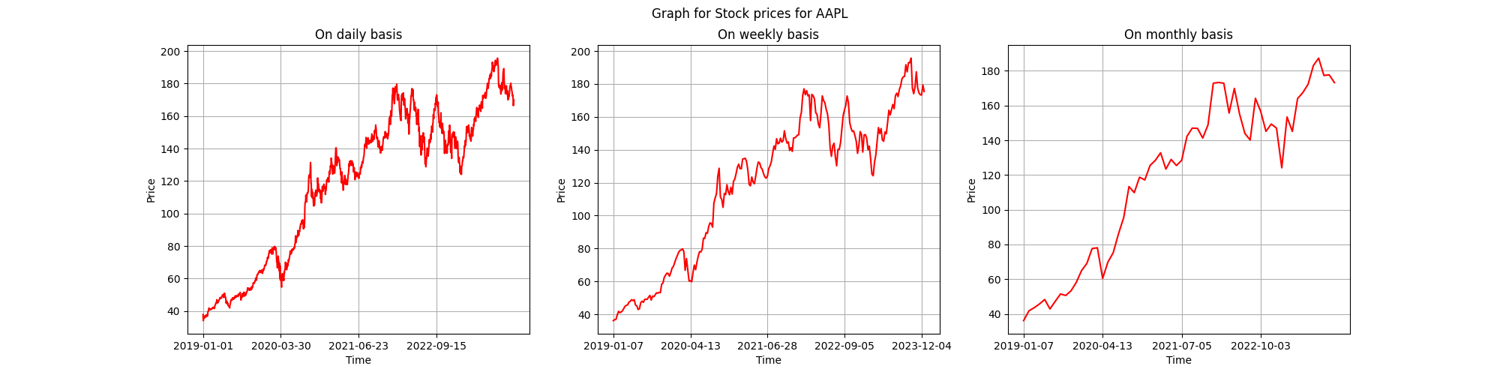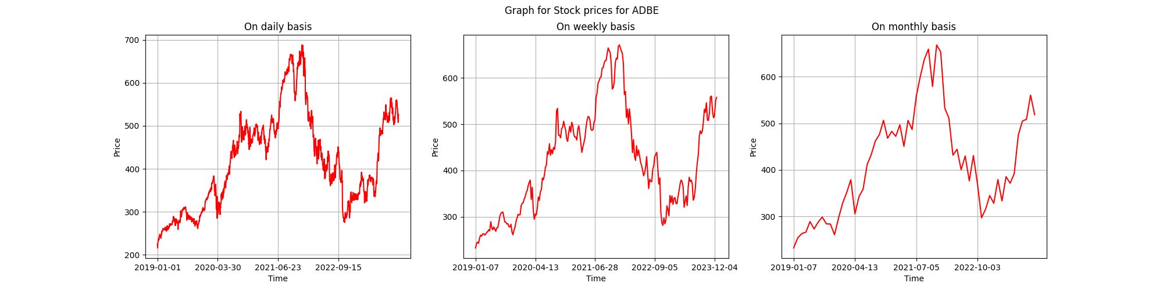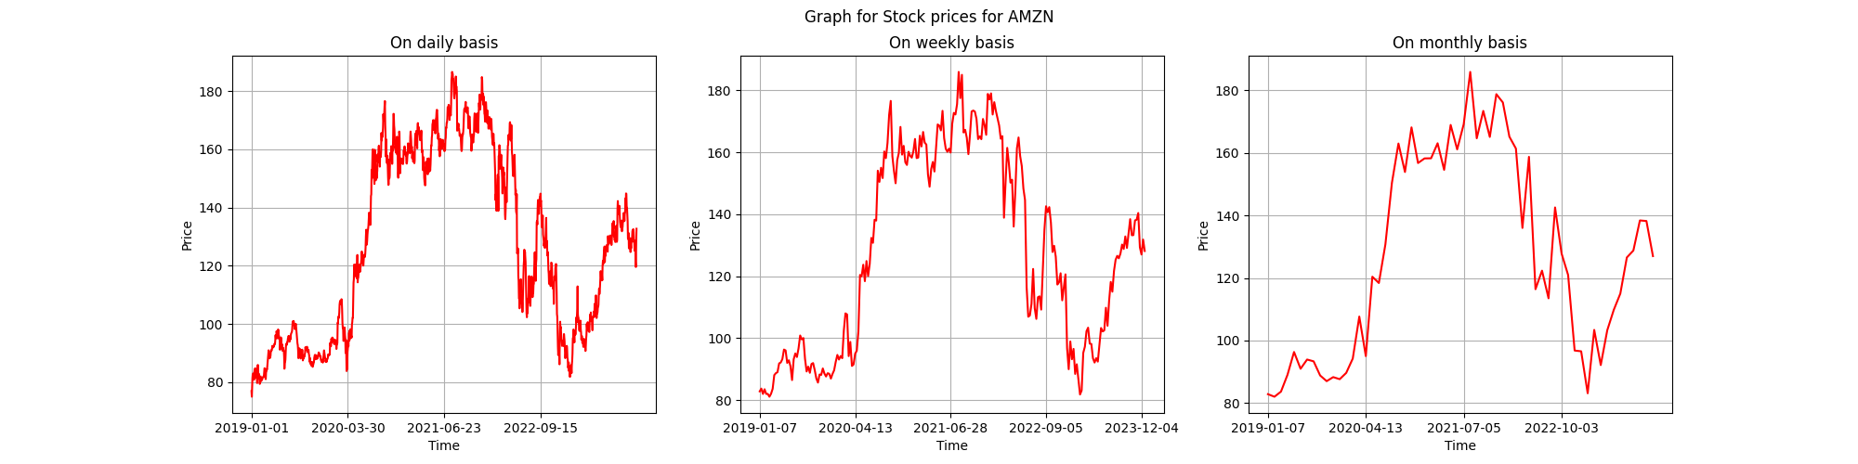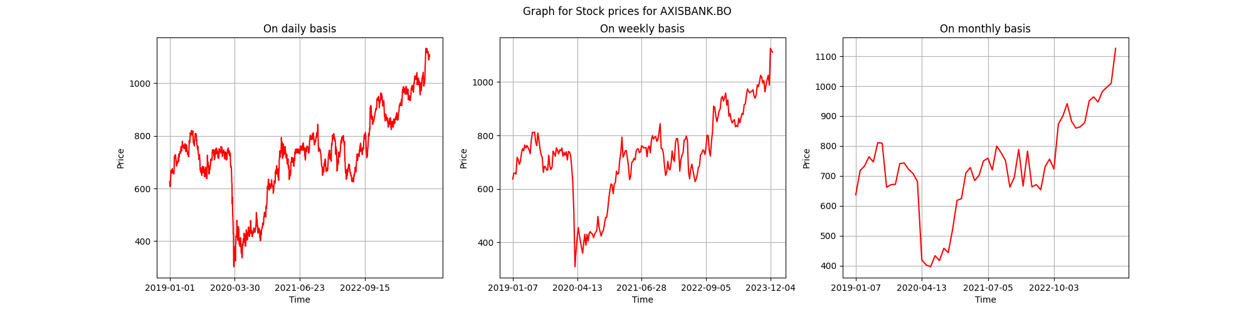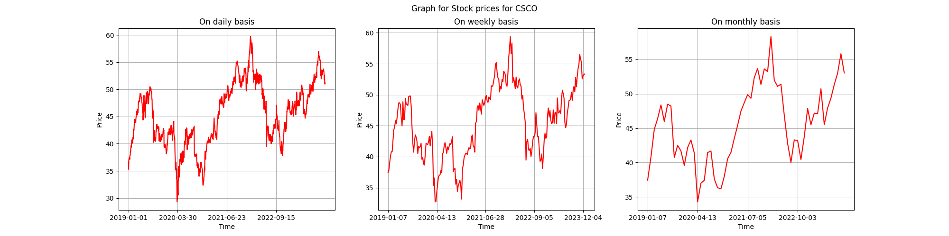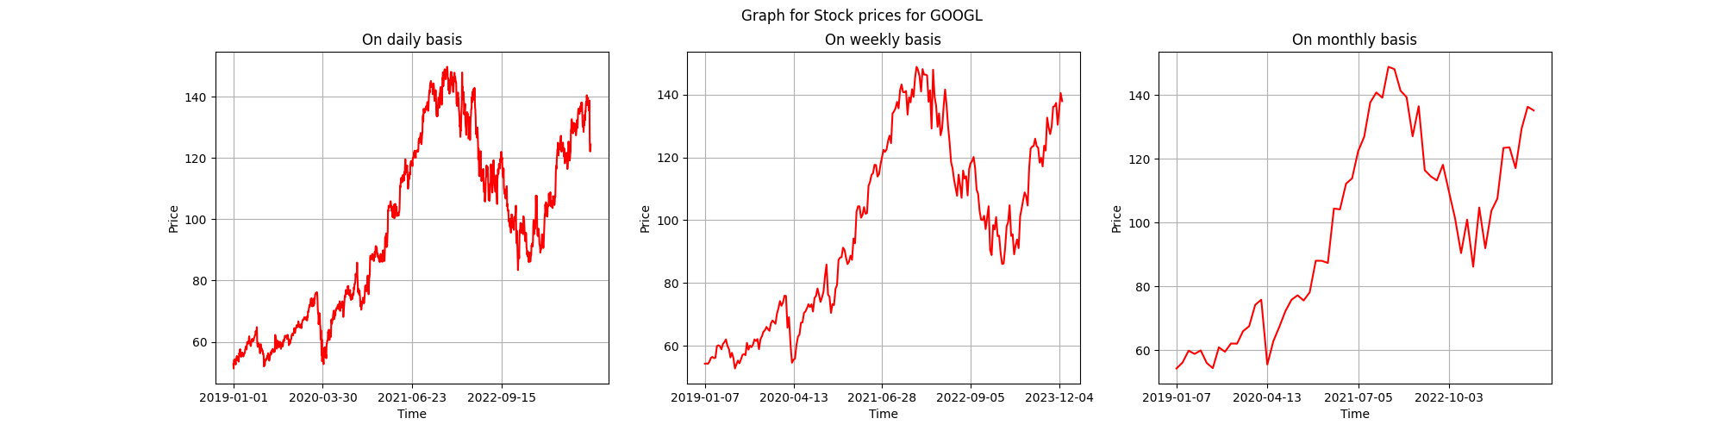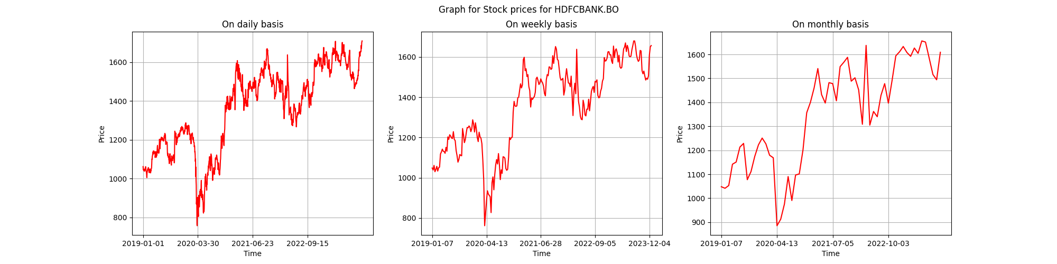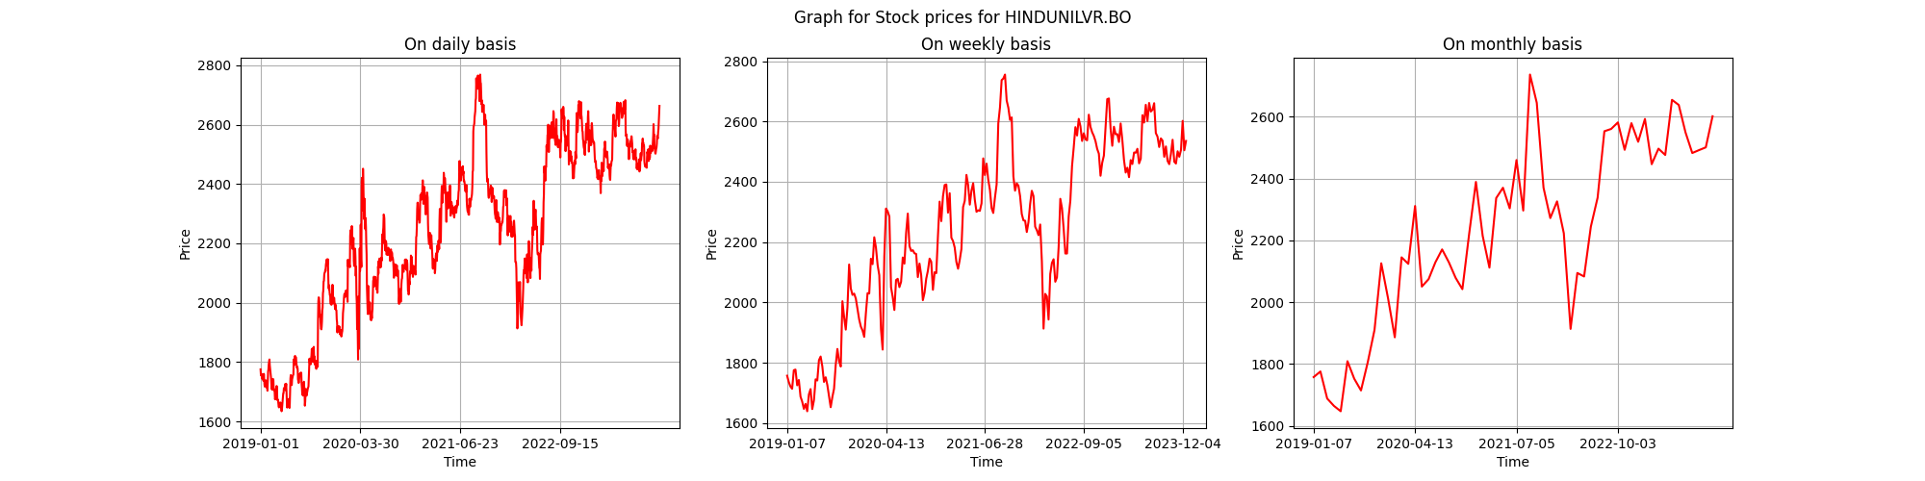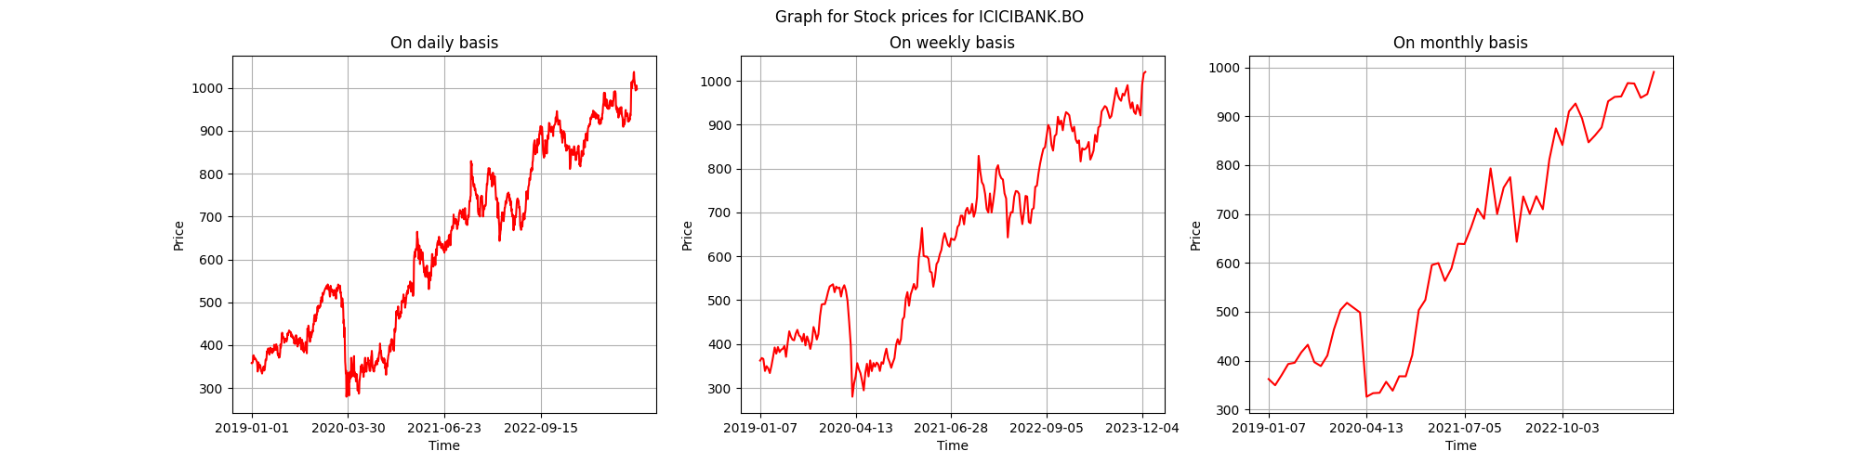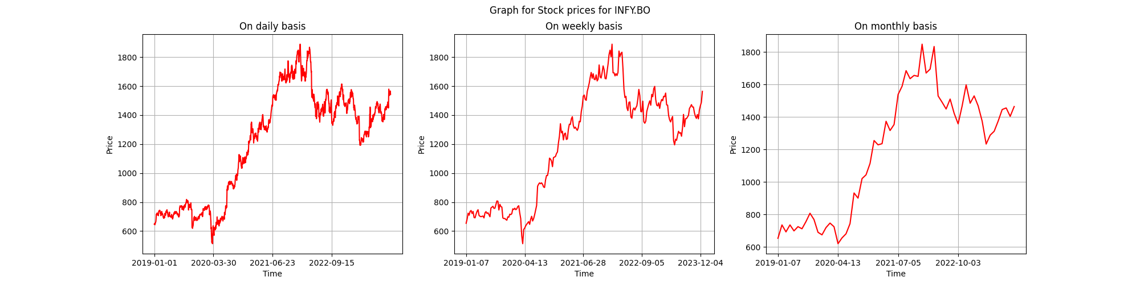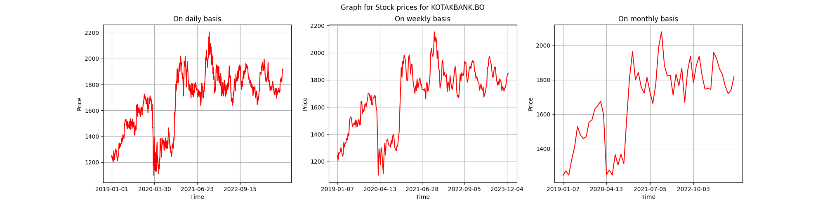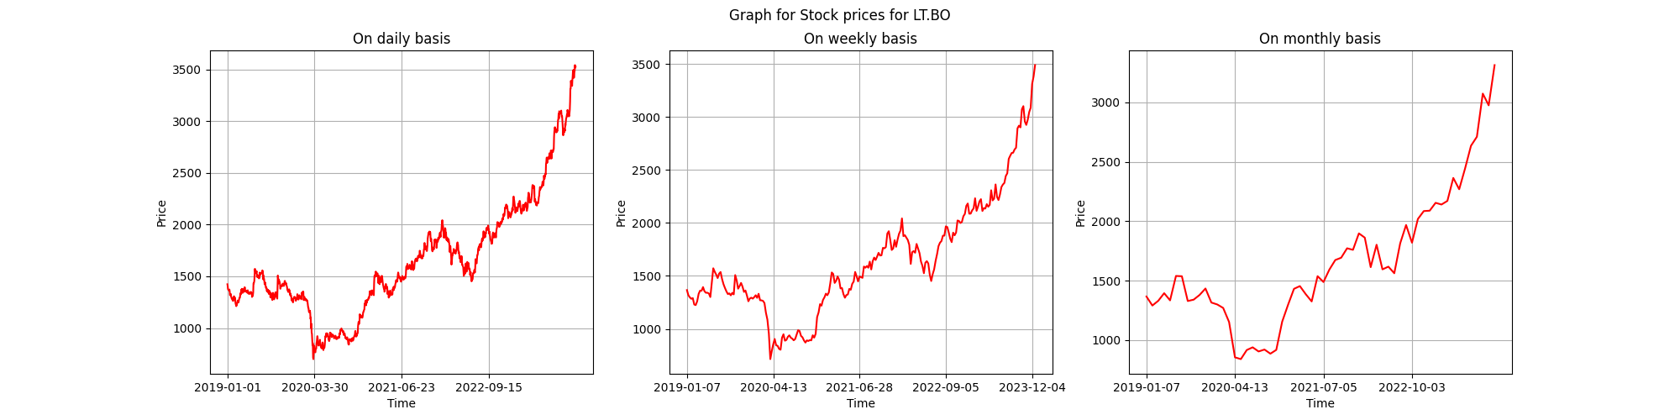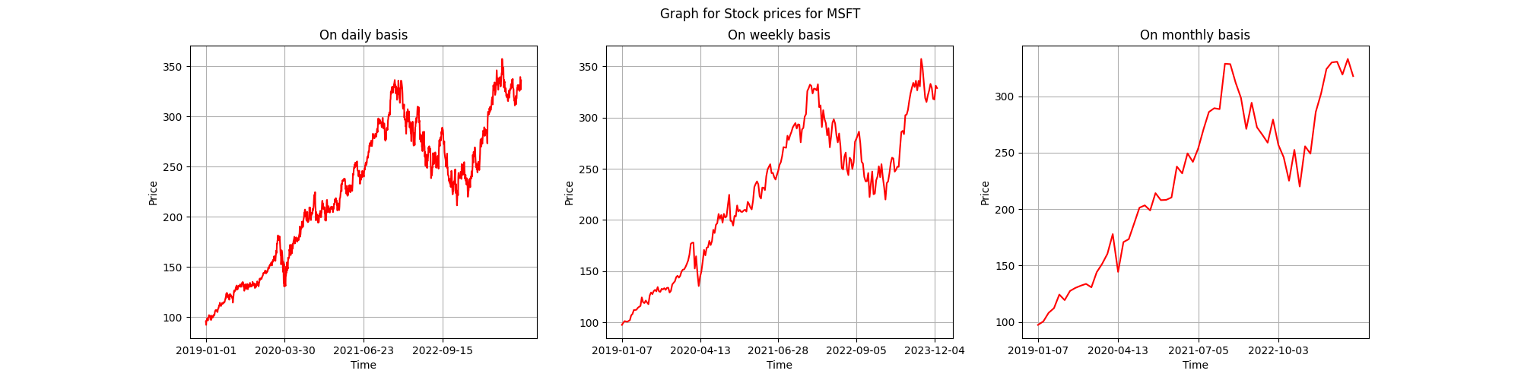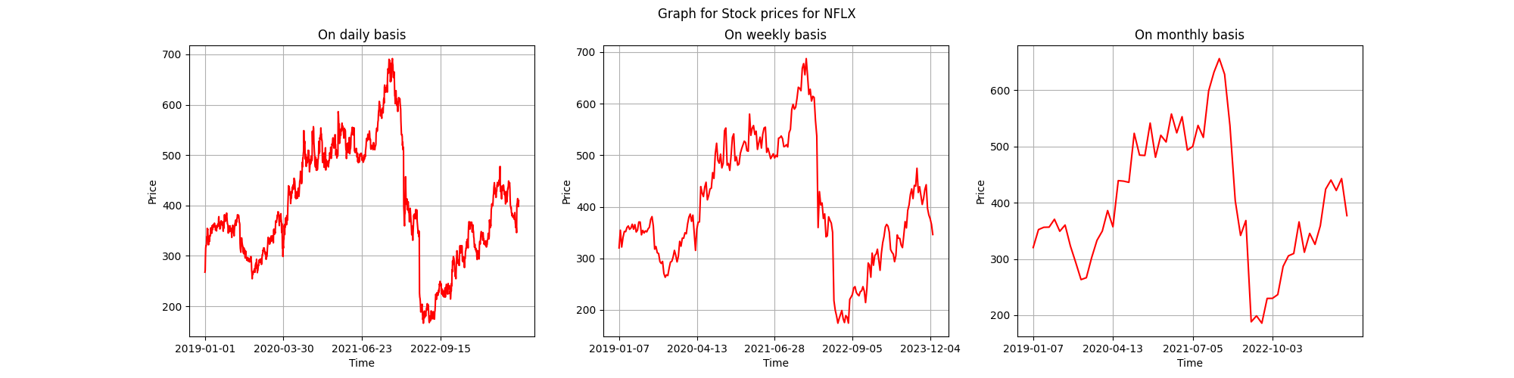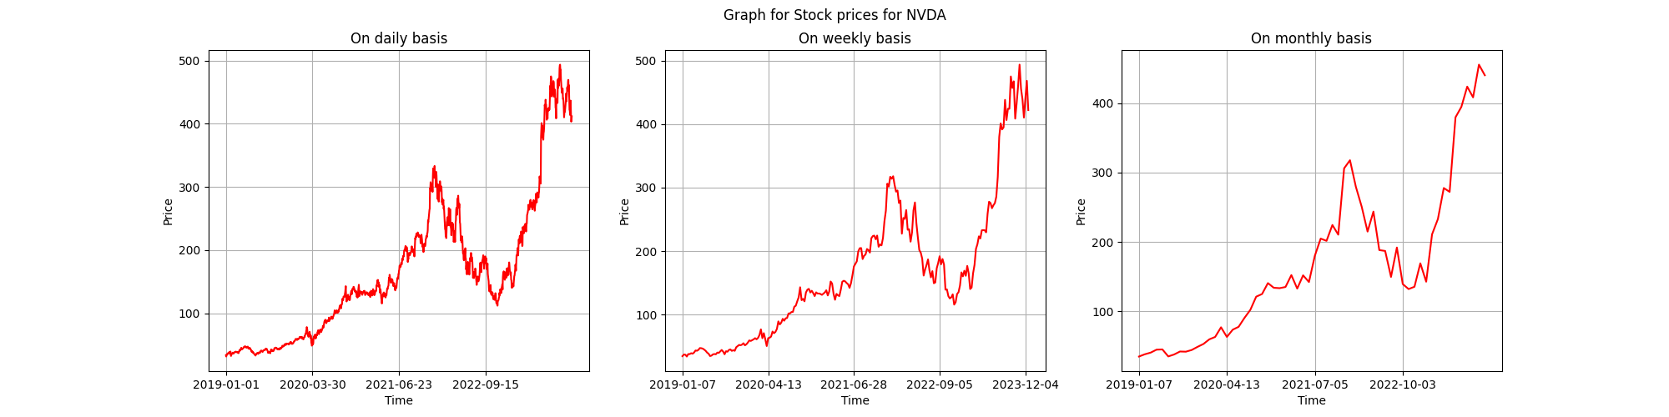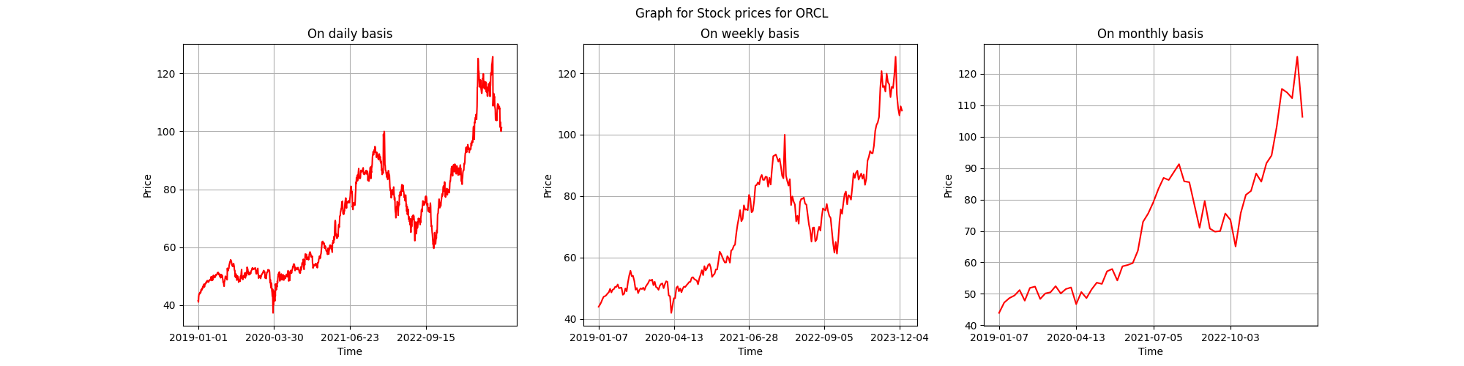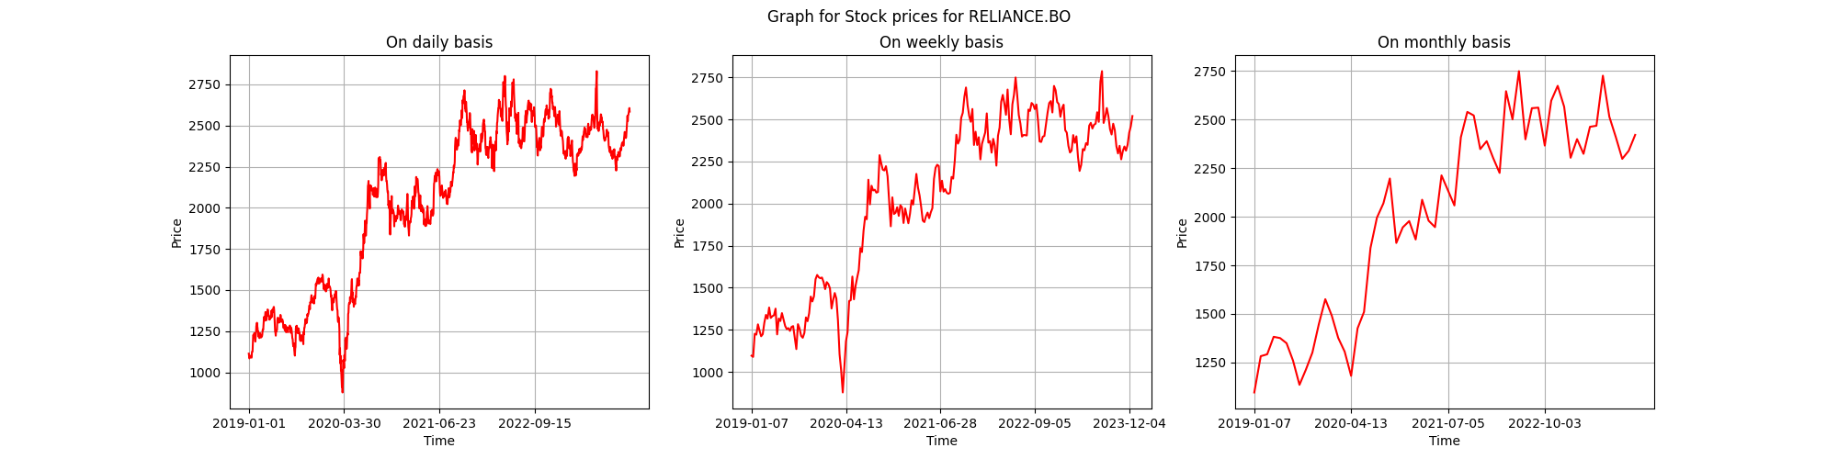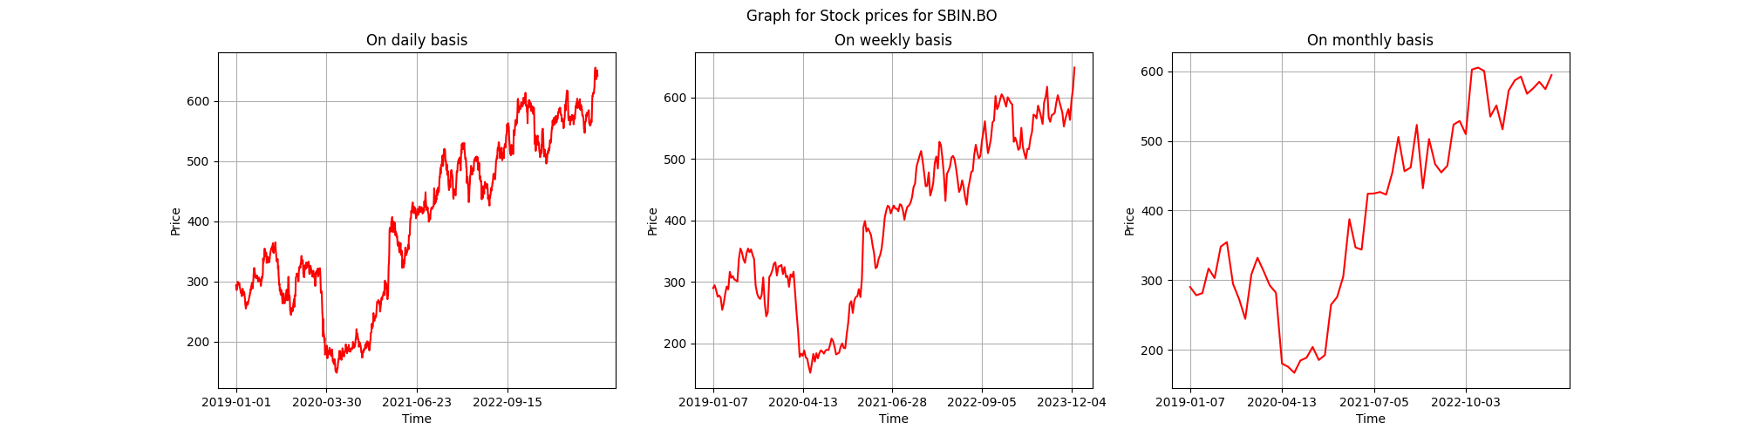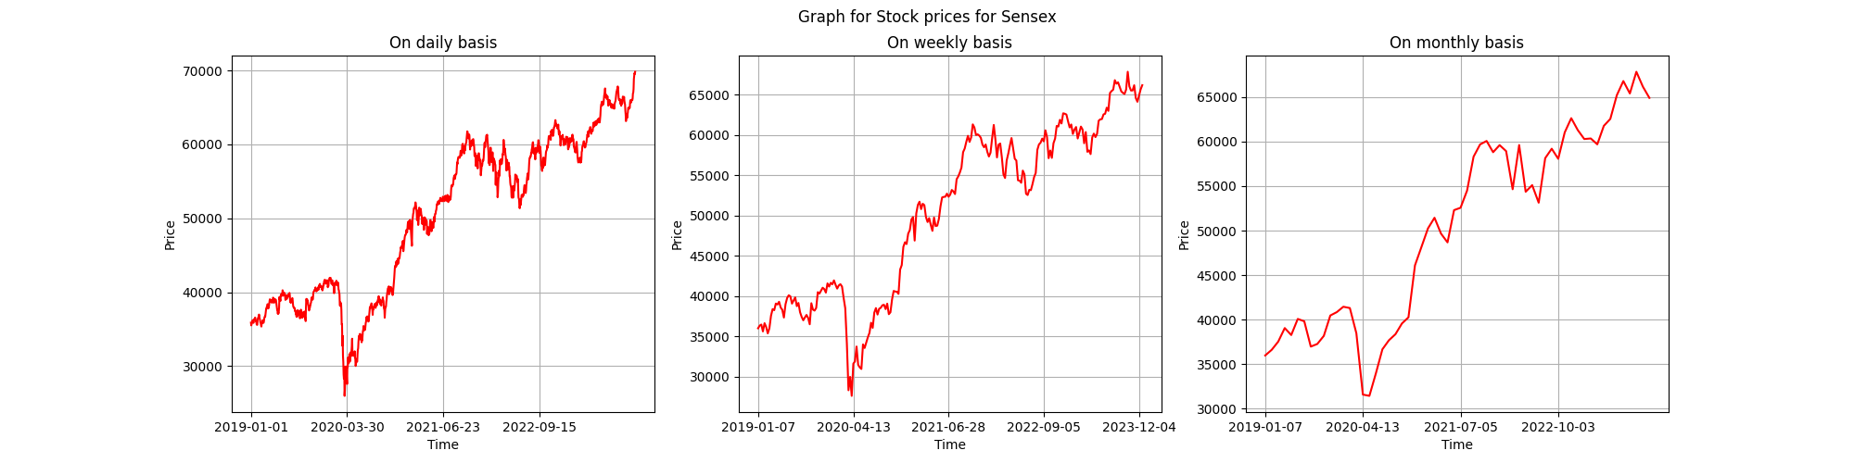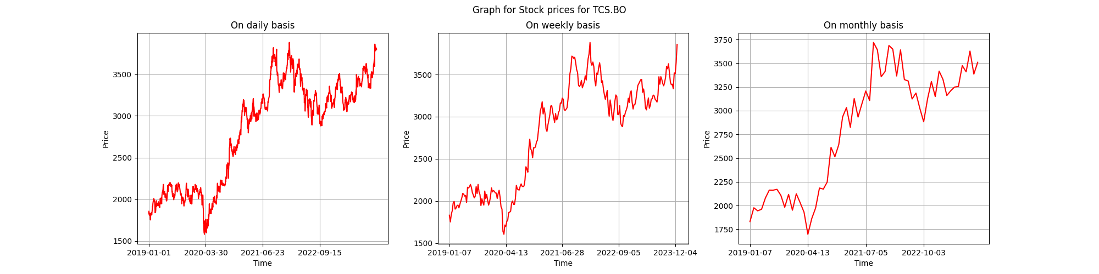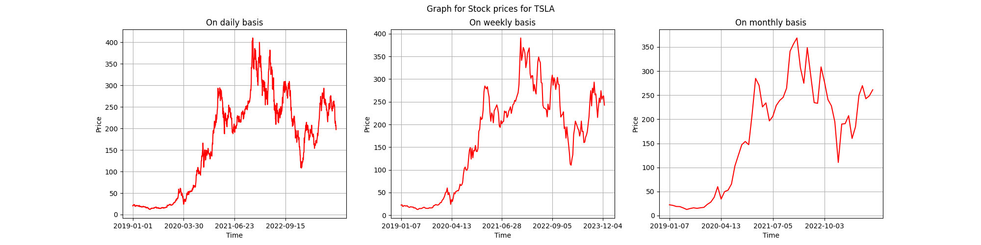

The plots for the Stock Prices and NSE Index (Nifty) for the data in nsedata1.csv are as follows:

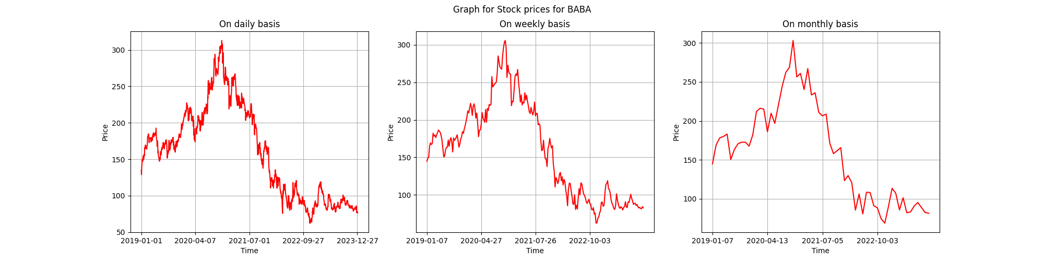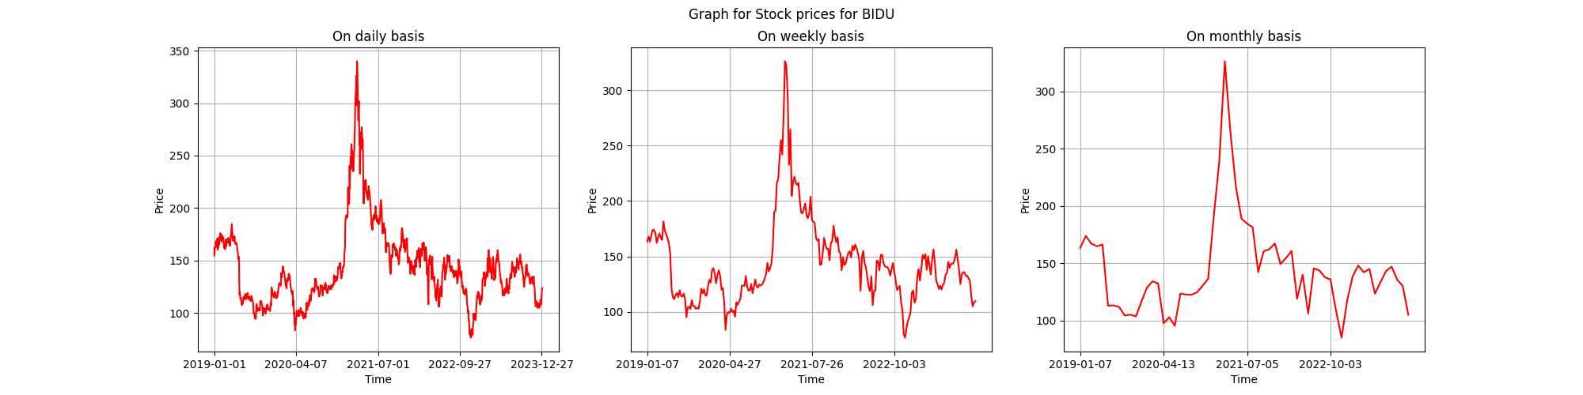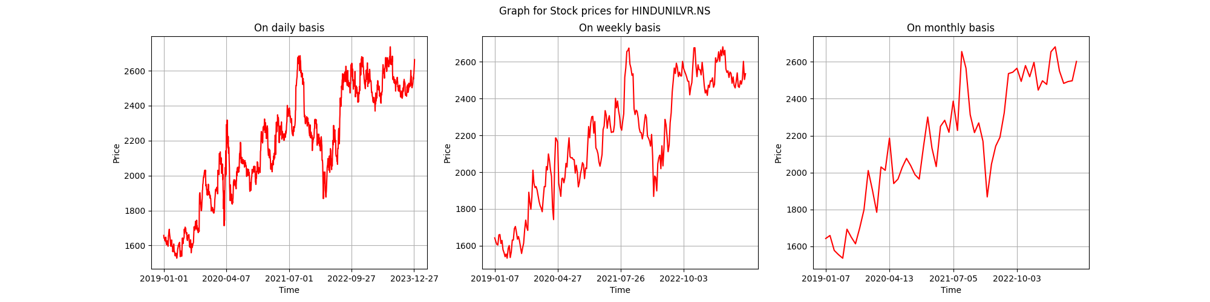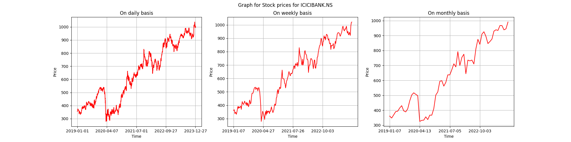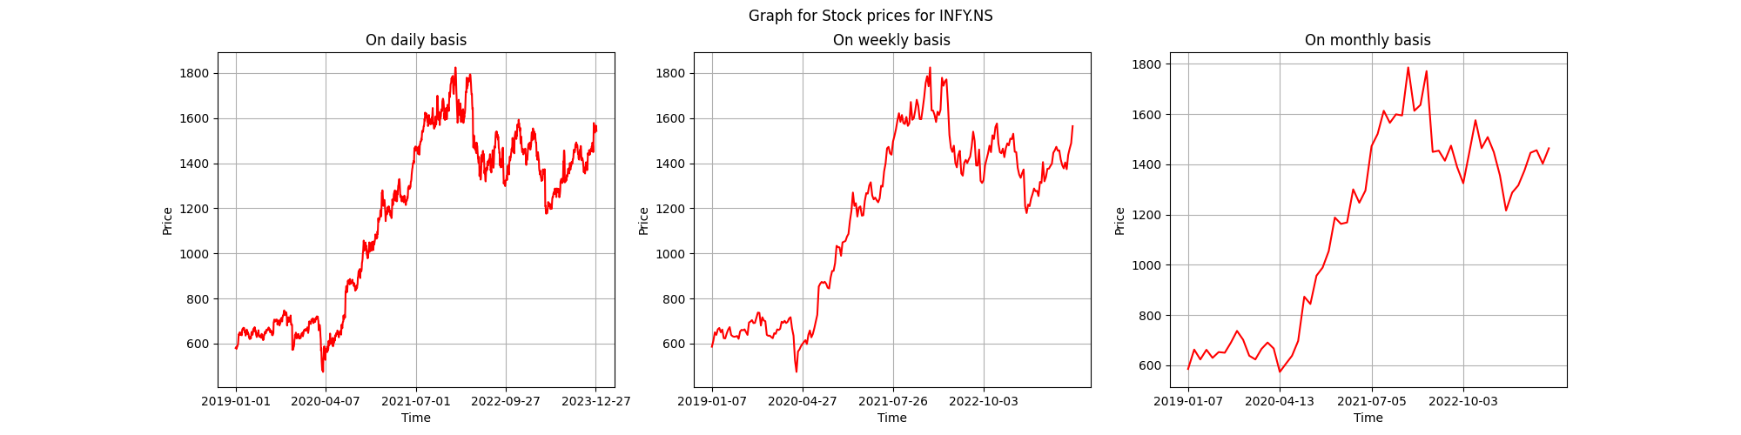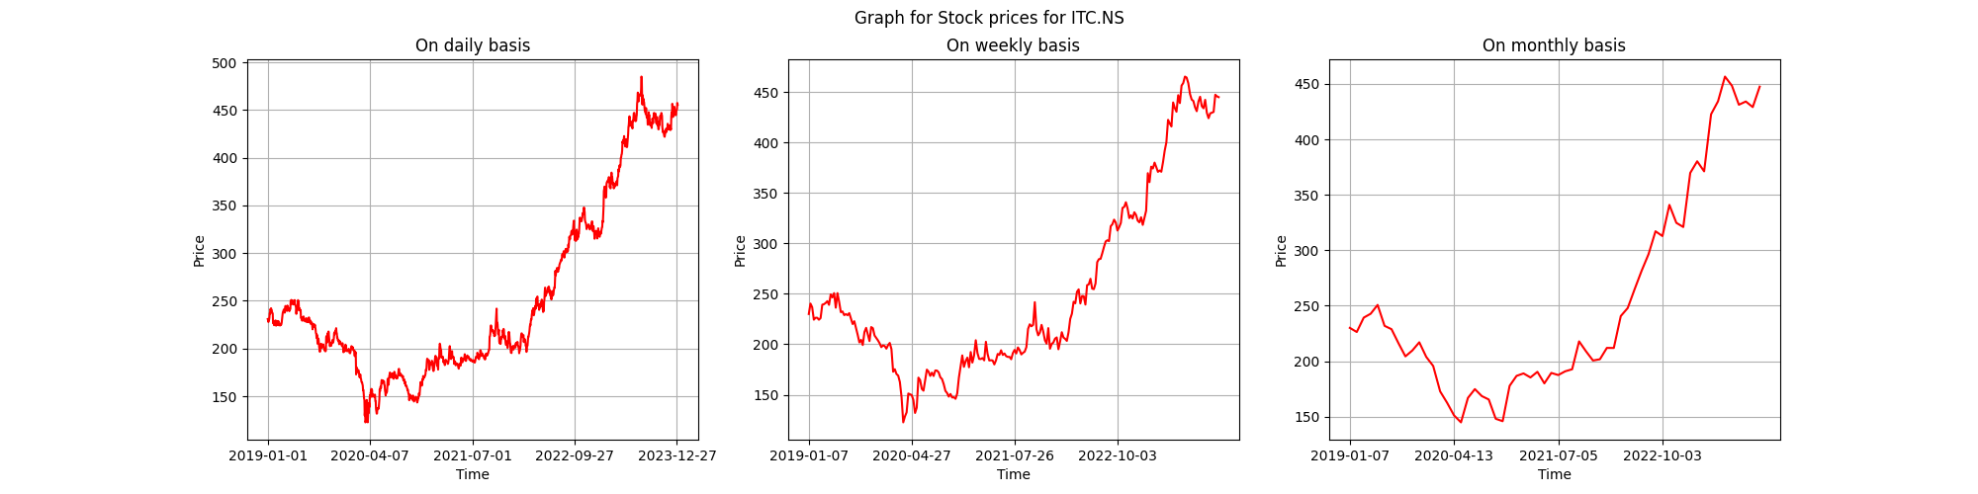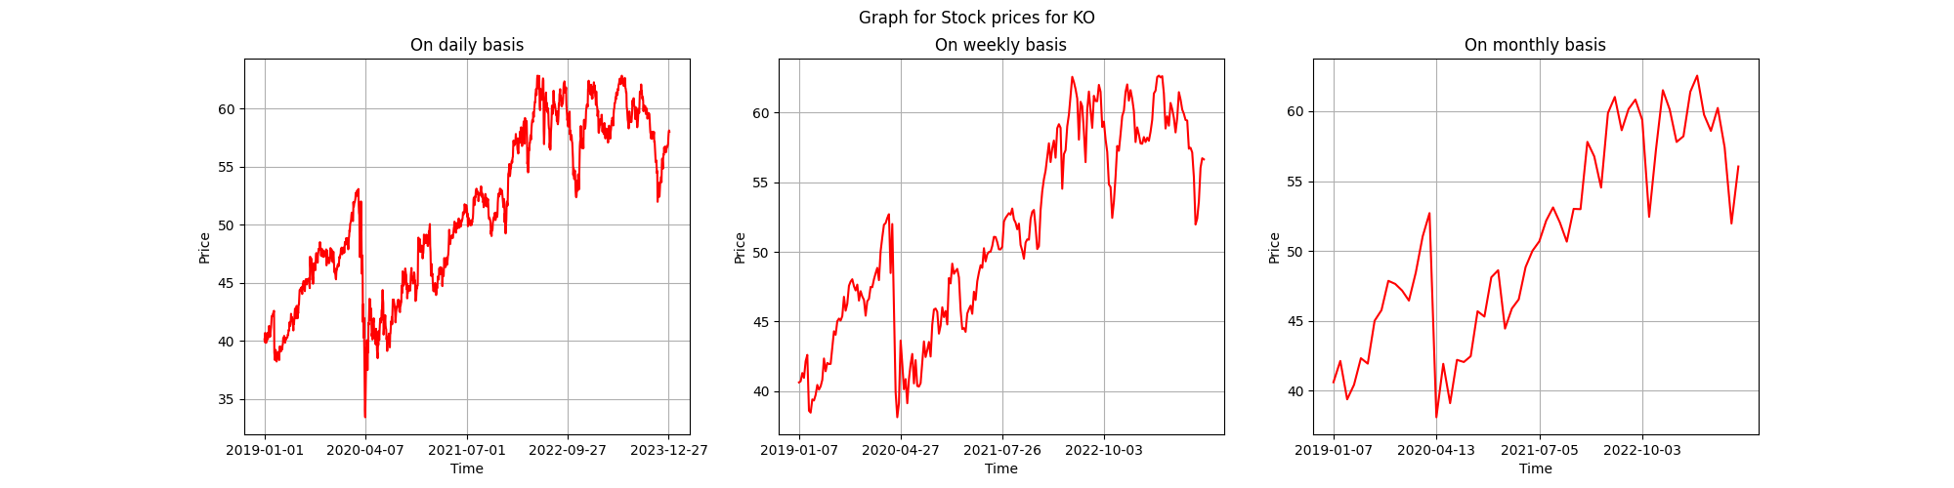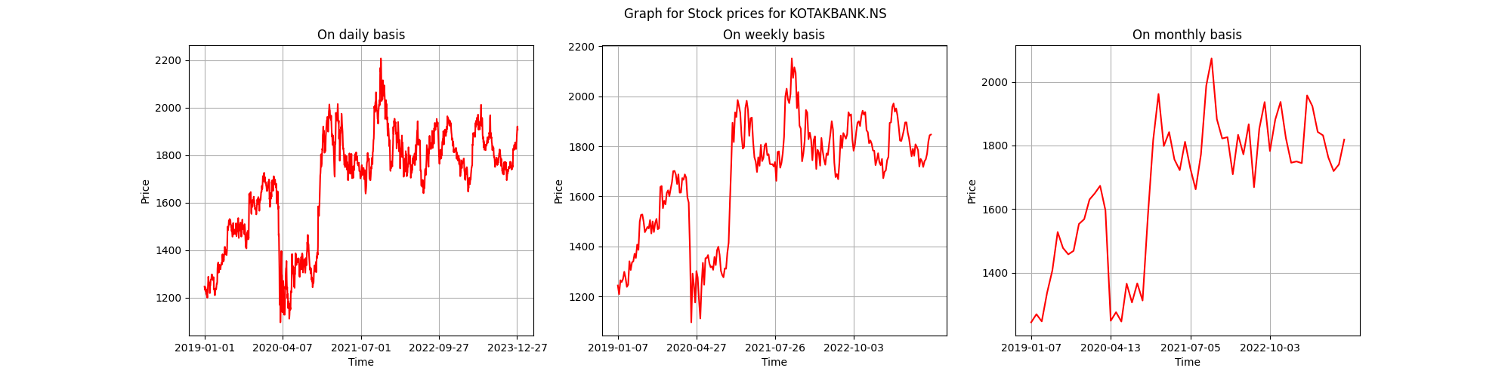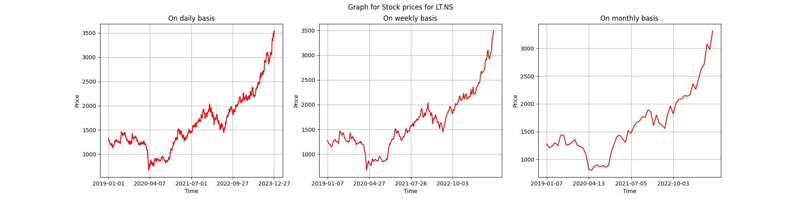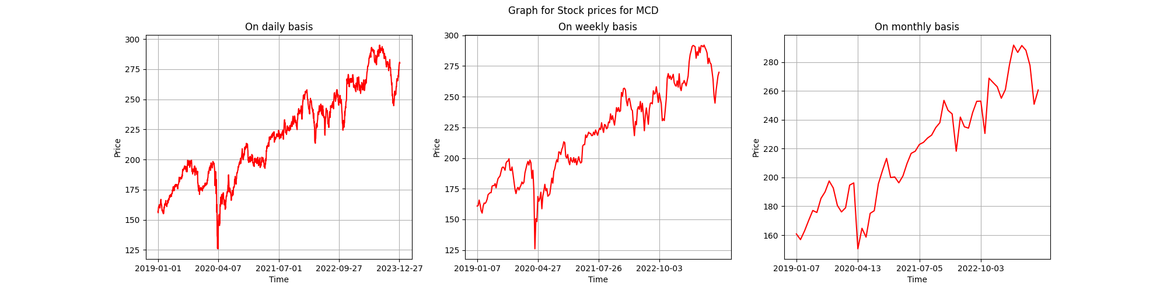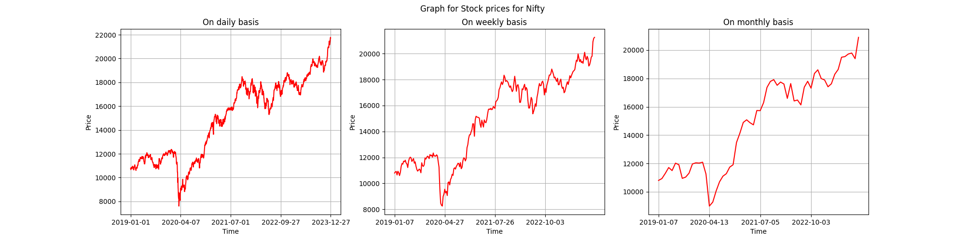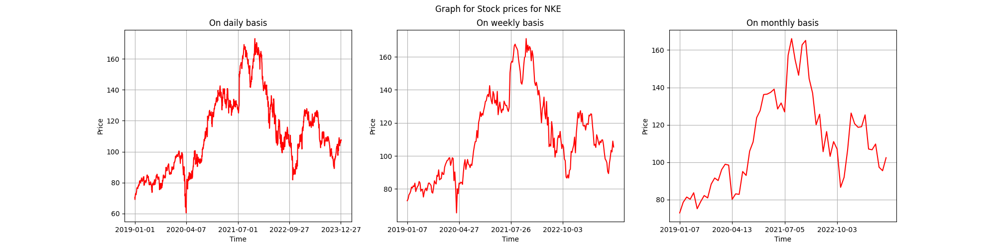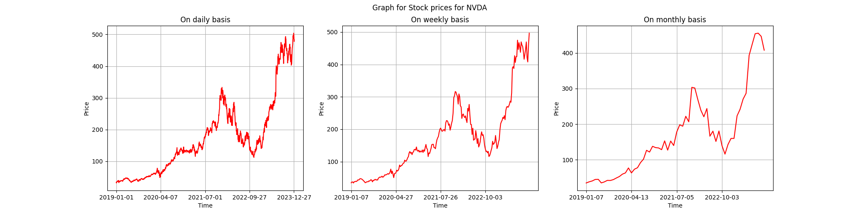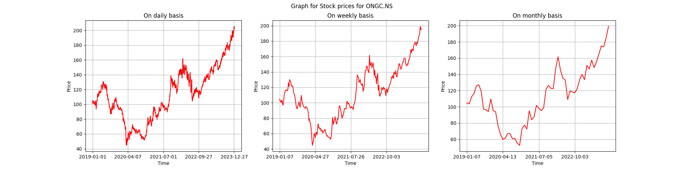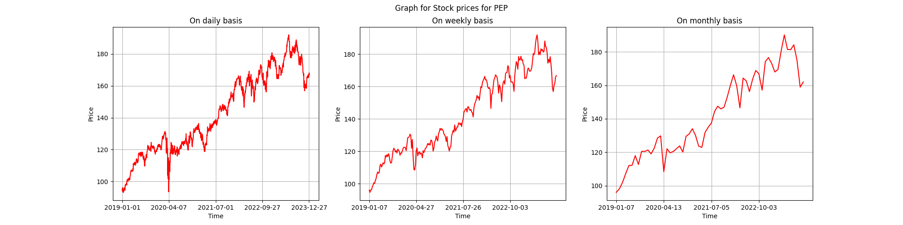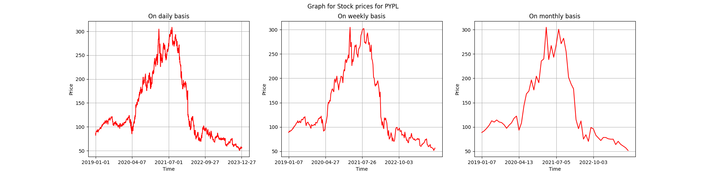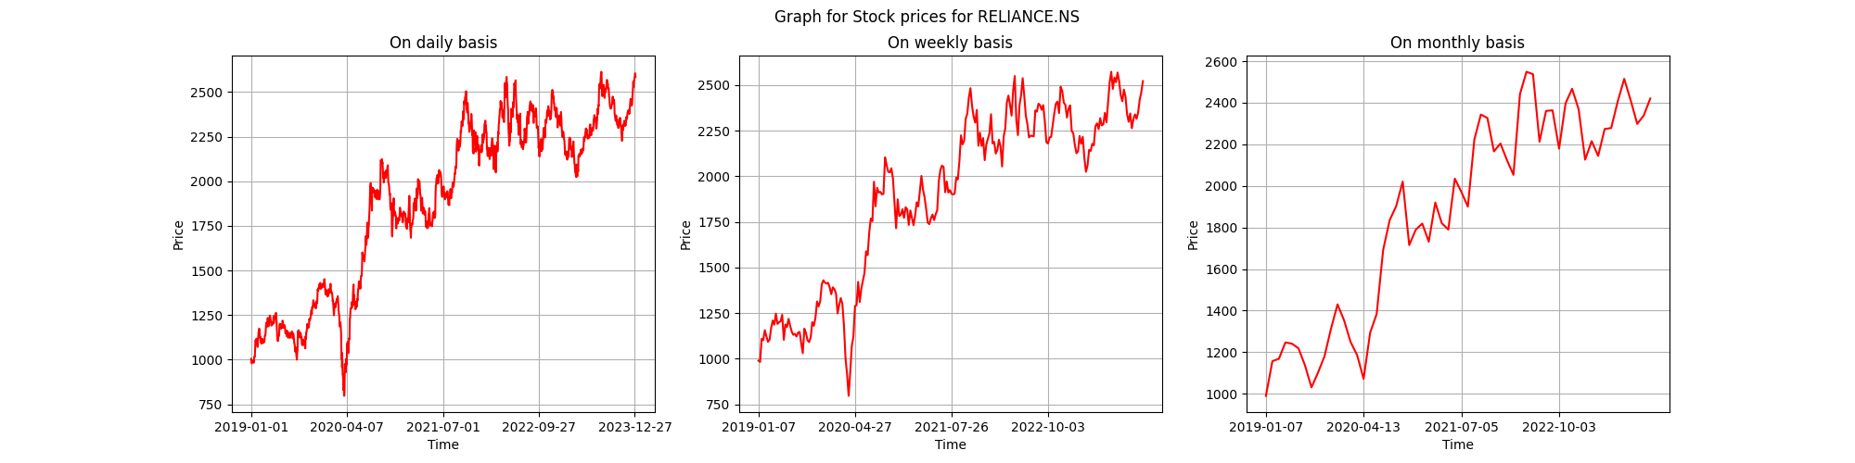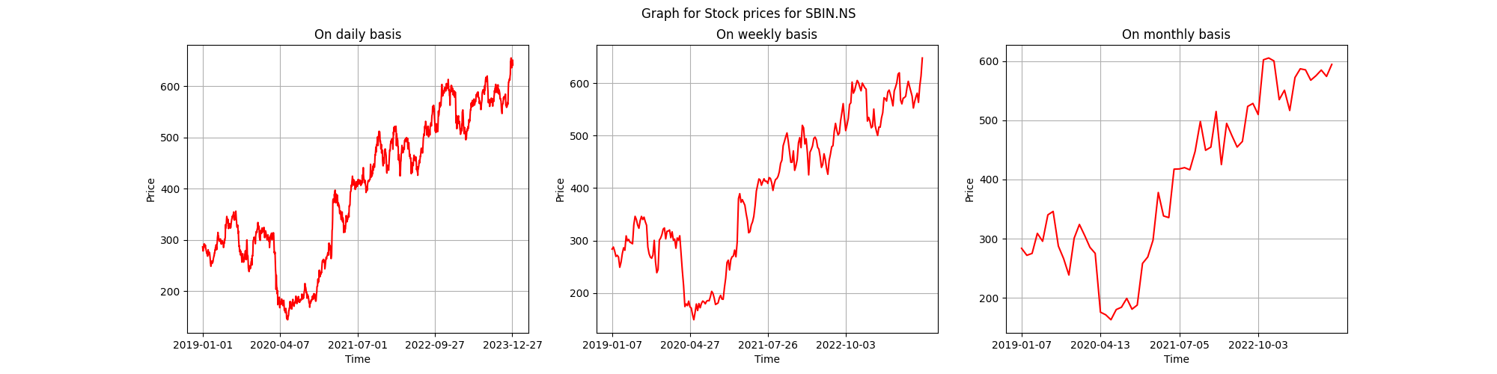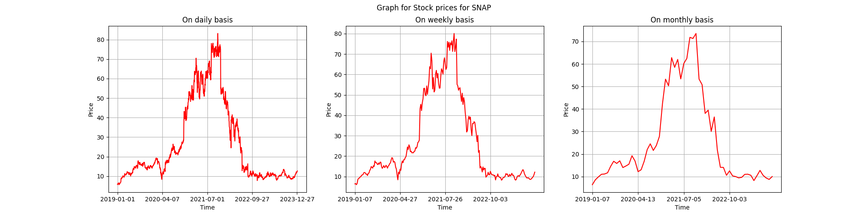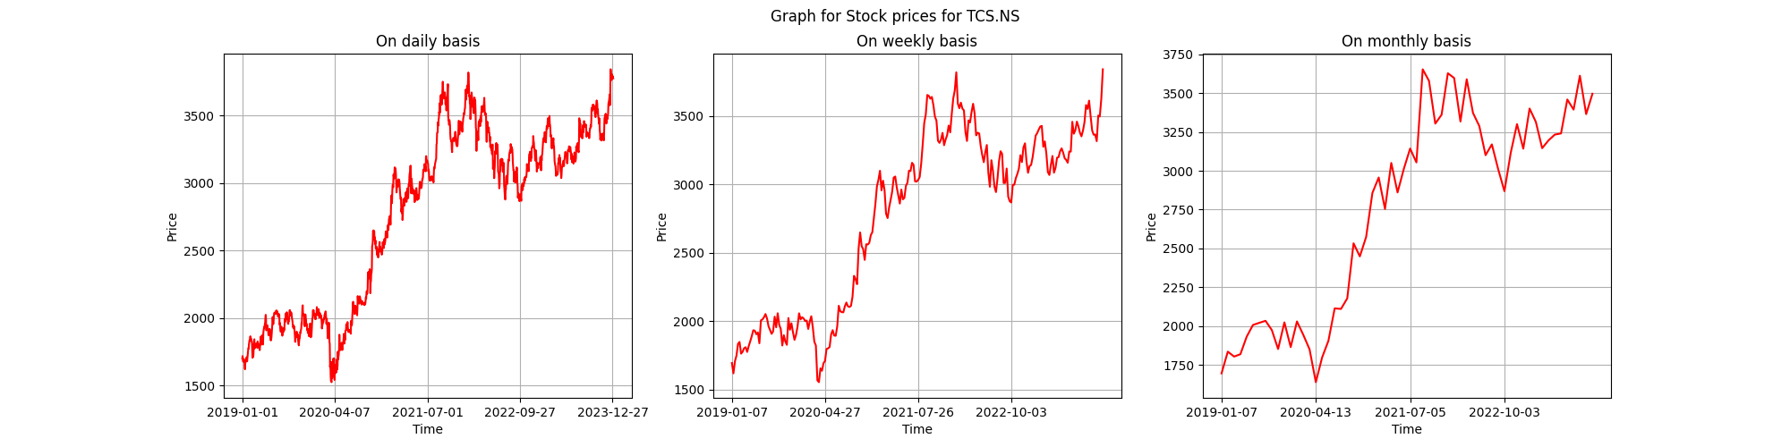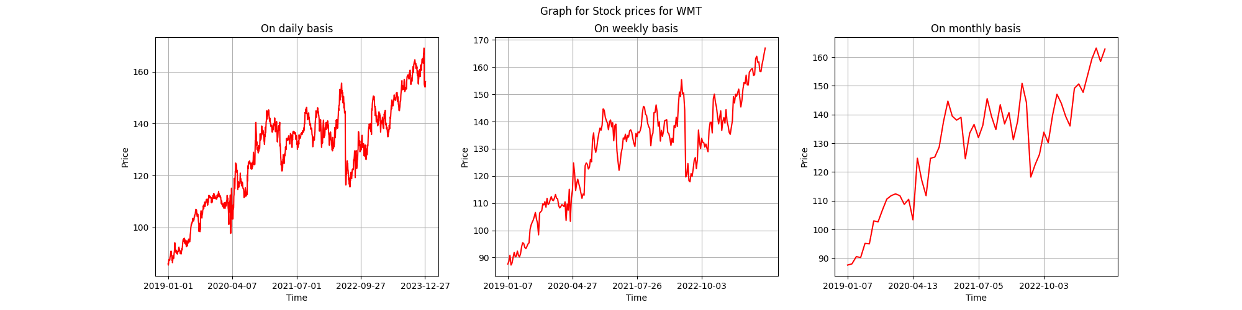

Question 2:

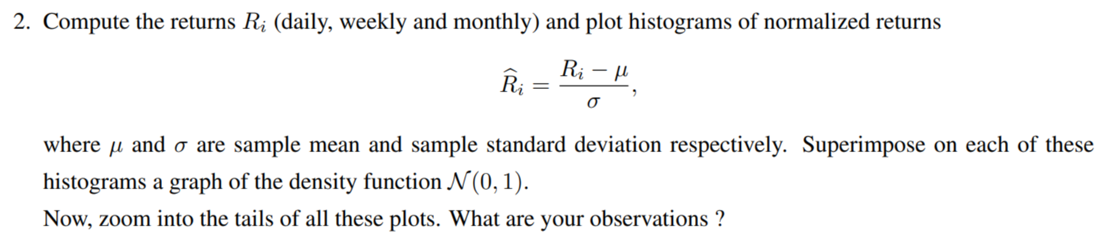

The histograms of the normalized returns superimposed by a graph of the density function N(0,1) for the data in bsedata1.csv are as follows:

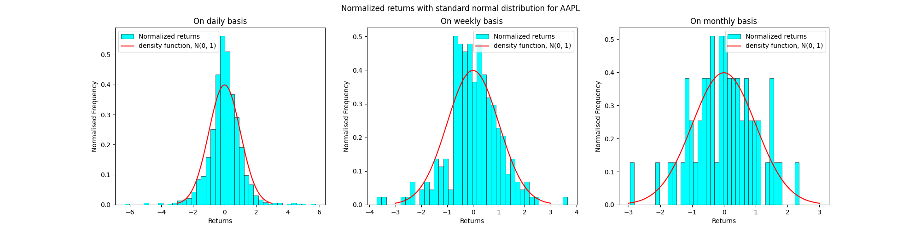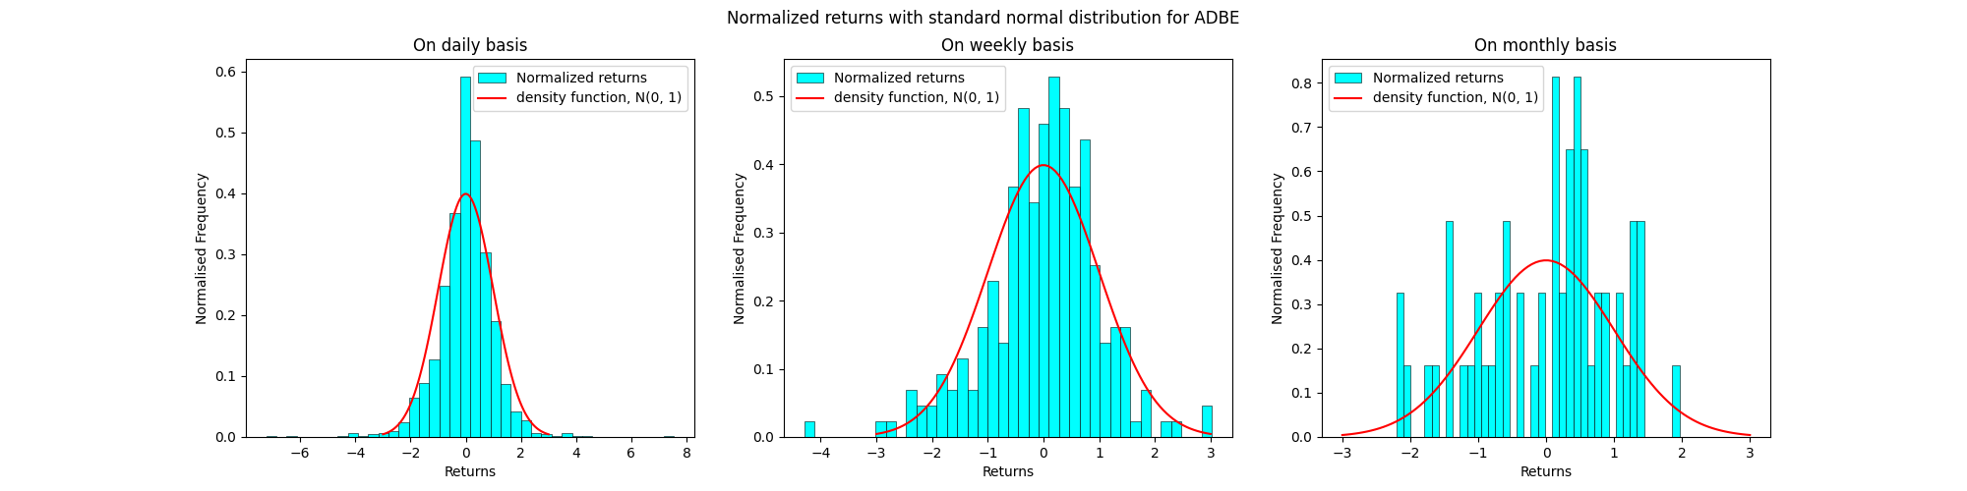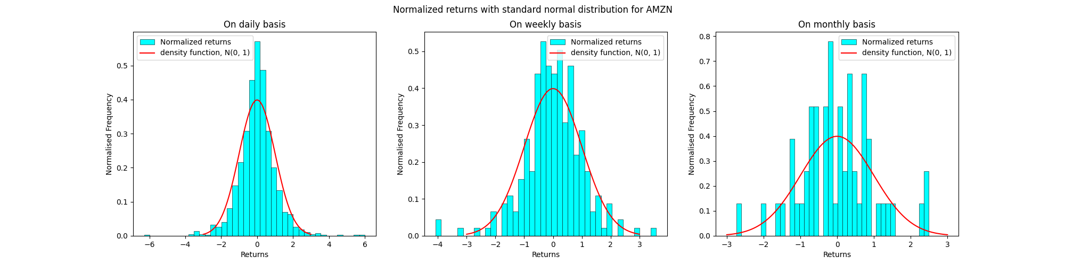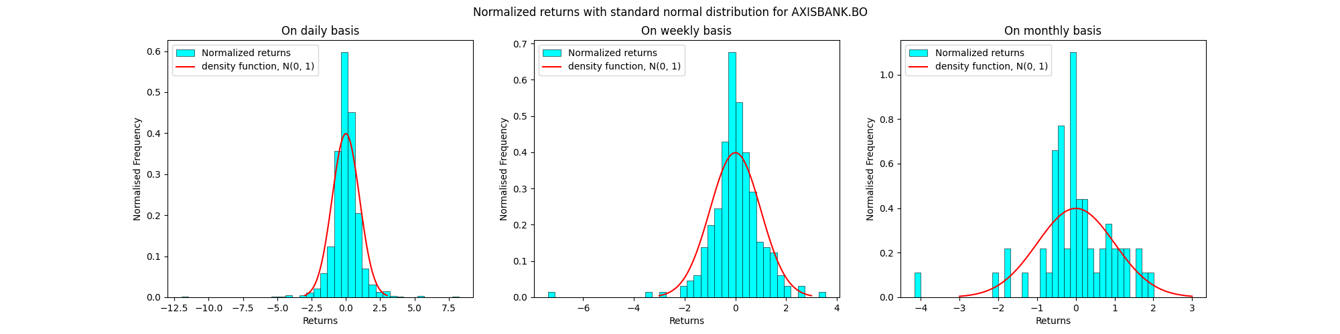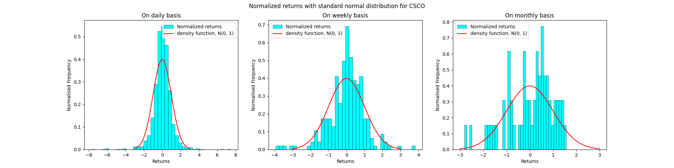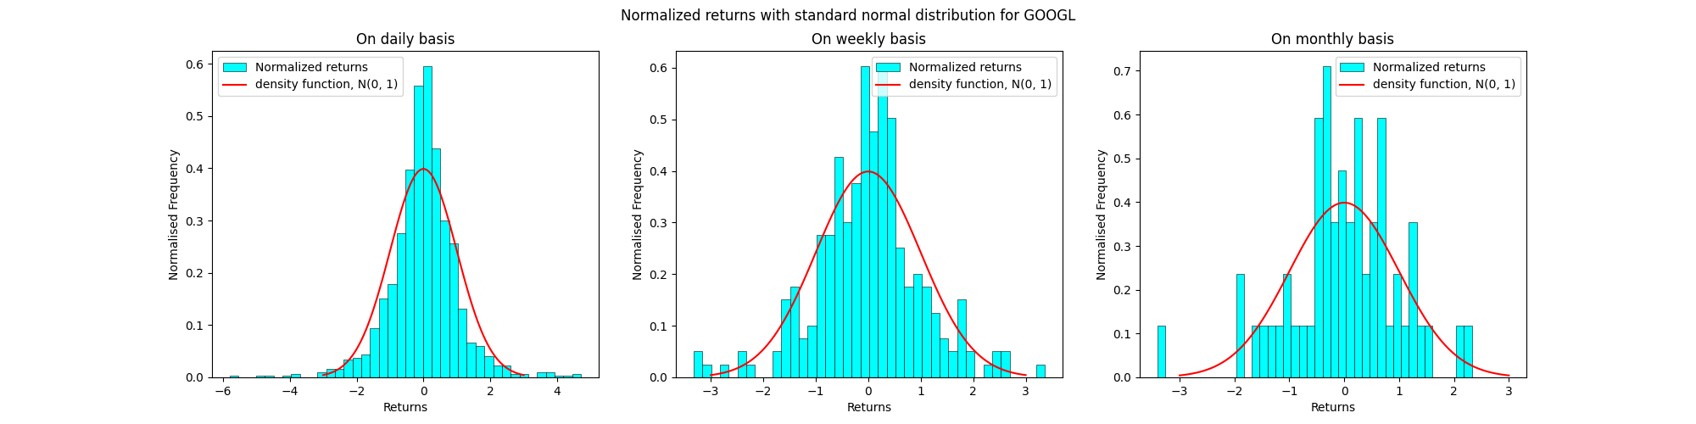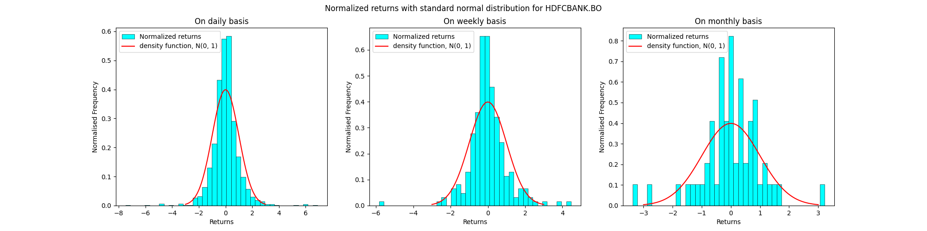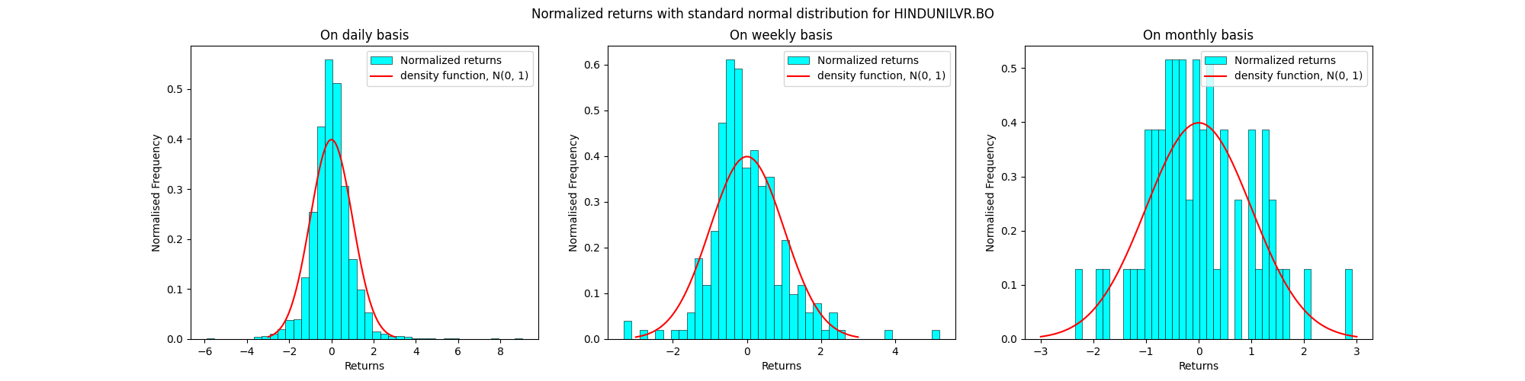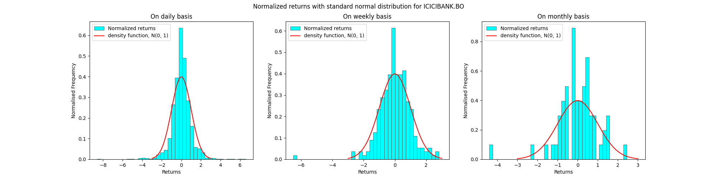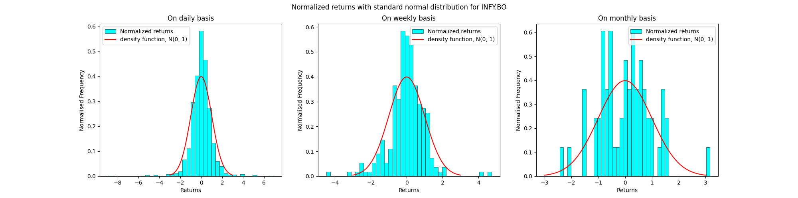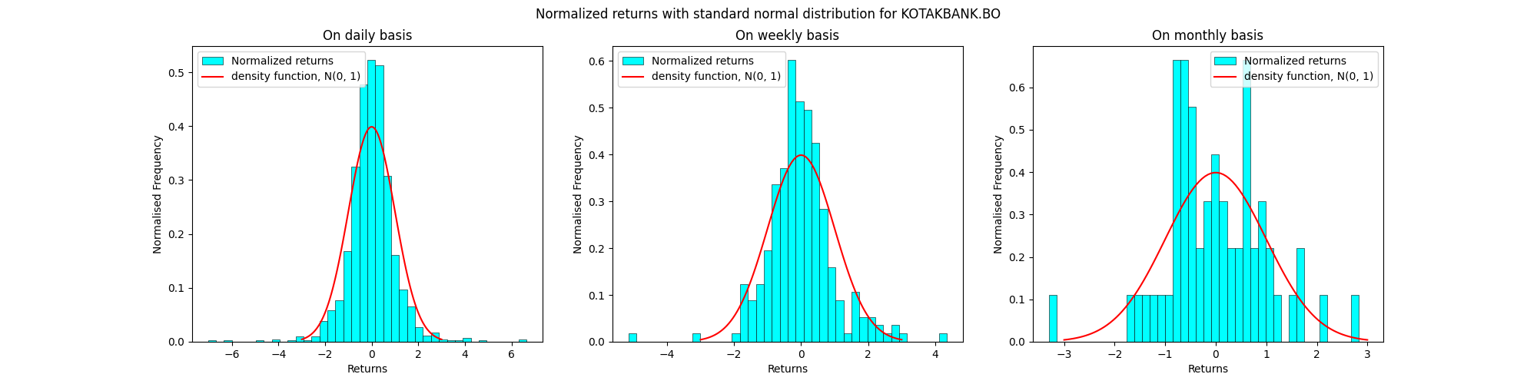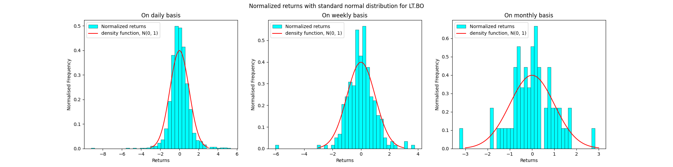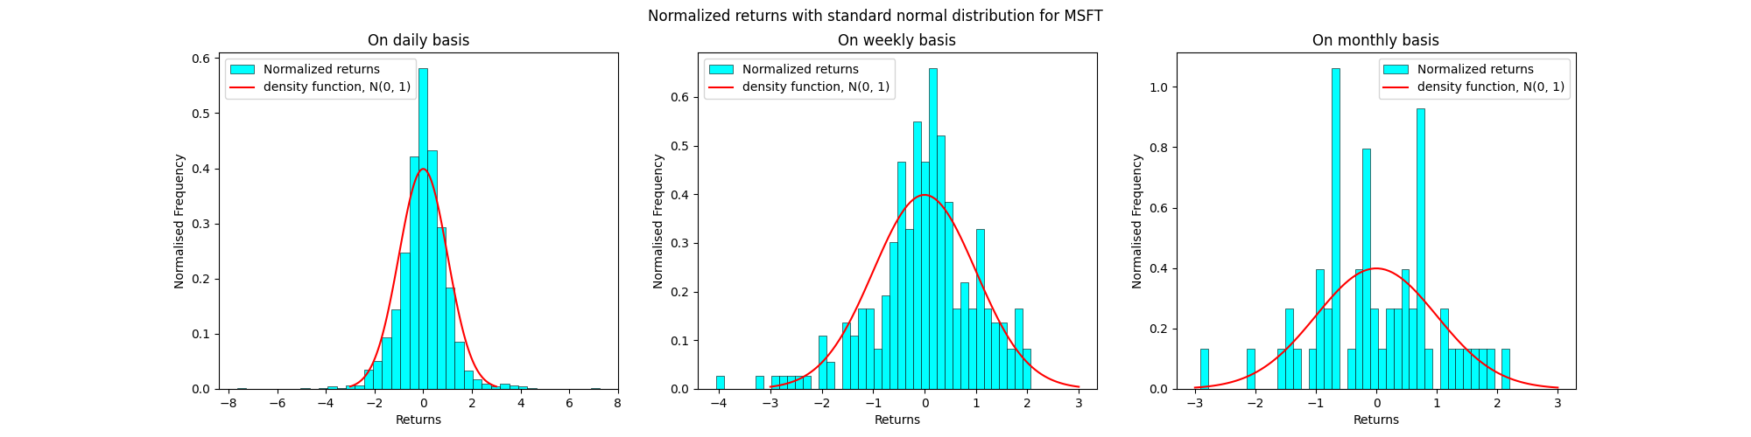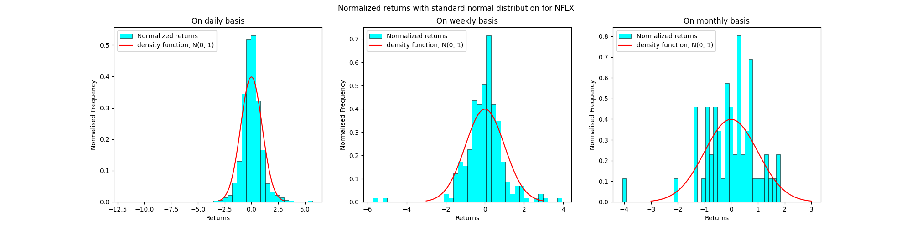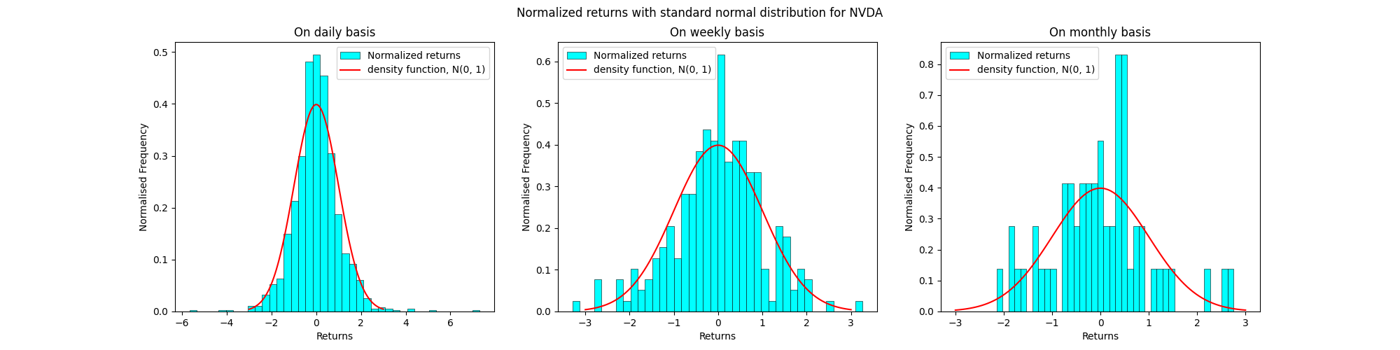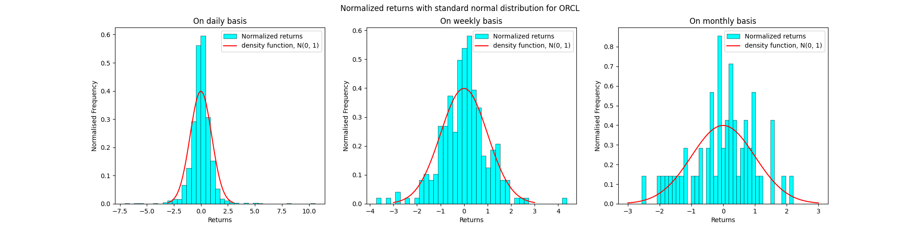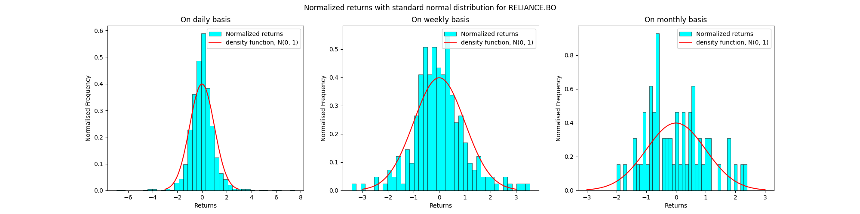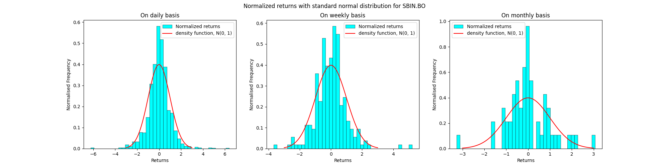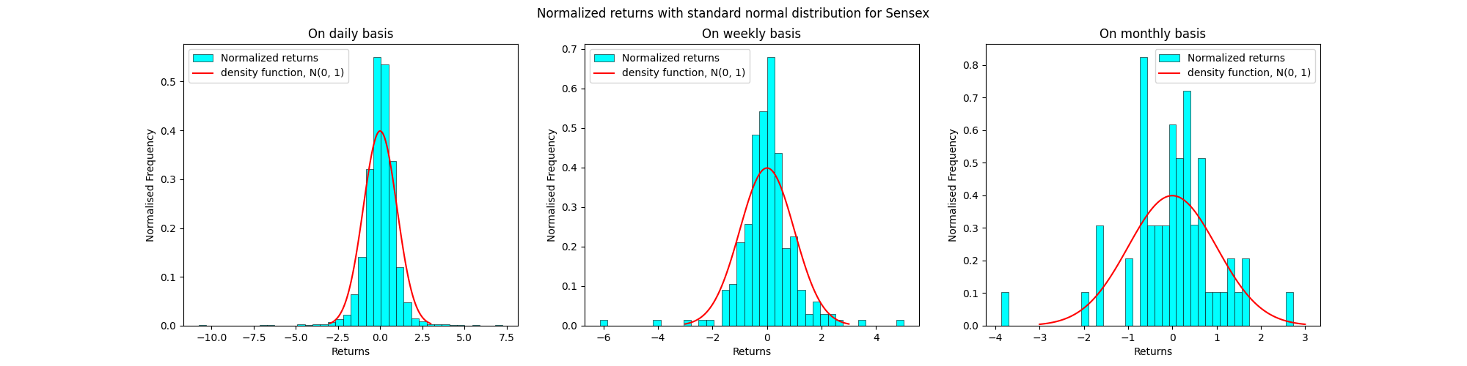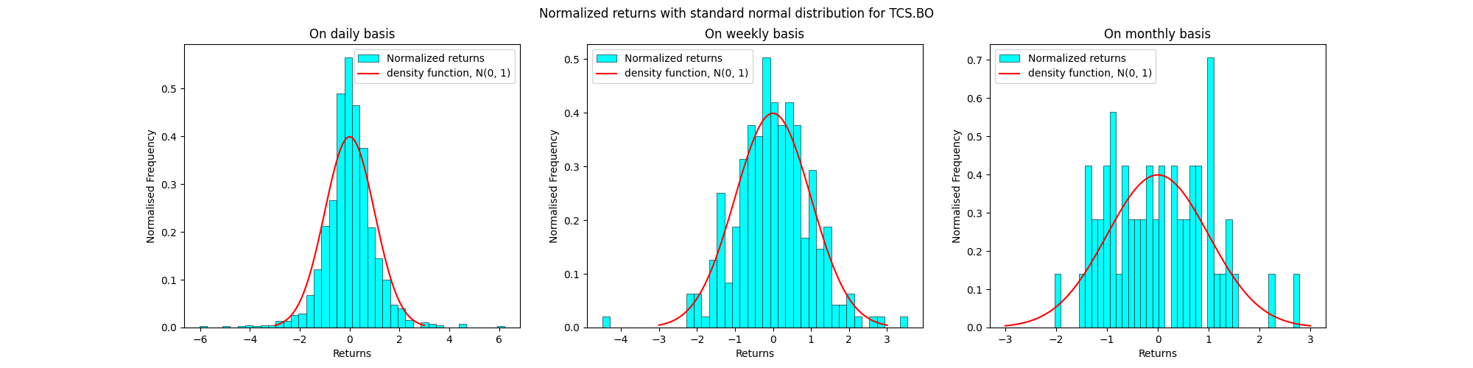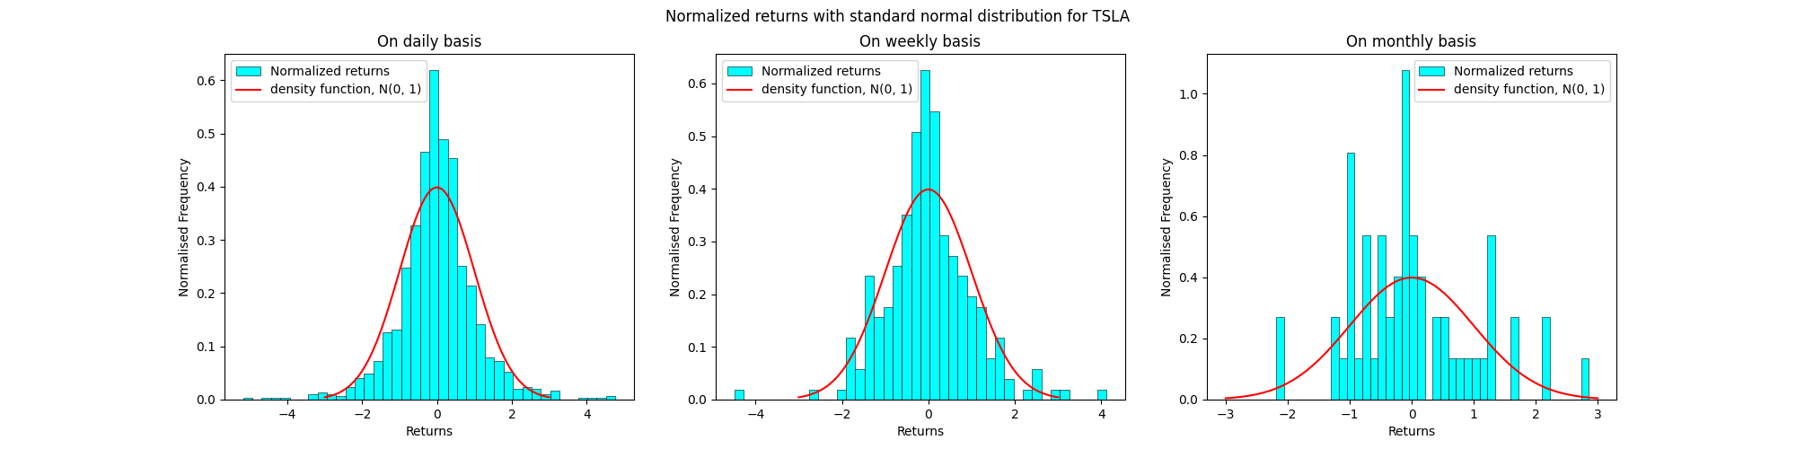

The histograms of the normalized returns superimposed by a graph of the density function N(0,1) for the data in nsedata1.csv are as follows:

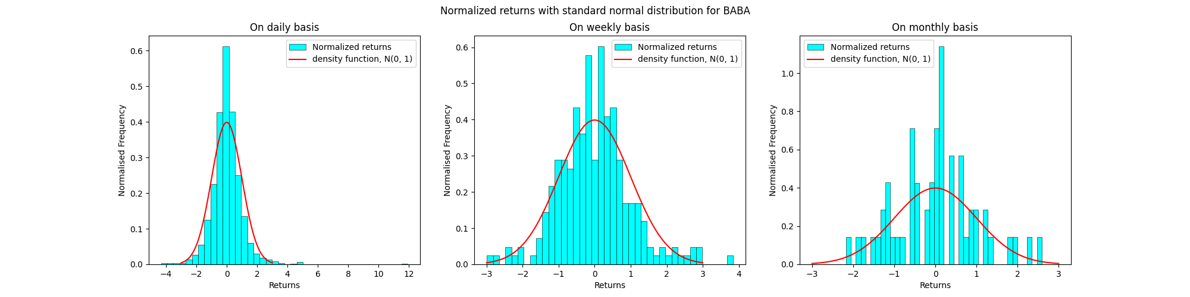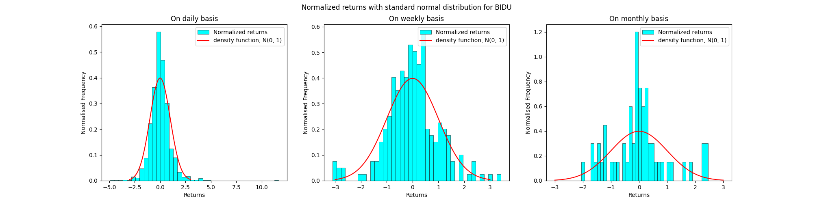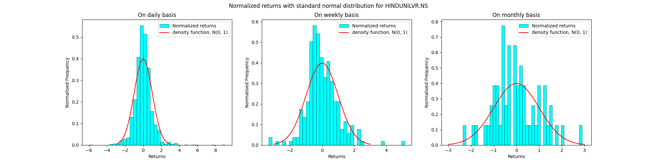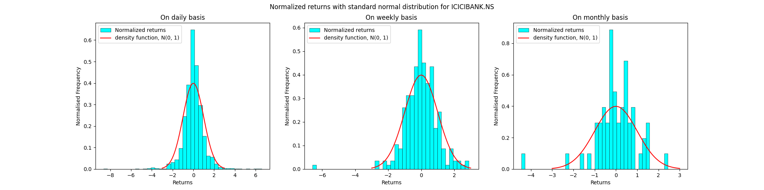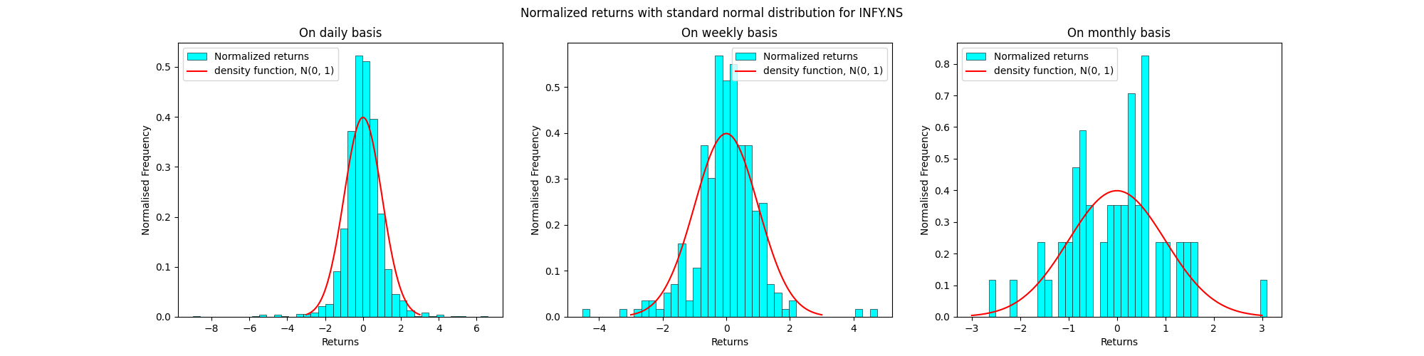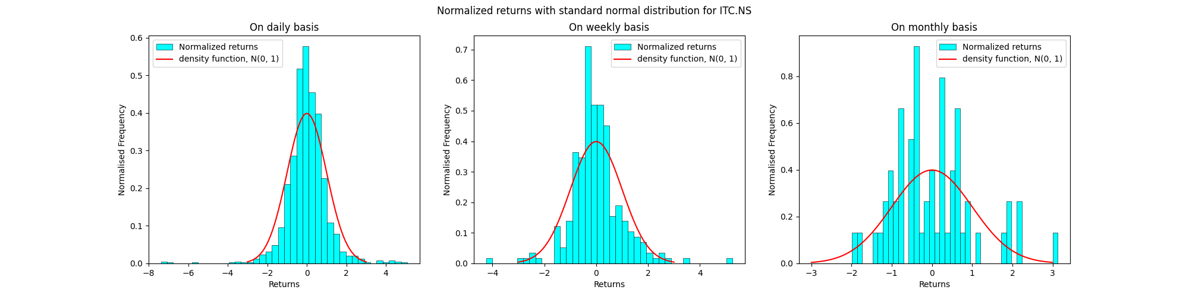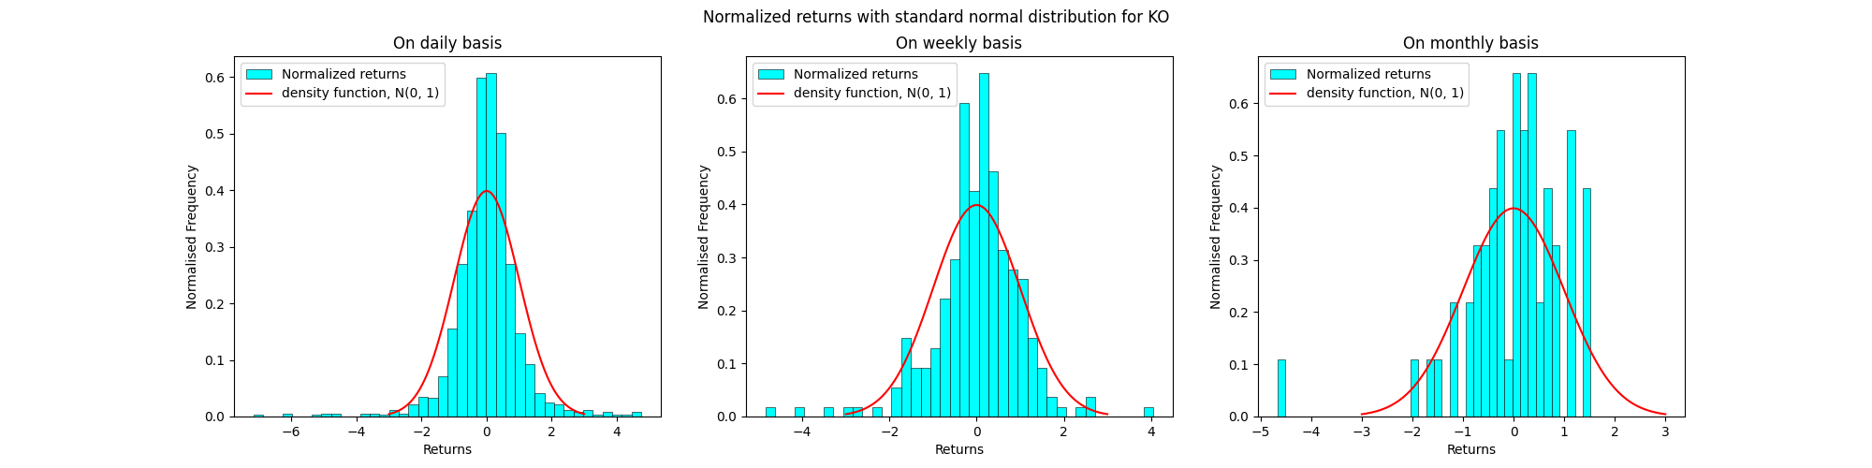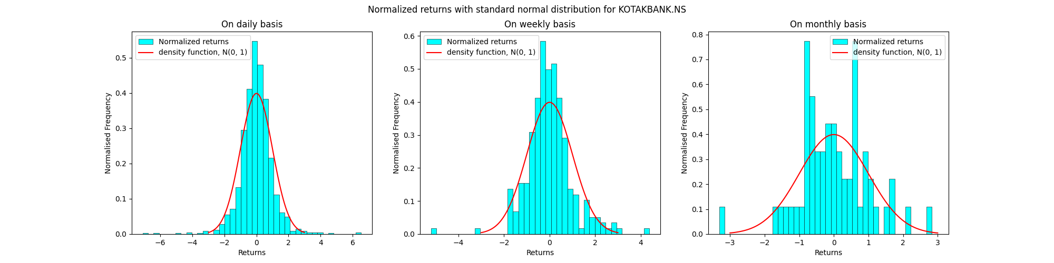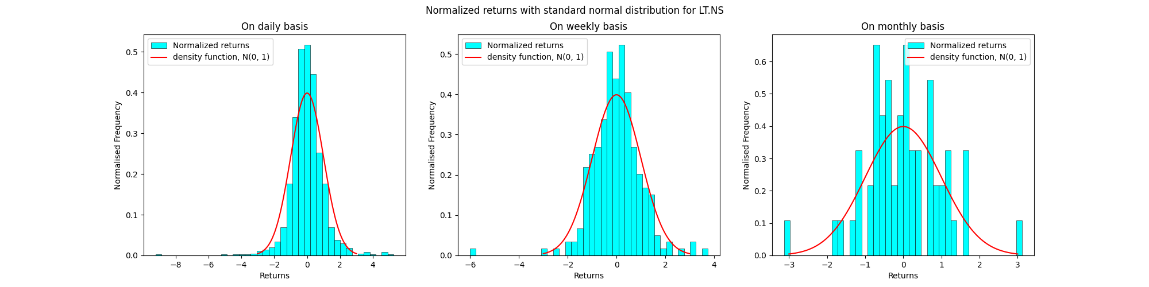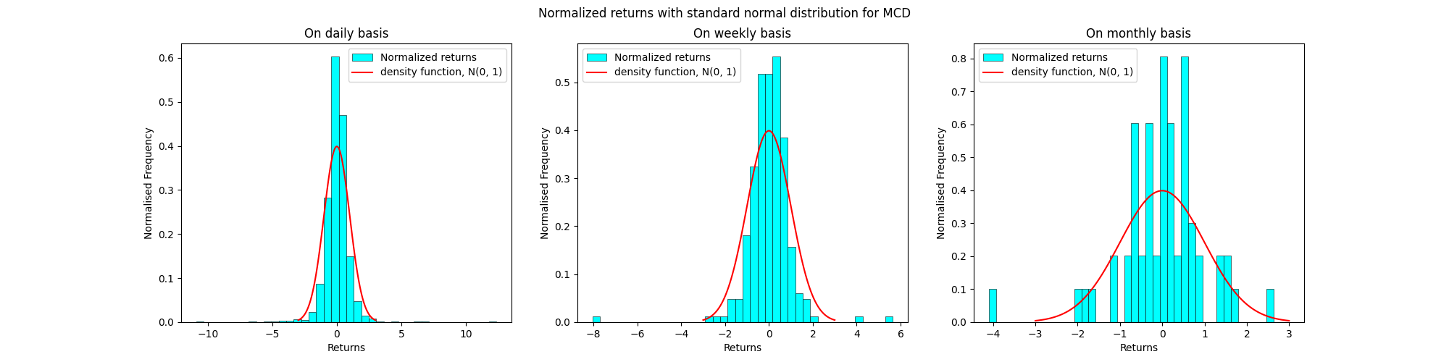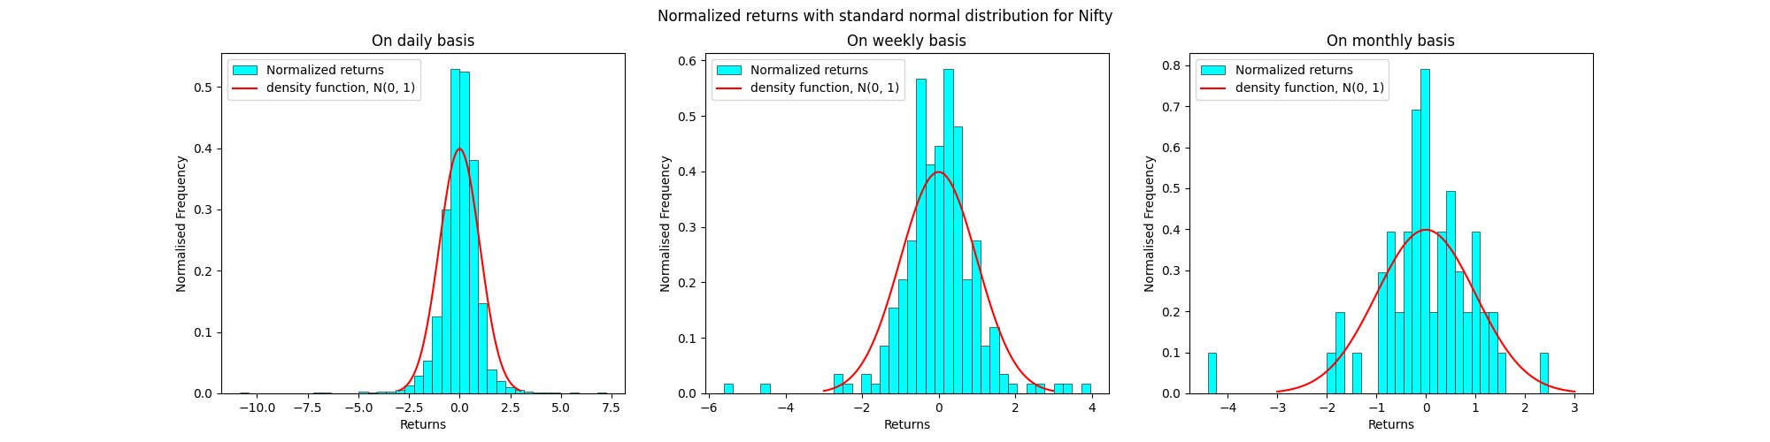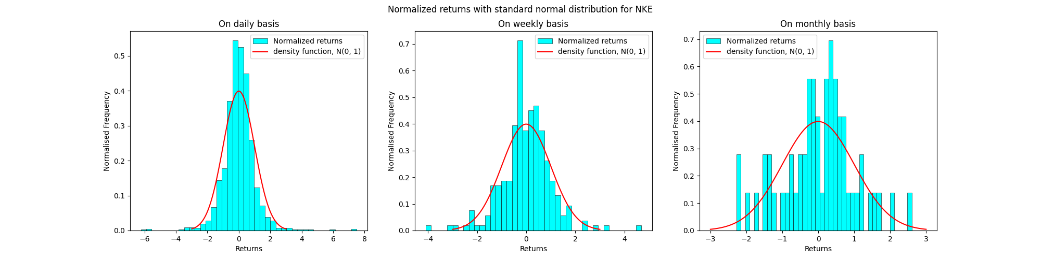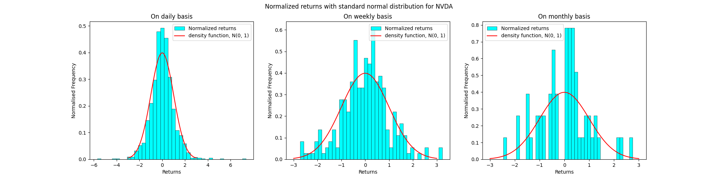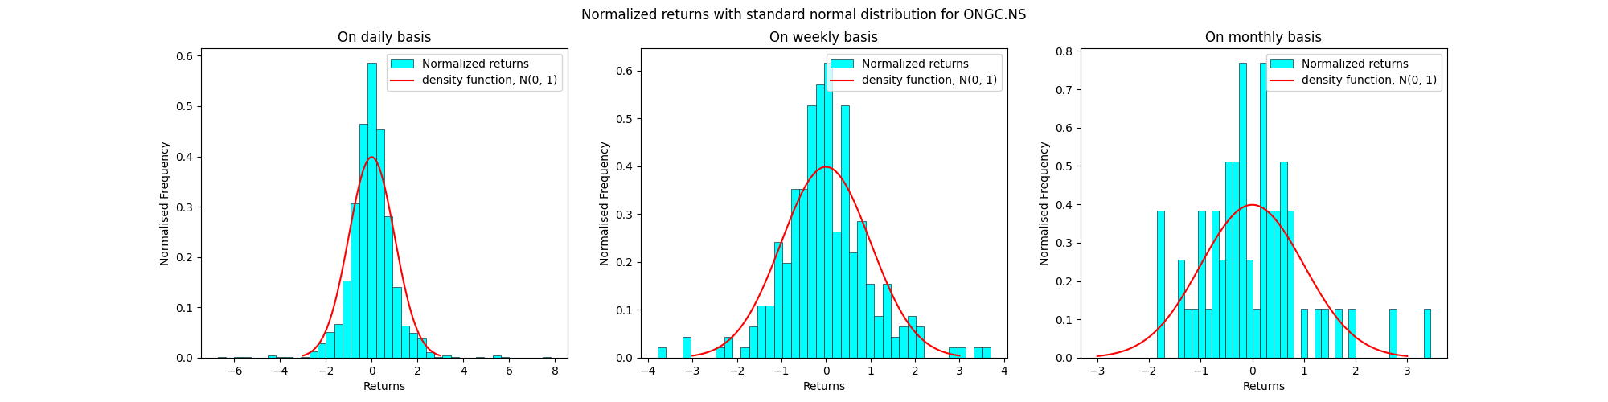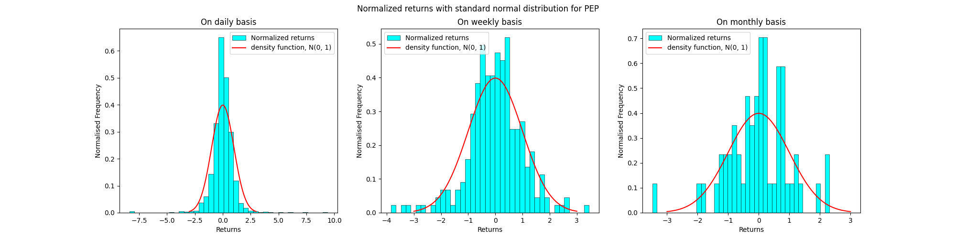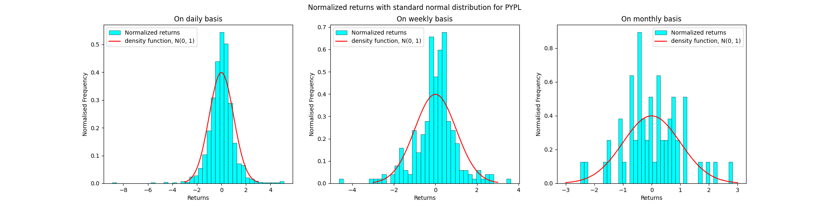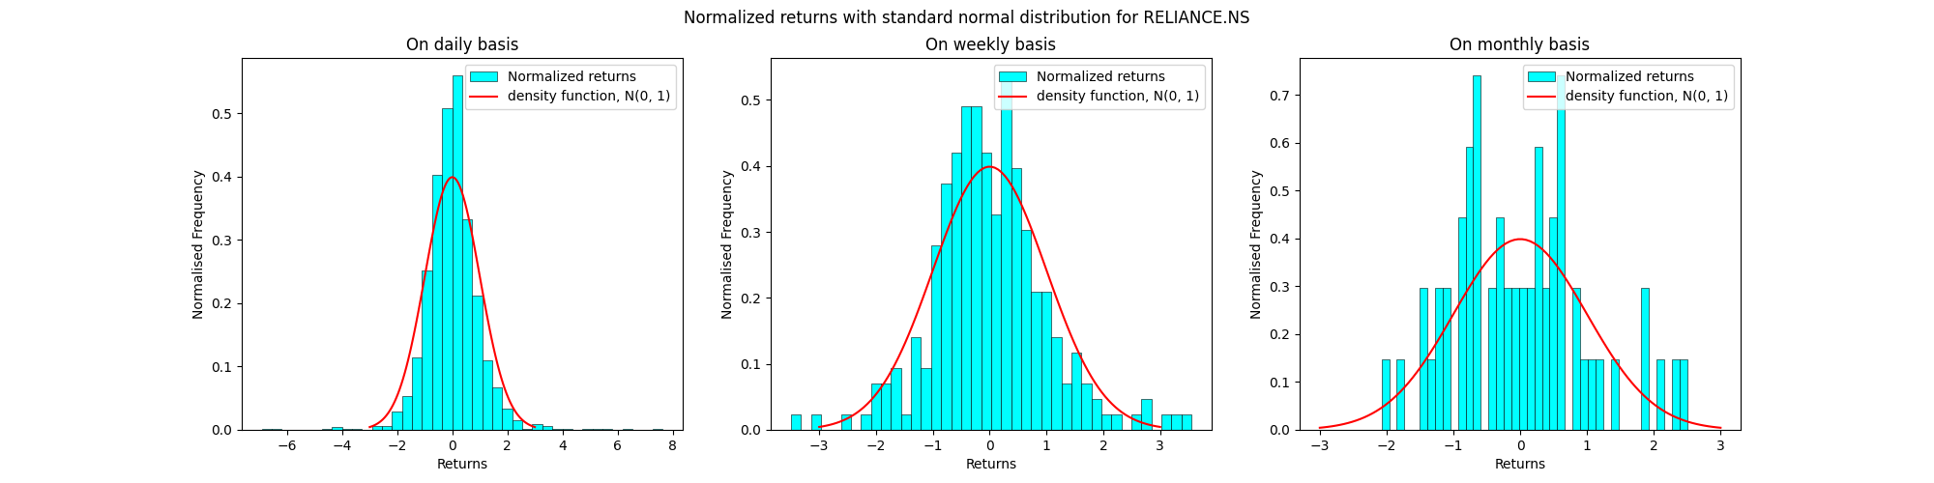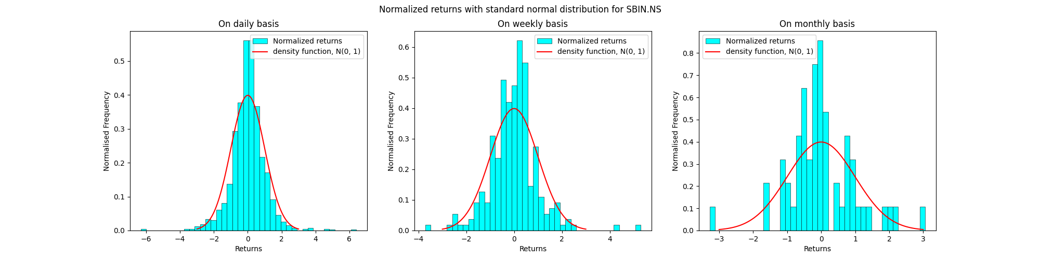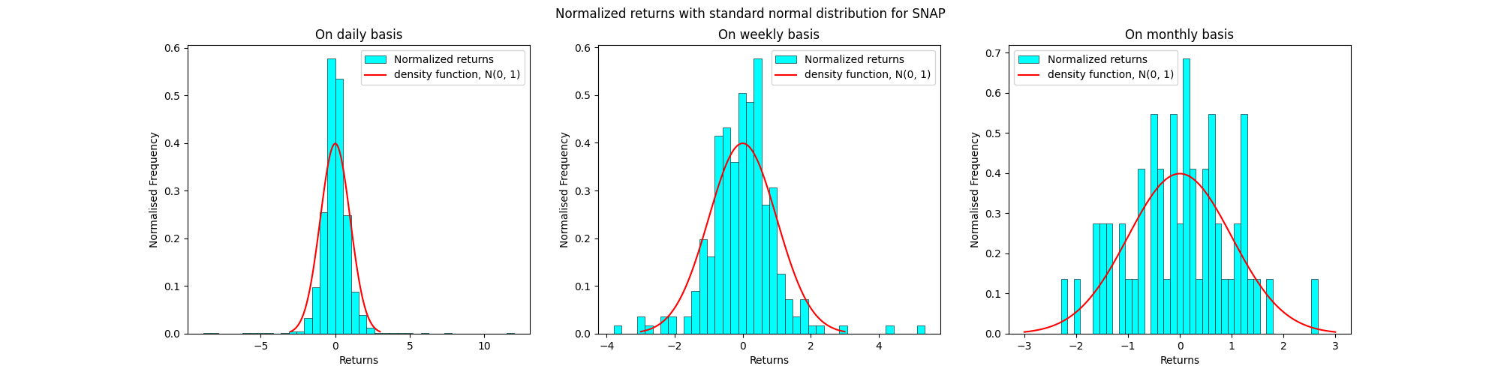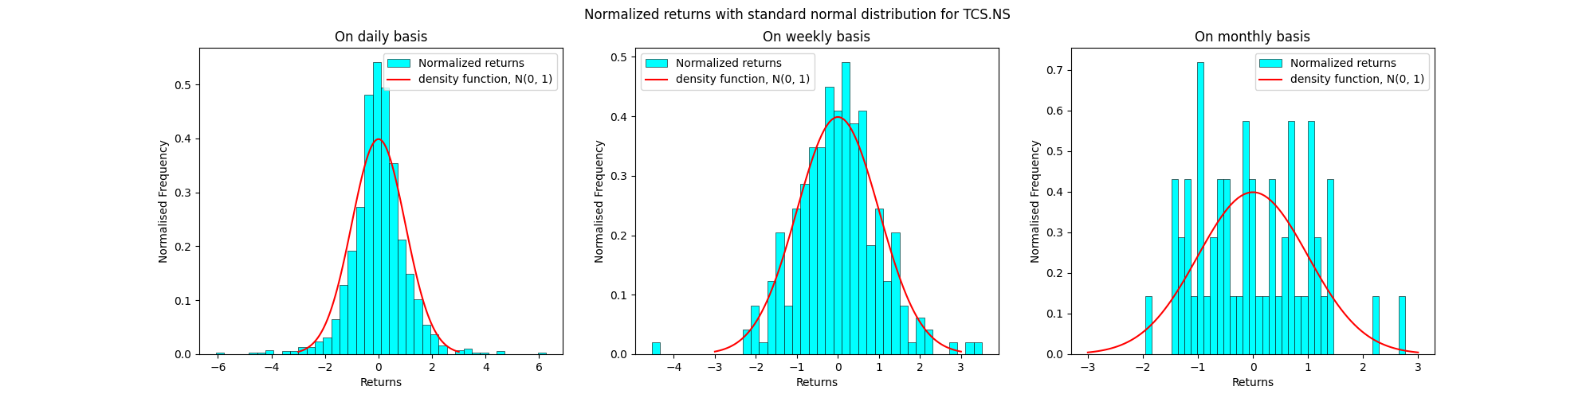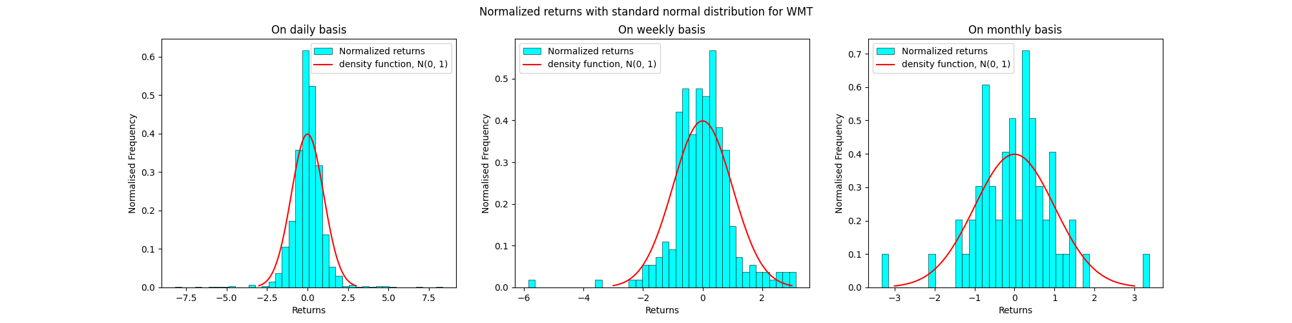

**Observations:**

* The accuracy of the N(0, 1) in estimating normalized returns is notably higher when computed on a daily basis rather than weekly or monthly intervals.
* The deviations arise from random fluctuations in real-world market dynamics, rendering a simplistic Gaussian distribution inadequate for complete modeling.
* Examination of the tails of these distributions reveals notable discrepancies. While the N(0, 1) curve sharply declines to zero, actual returns exhibit persistence. We can observe more deviations at the tails. This suggests a need for a more sophisticated model incorporating a blend of distributions to account for these variations.
* This phenomenon, known as leptokurtic behavior, entails elevated peaks and heavier tails.

Question 3:



The histograms of the normalized log returns superimposed by a graph of the density function N(0,1) for the data in bsedata1.csv are as follows:

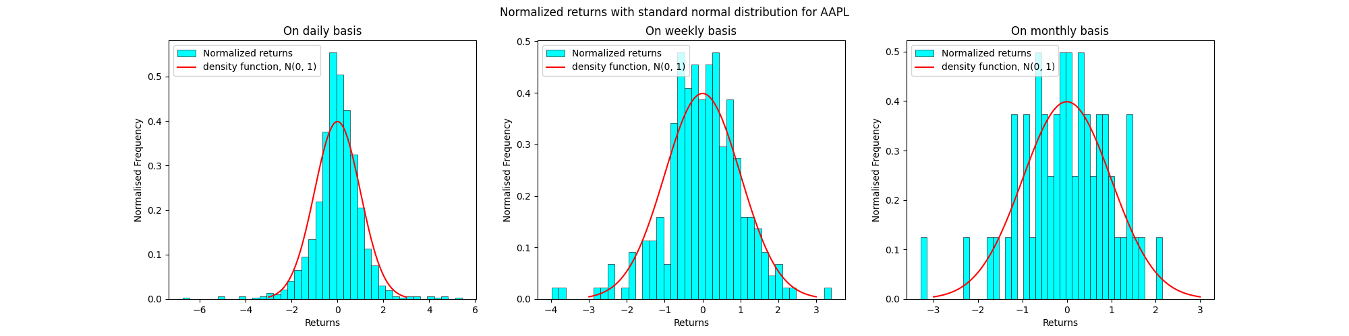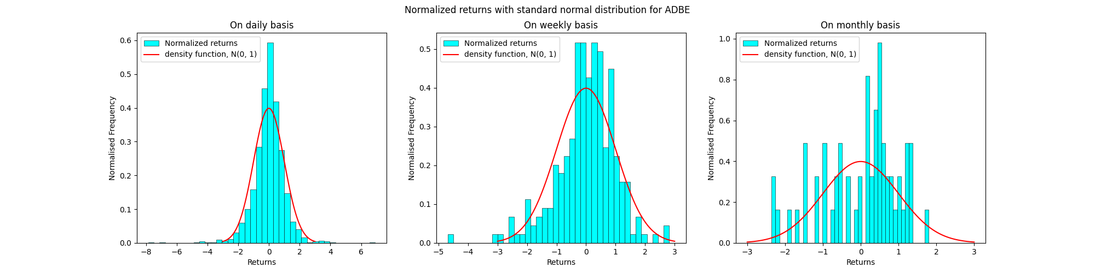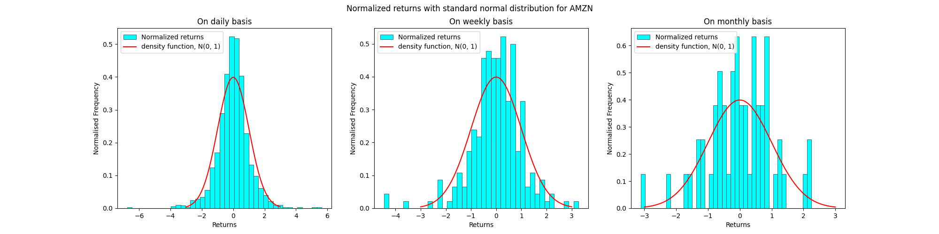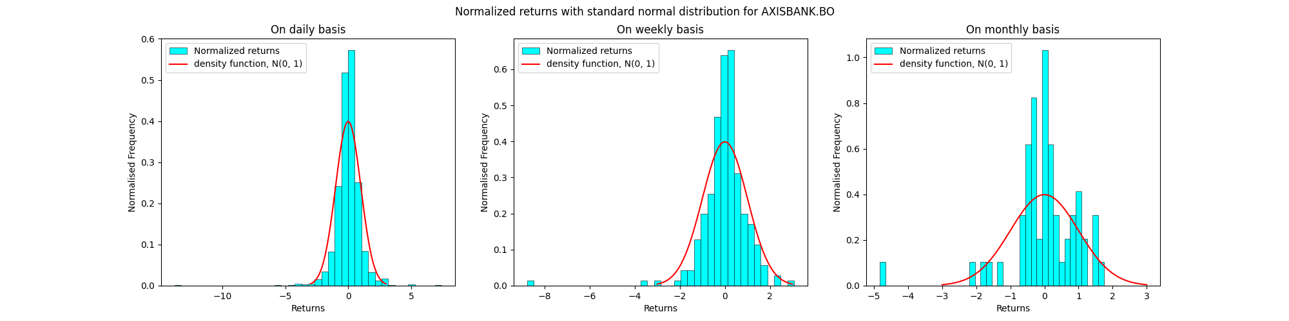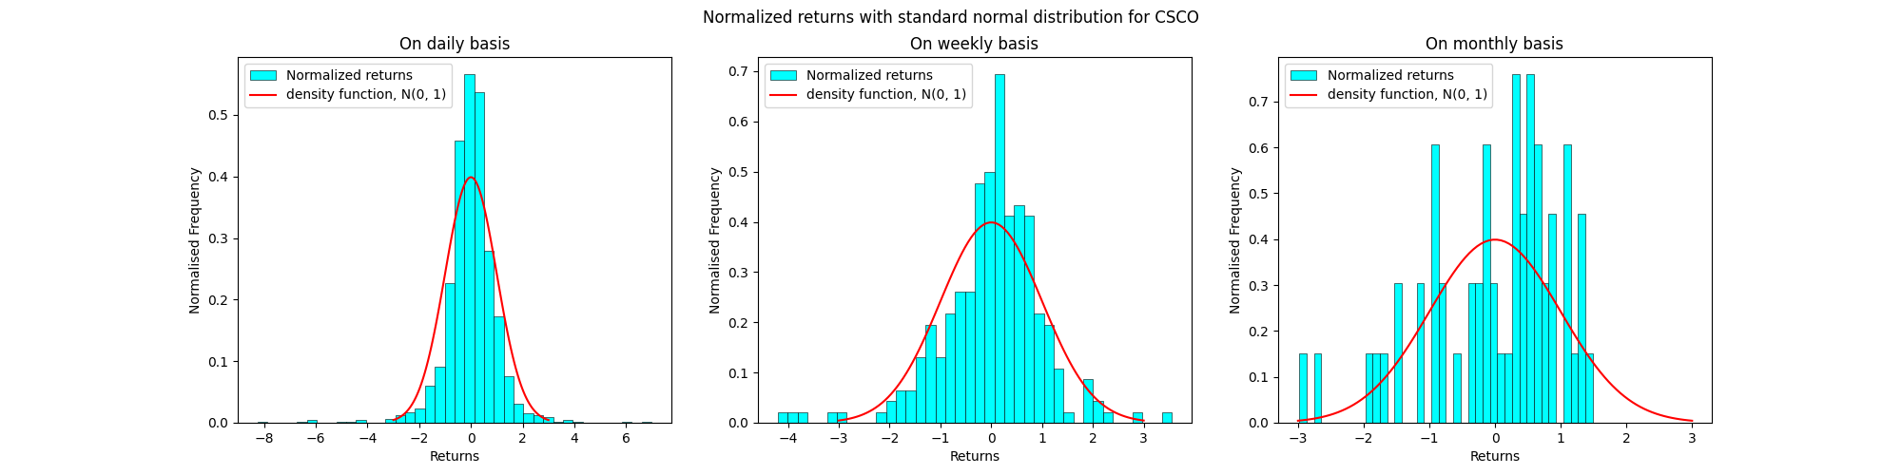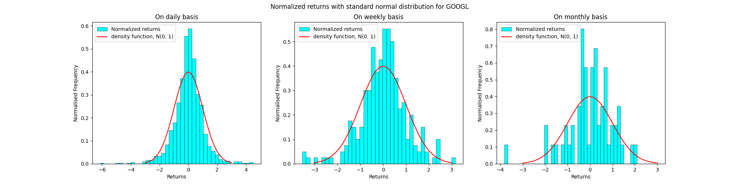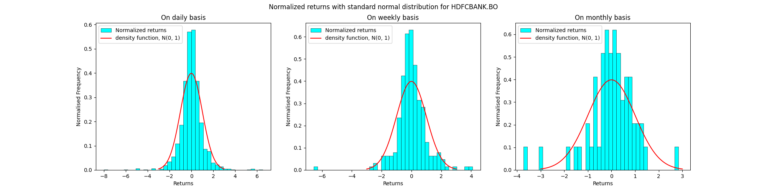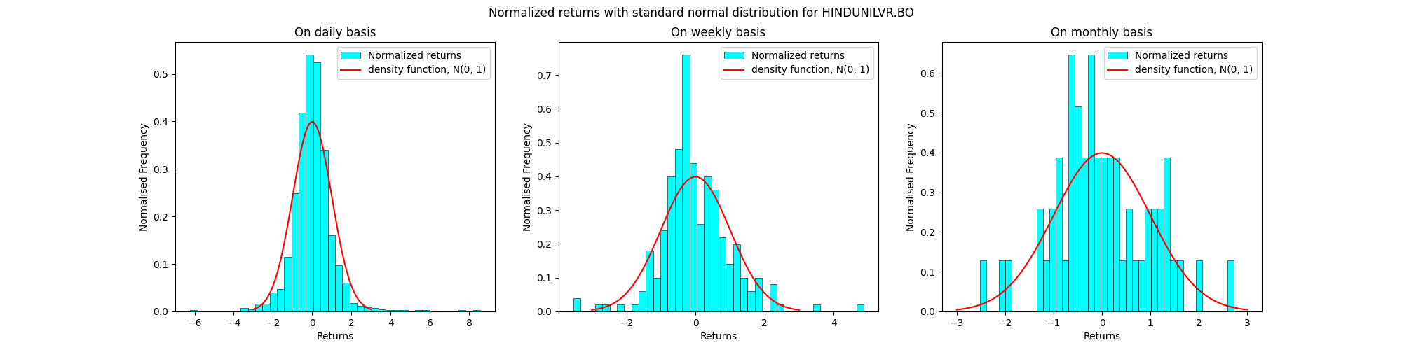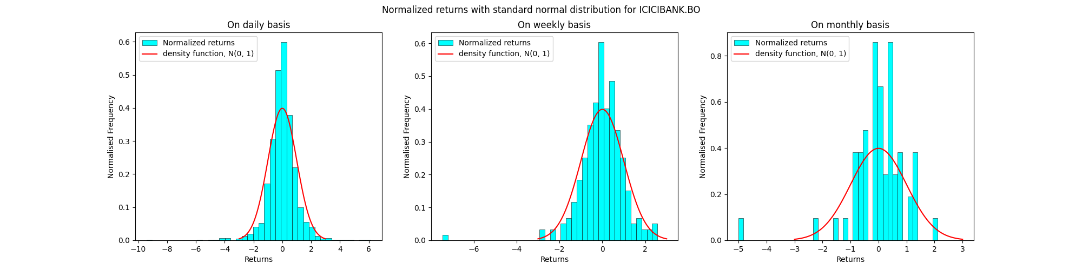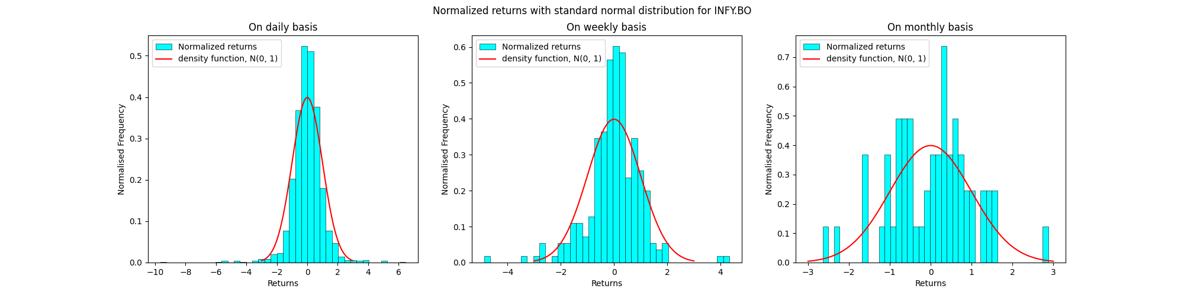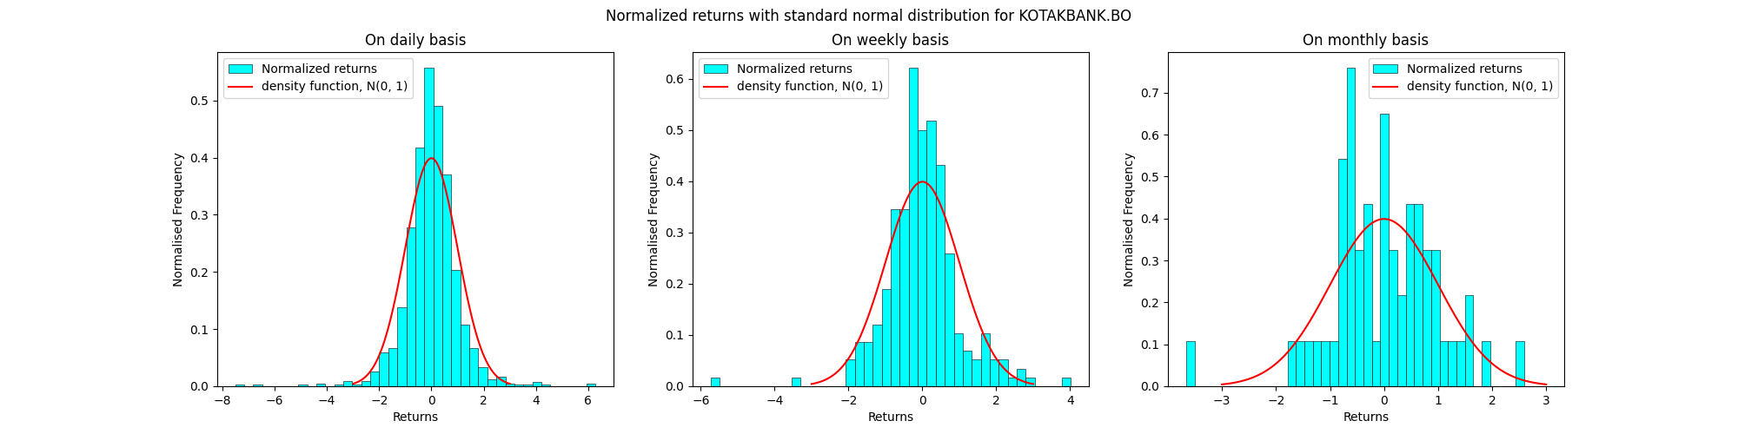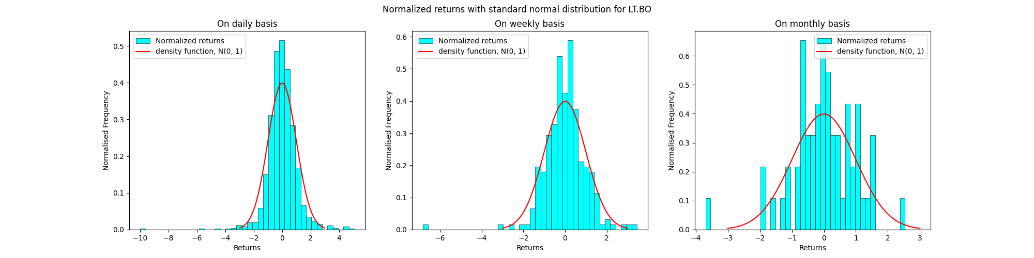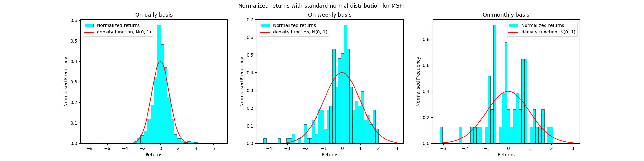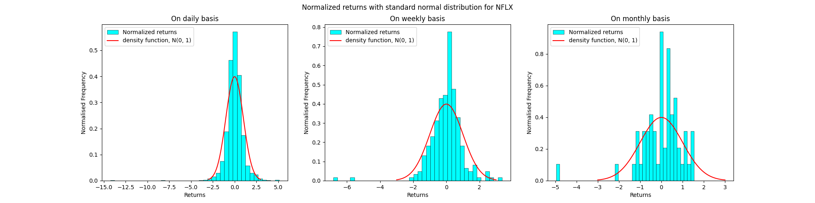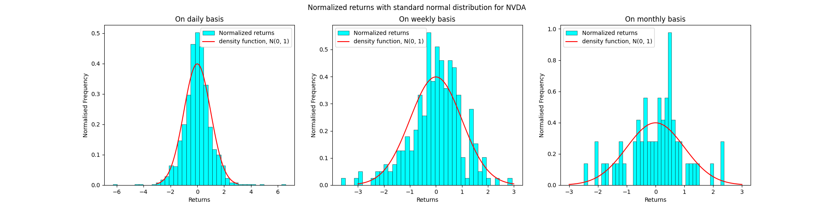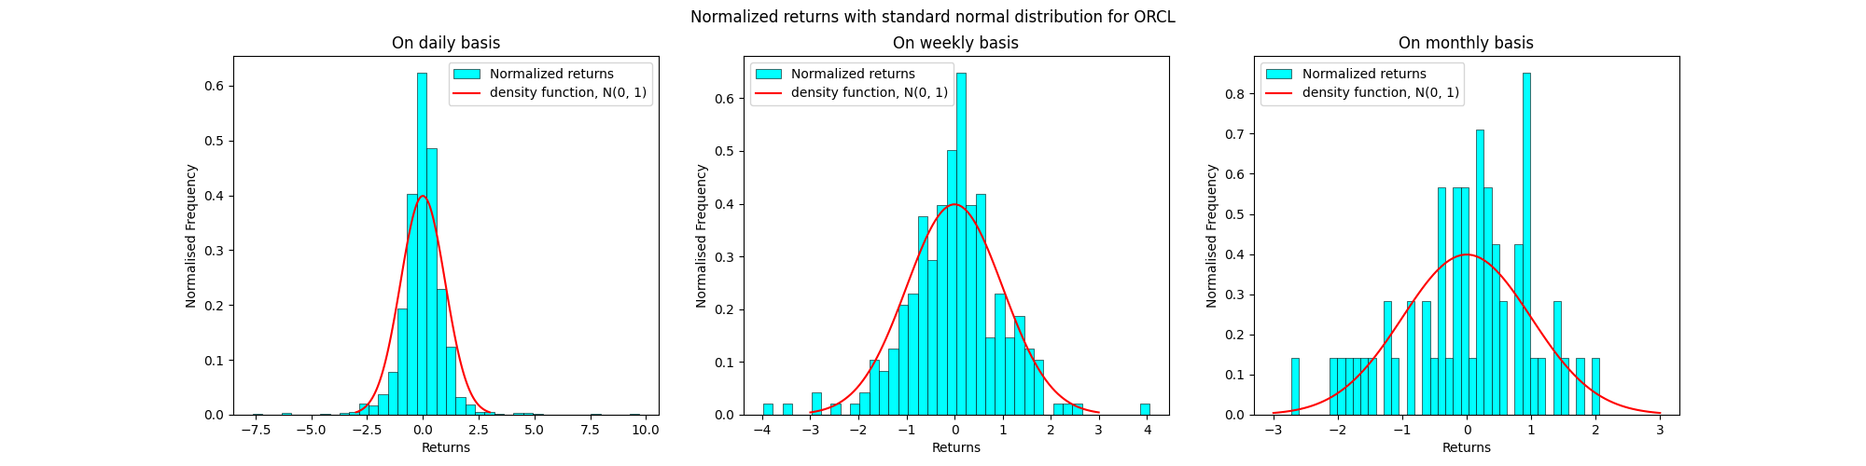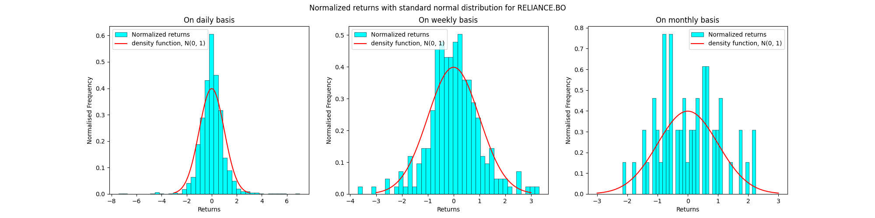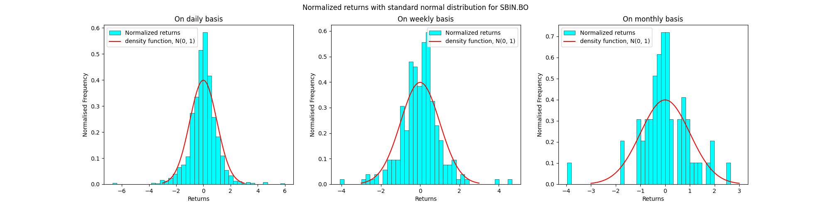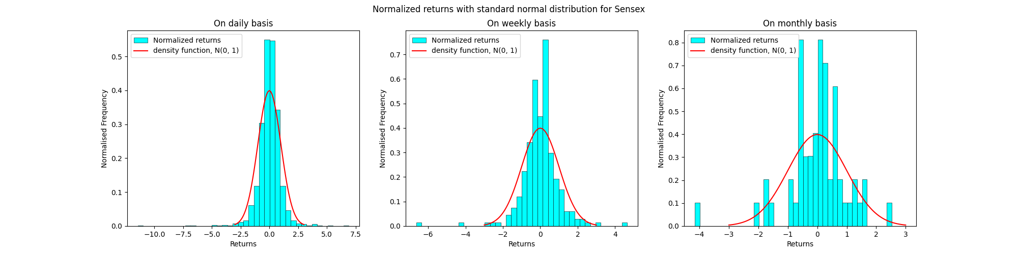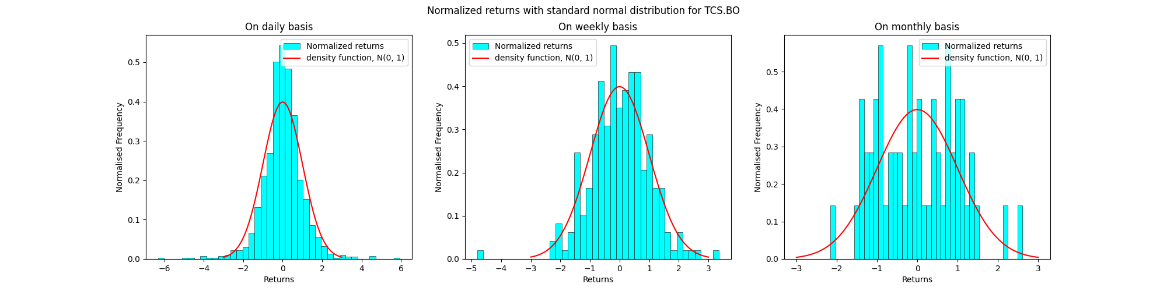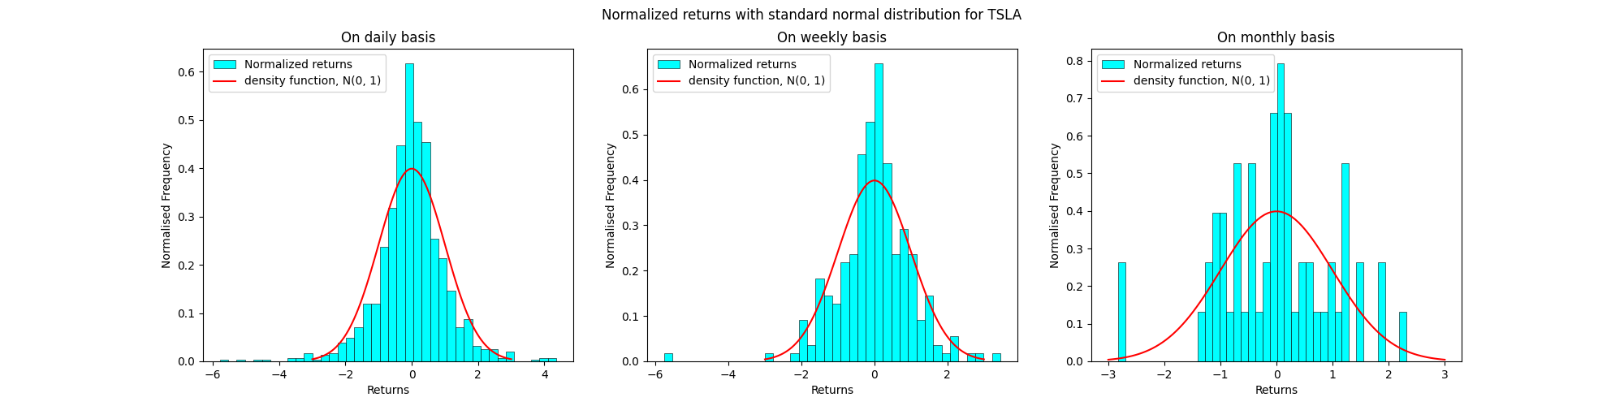

The histograms of the normalized log returns superimposed by a graph of the density function N(0,1) for the data in nsedata1.csv are as follows:

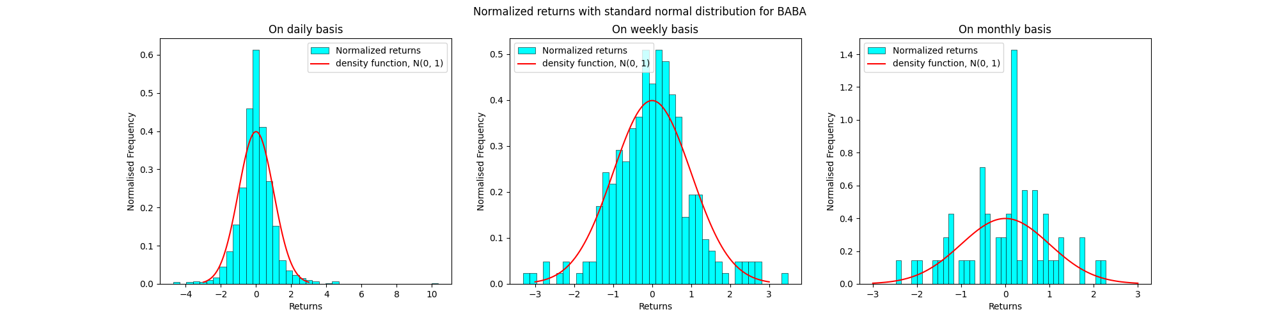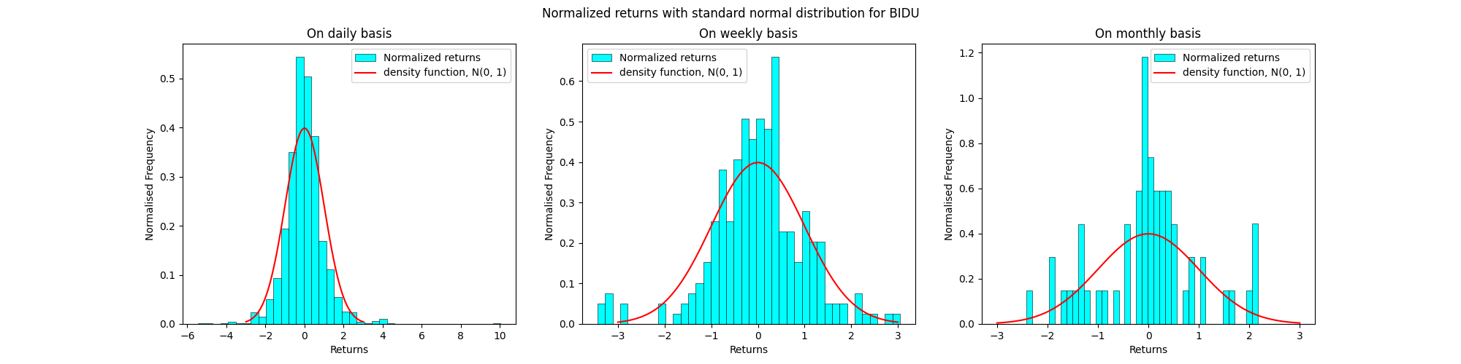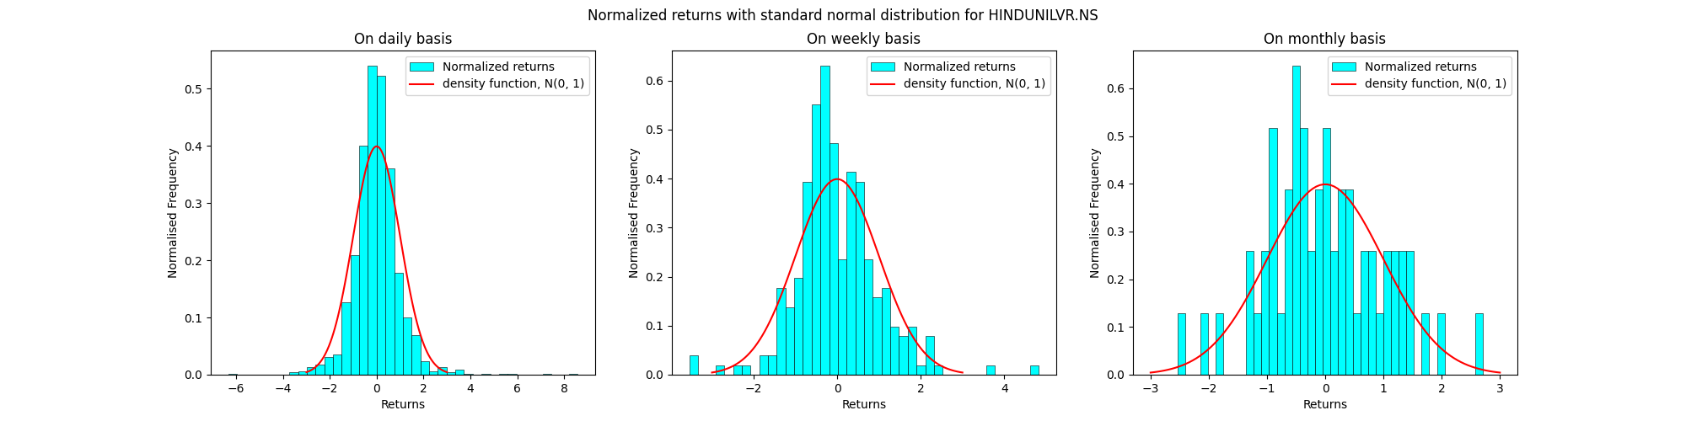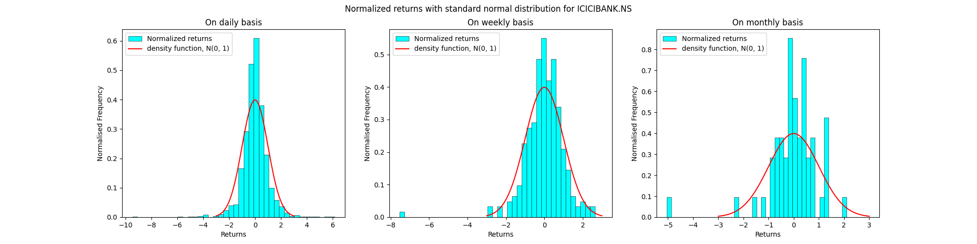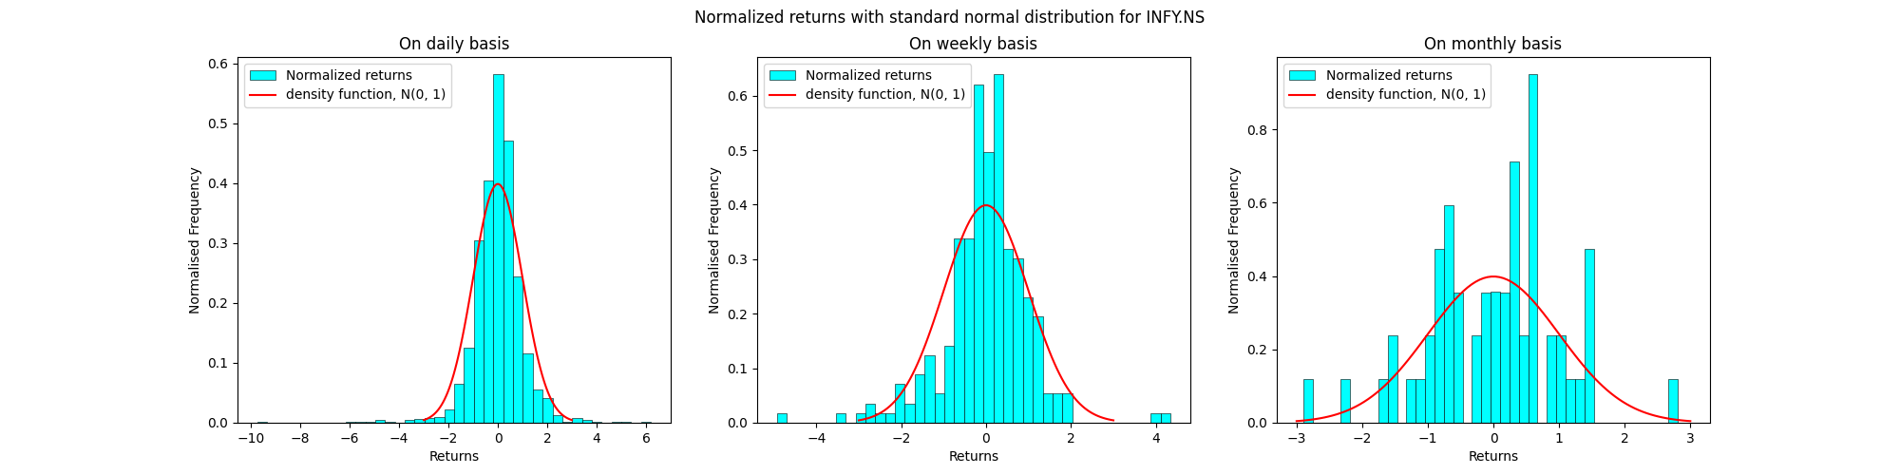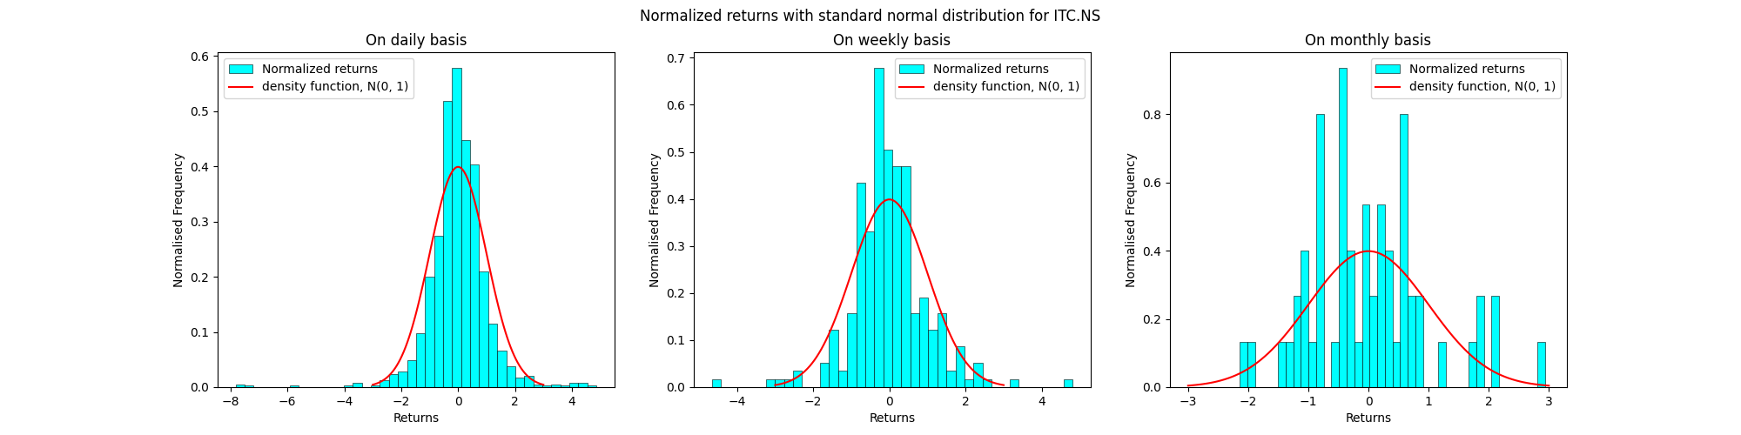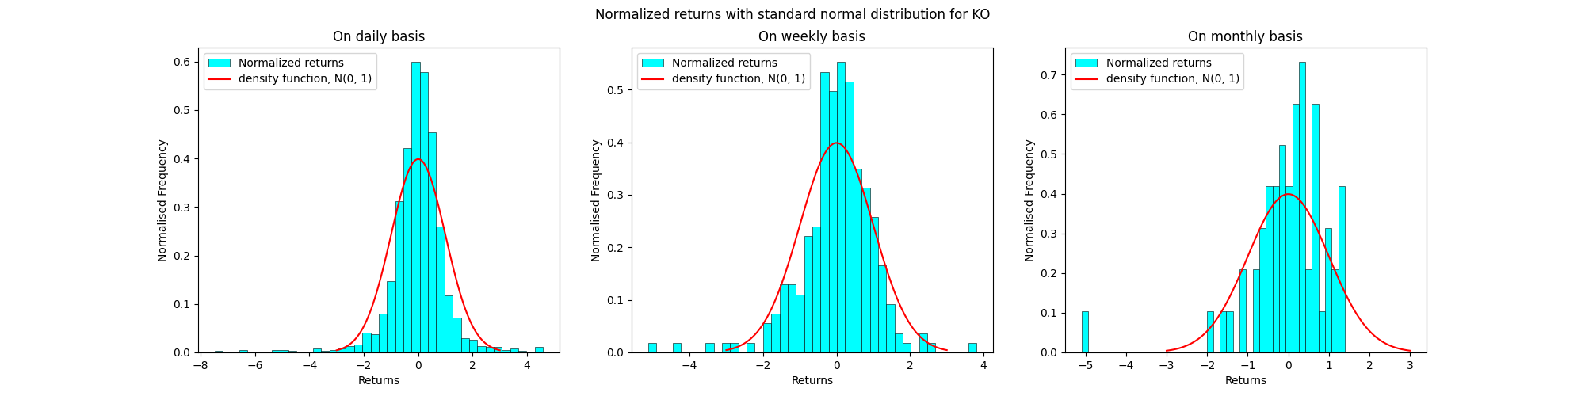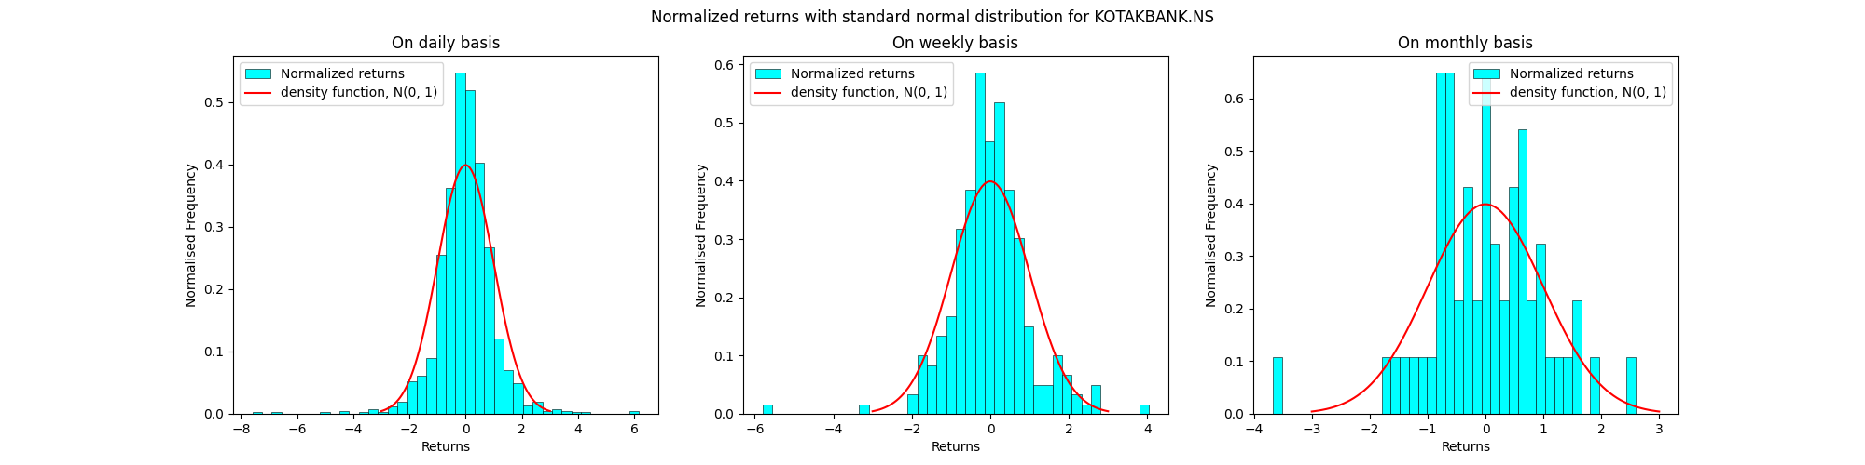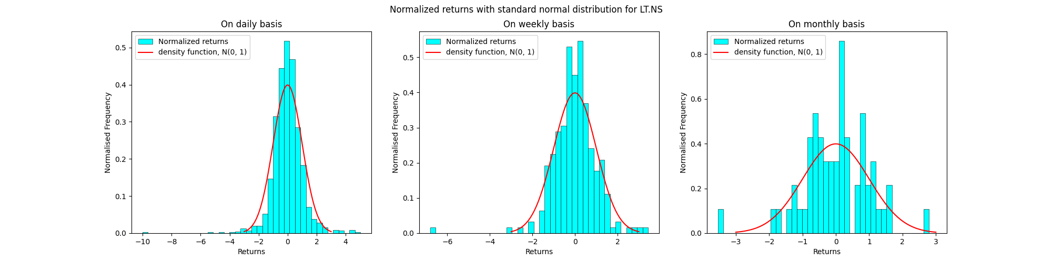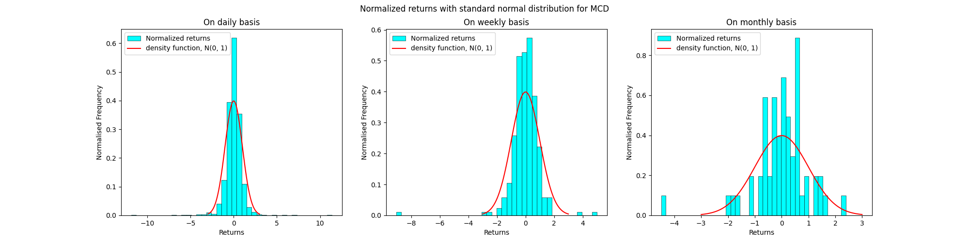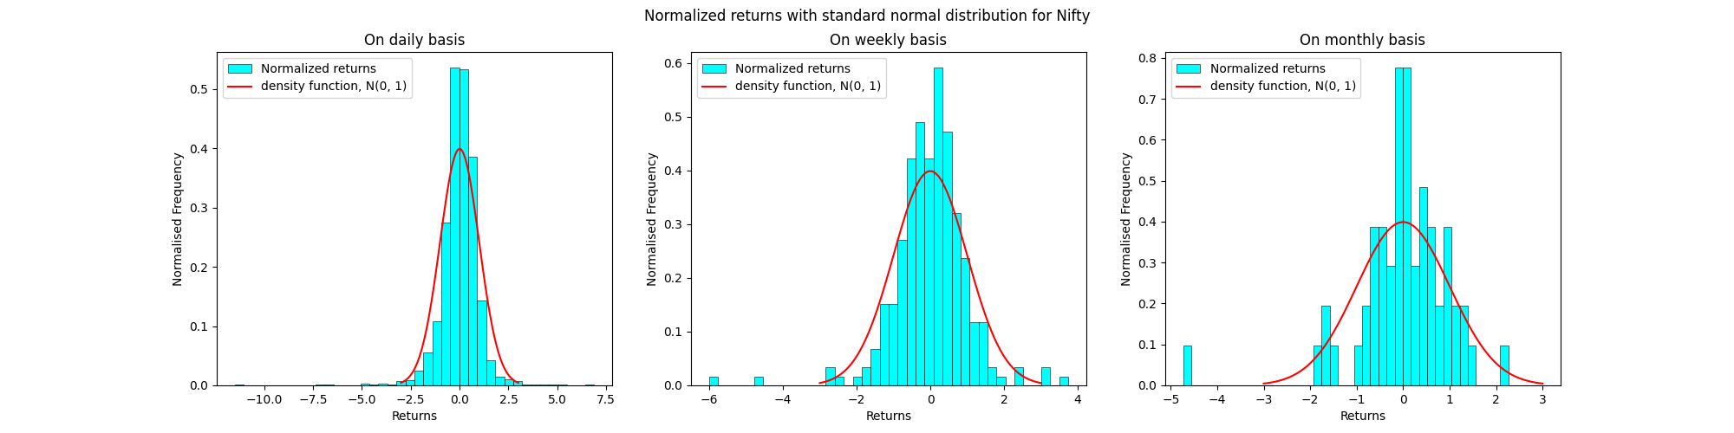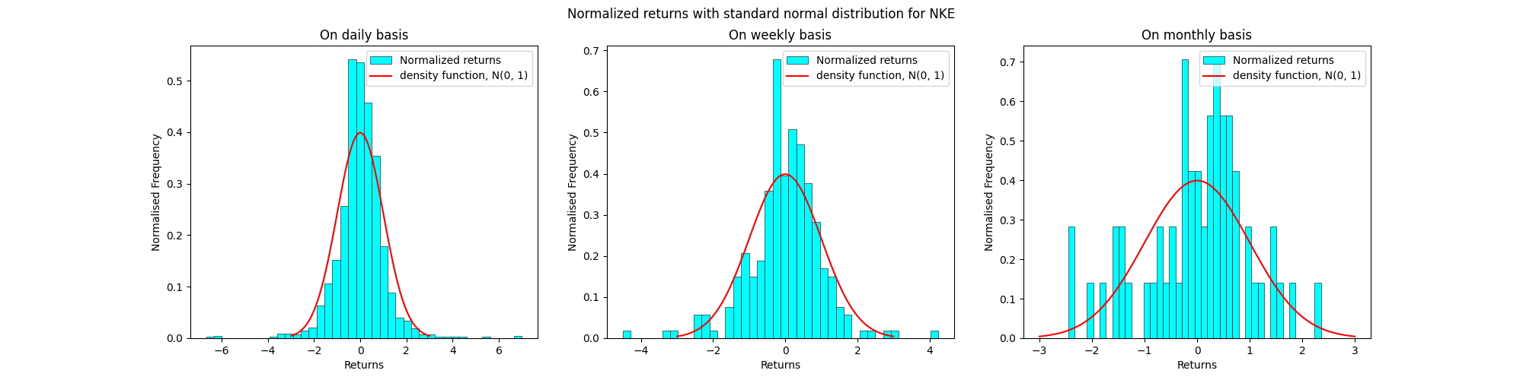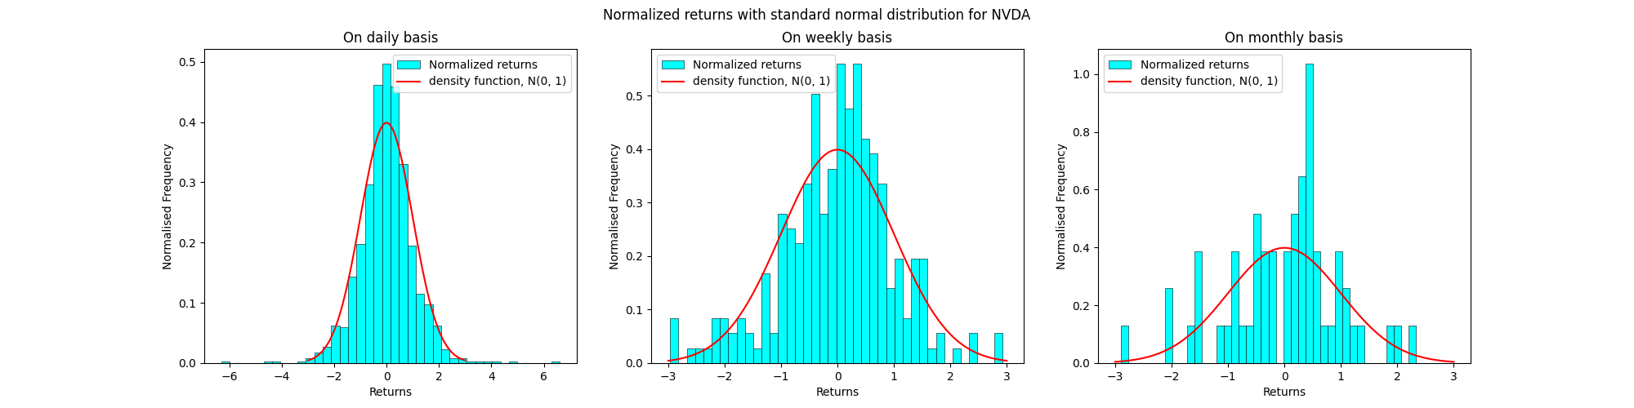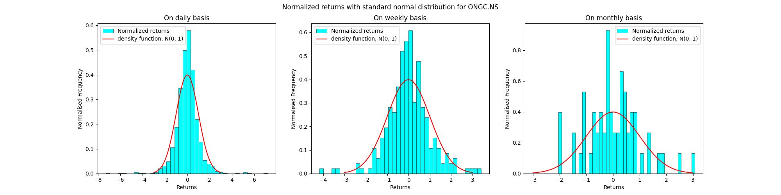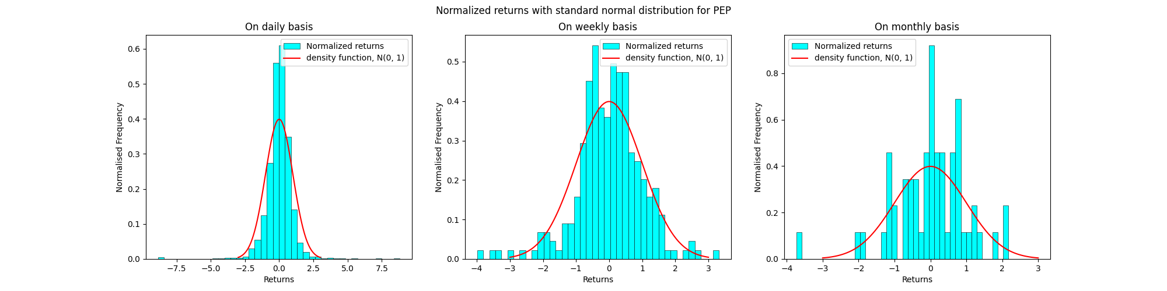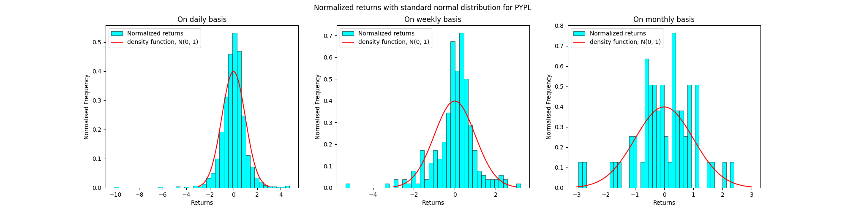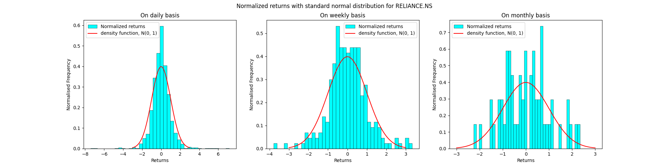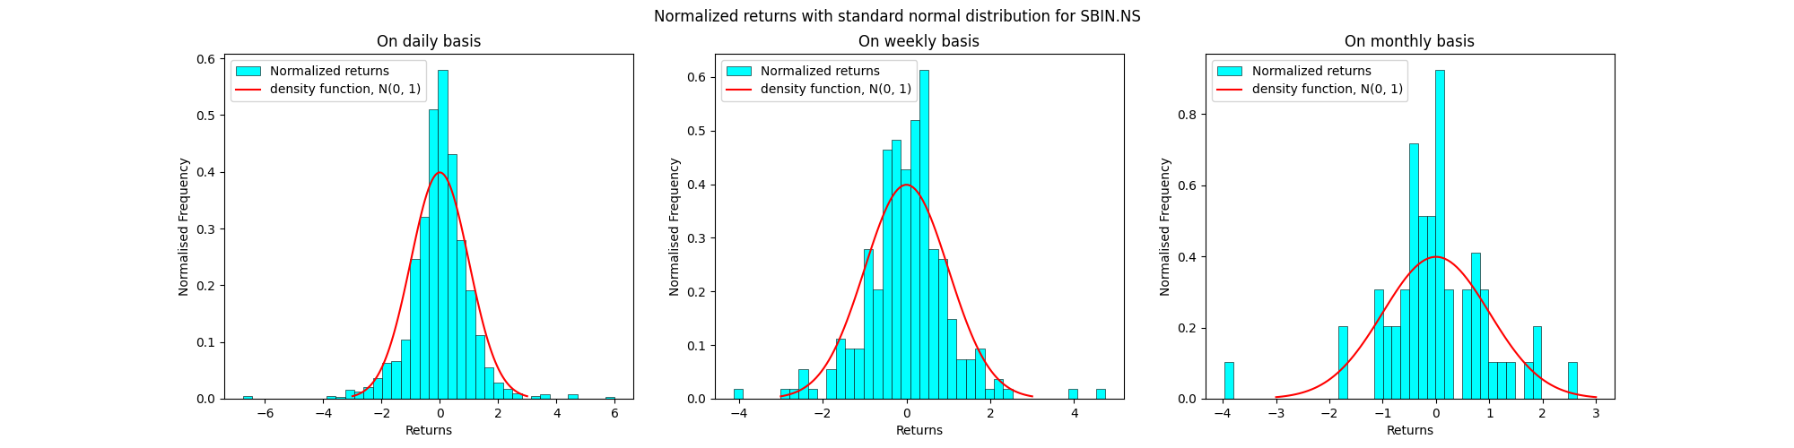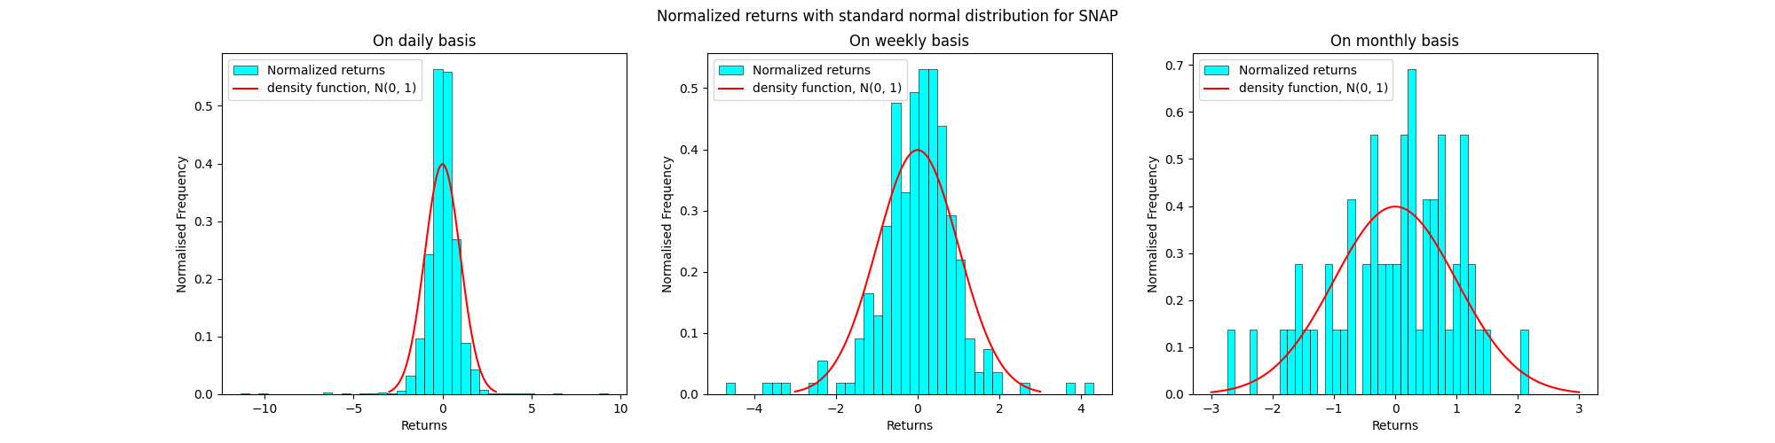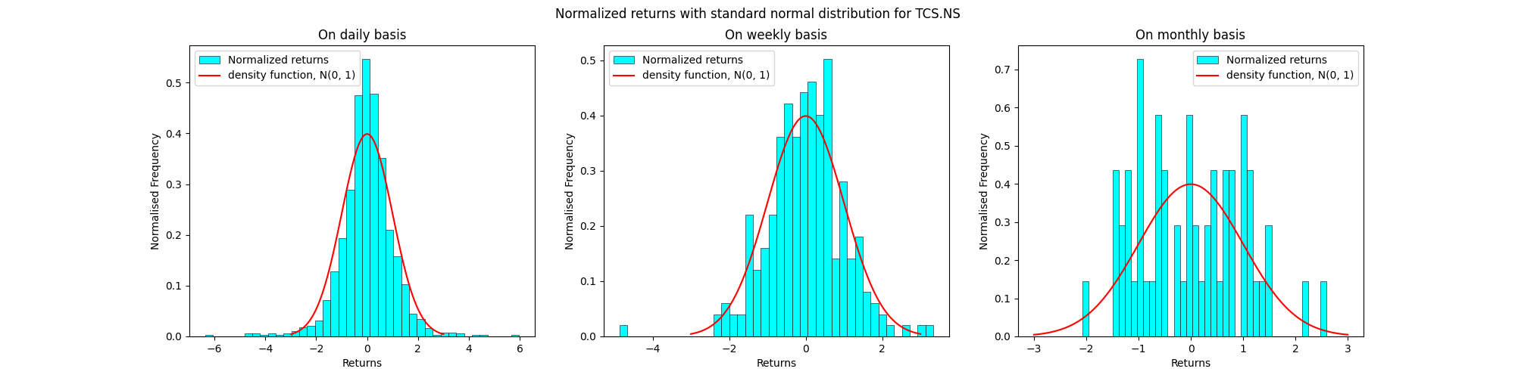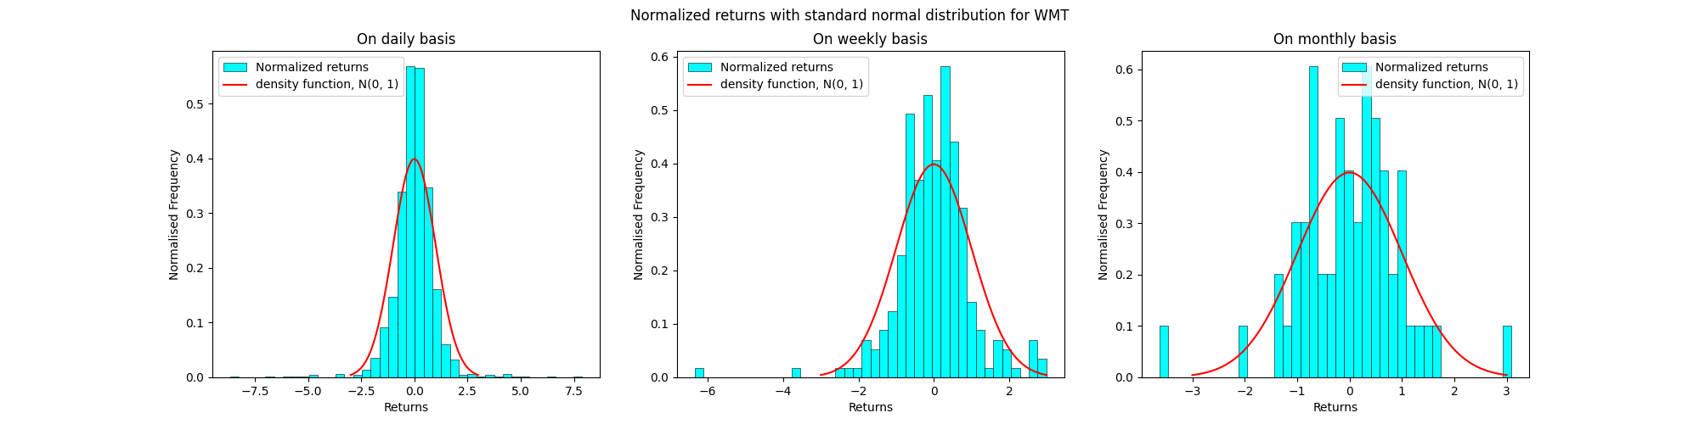

**Observations:**

The observations are not much different if we use log returns. The fundamental concept, particularly applicable to equities, revolves around the notion that the distribution of security prices follows a log-normal pattern, hence arithmetic returns mirror this trend. Nonetheless, employing a log transformation yields approximately normal returns, which facilitates analytical processes. Assuming normal distribution offers convenient outcomes for the convolution of multivariate normal series, thereby enabling smoother time-aggregation procedures.

Question 4:

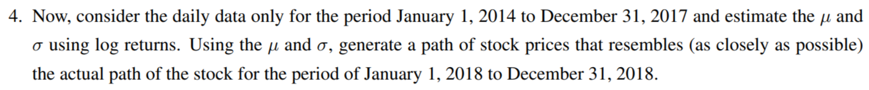

Geometric Brownian motion is used to model the scenario since stock prices behave like a stochastic process.

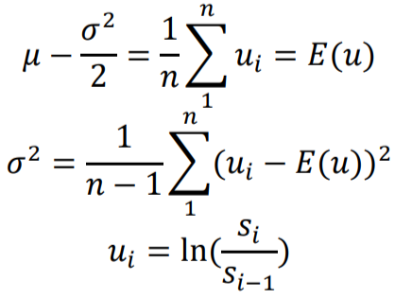

For daily data, the graphs of the generated path of stock prices along with the actual path of the stock for the stocks and Sensex in bsedata1.csv are as follows:

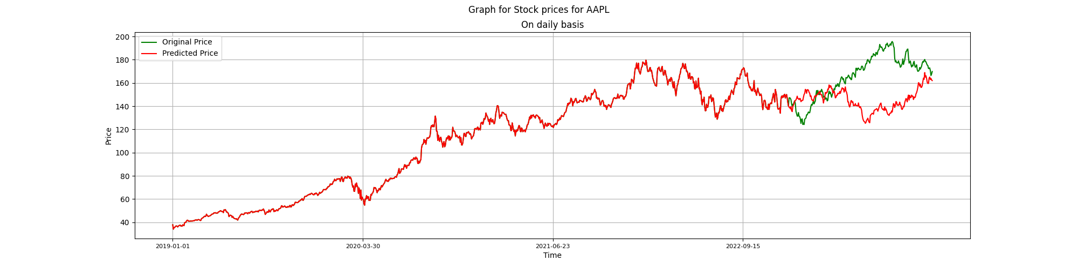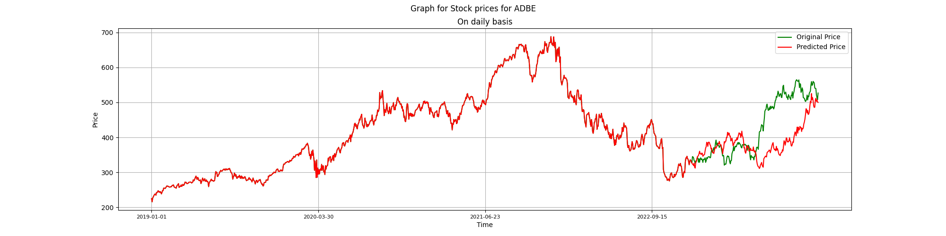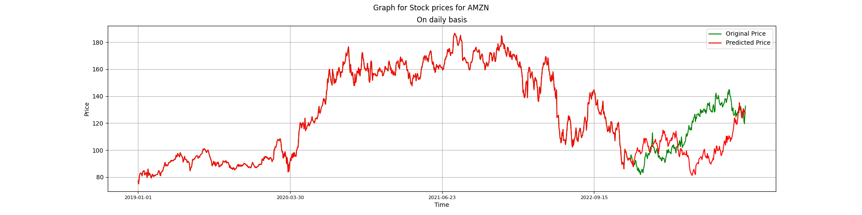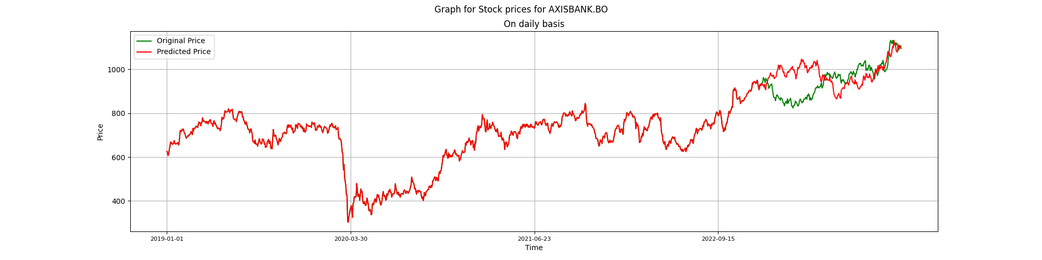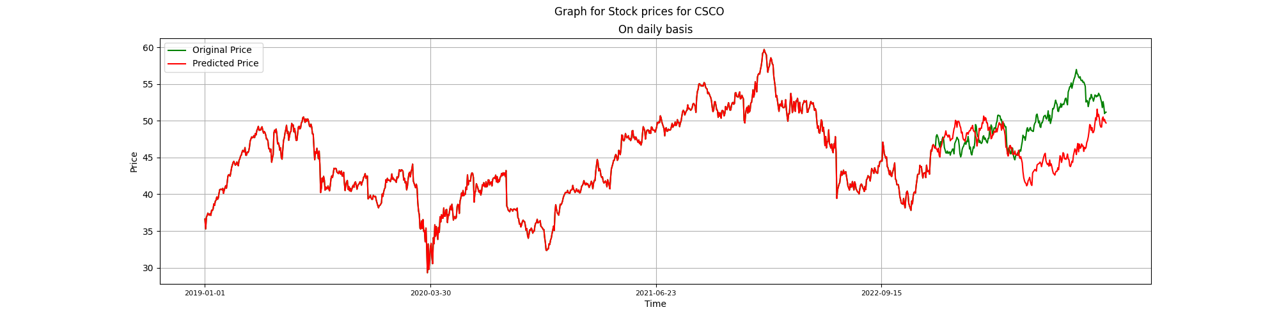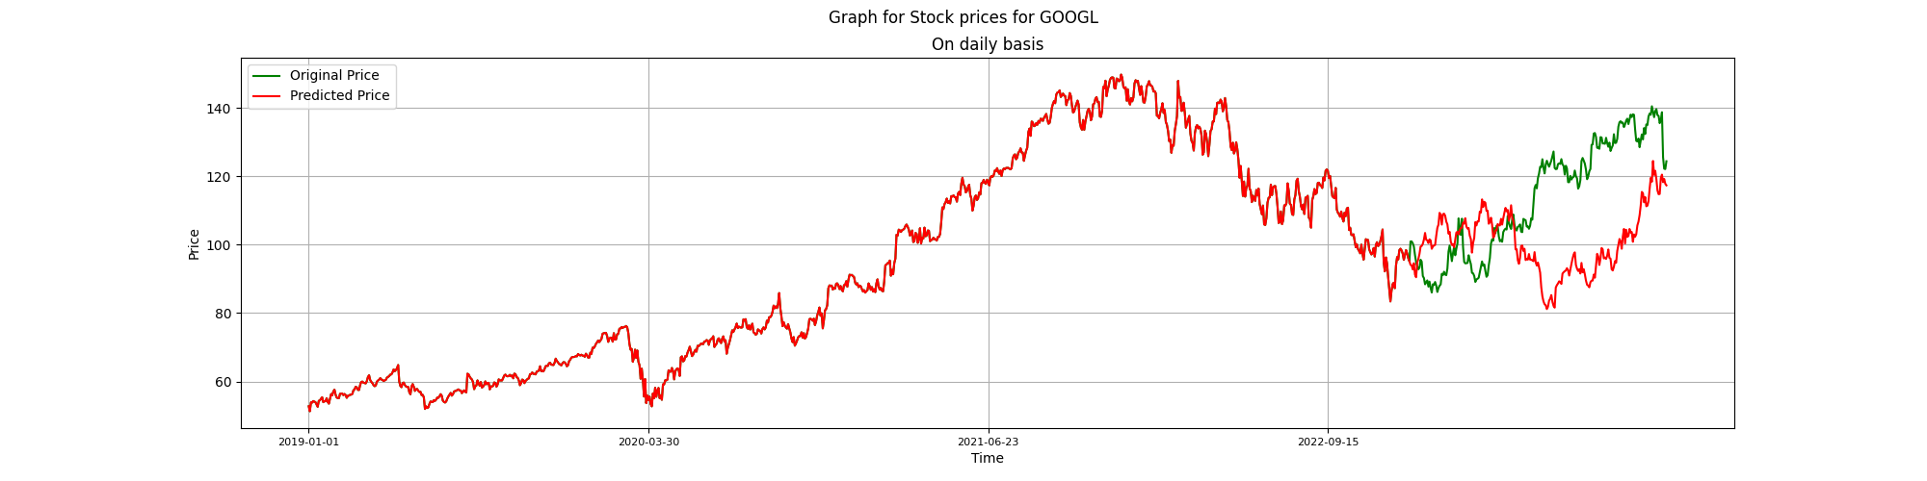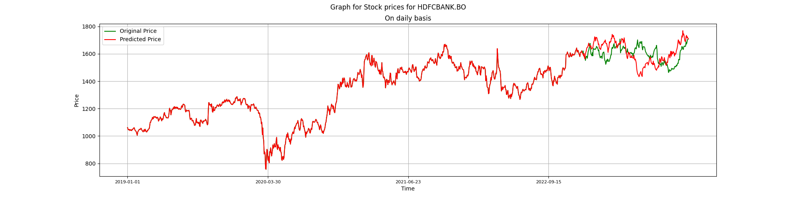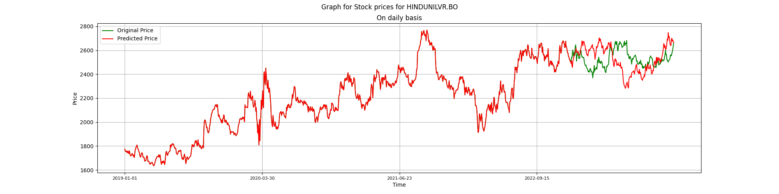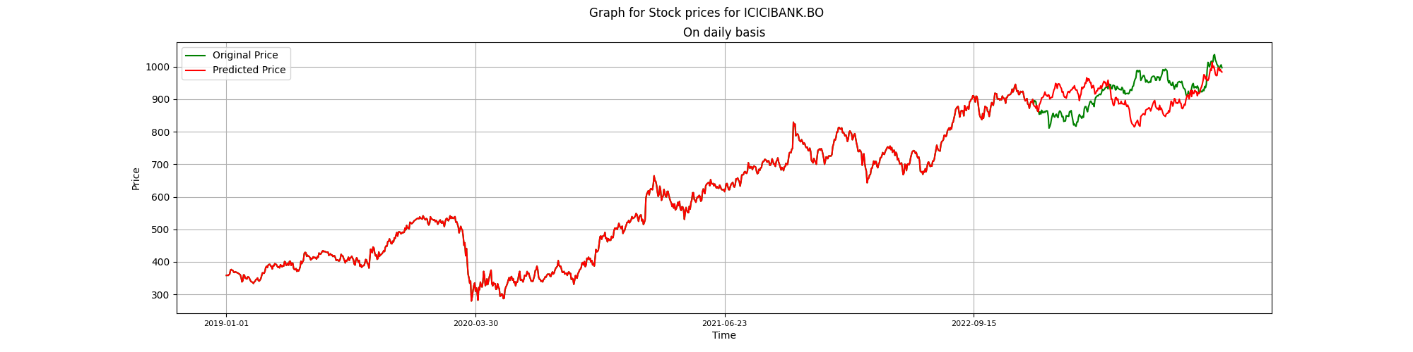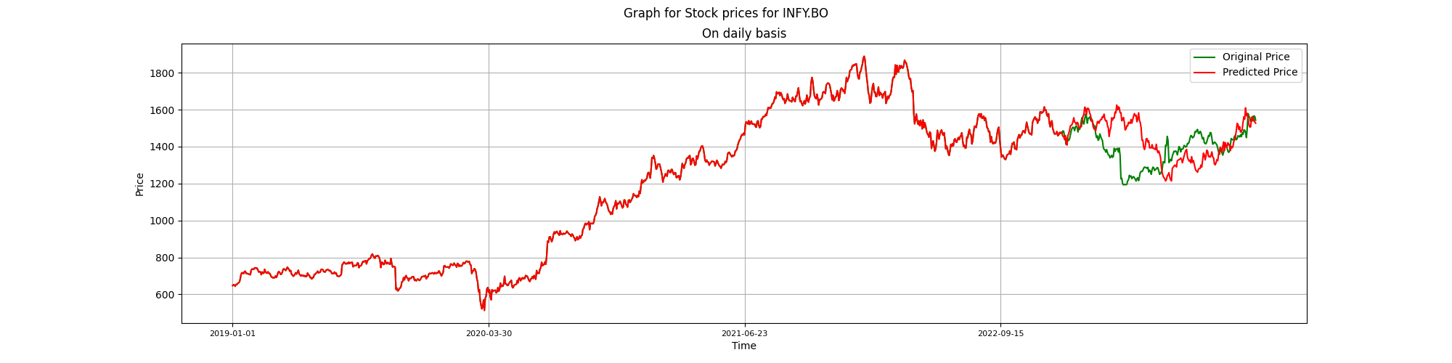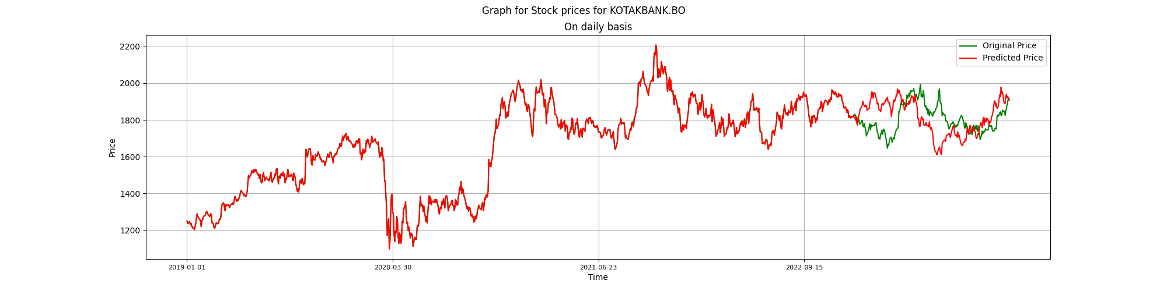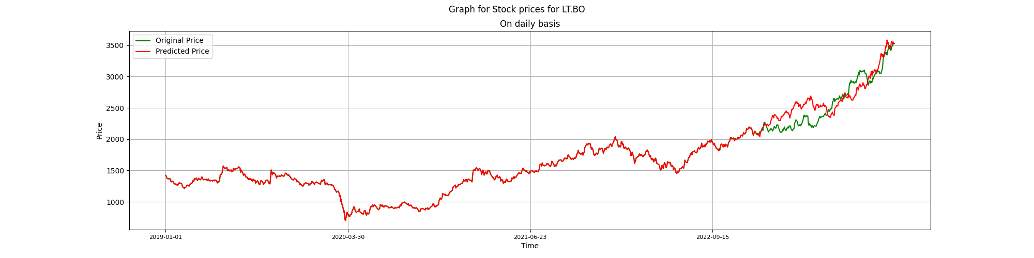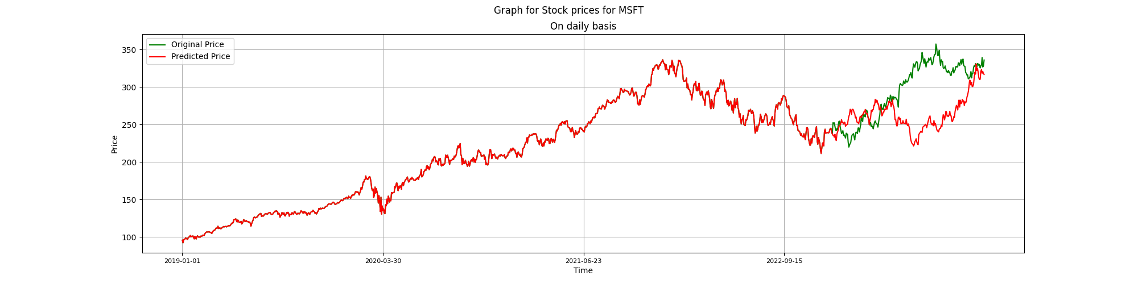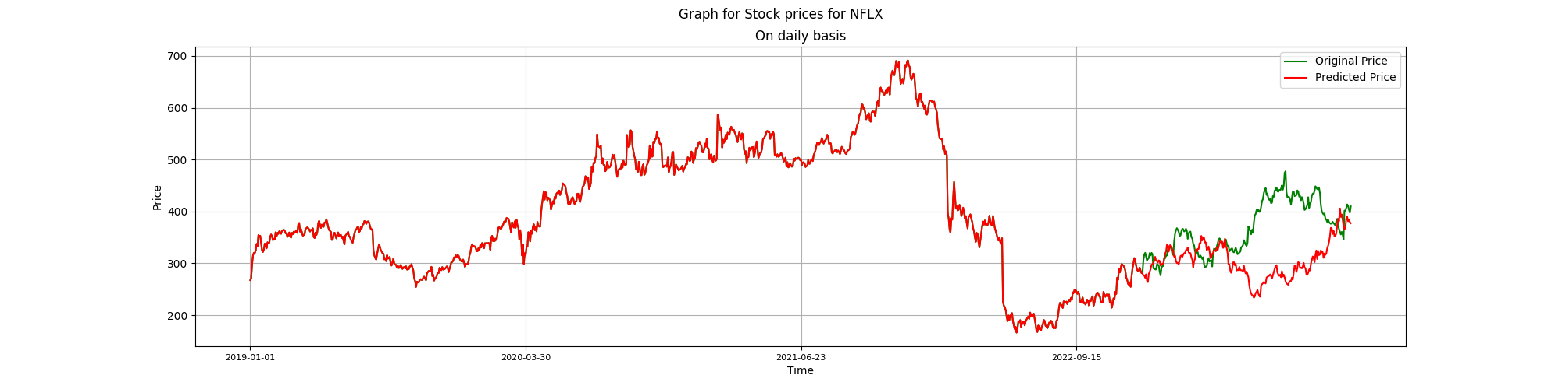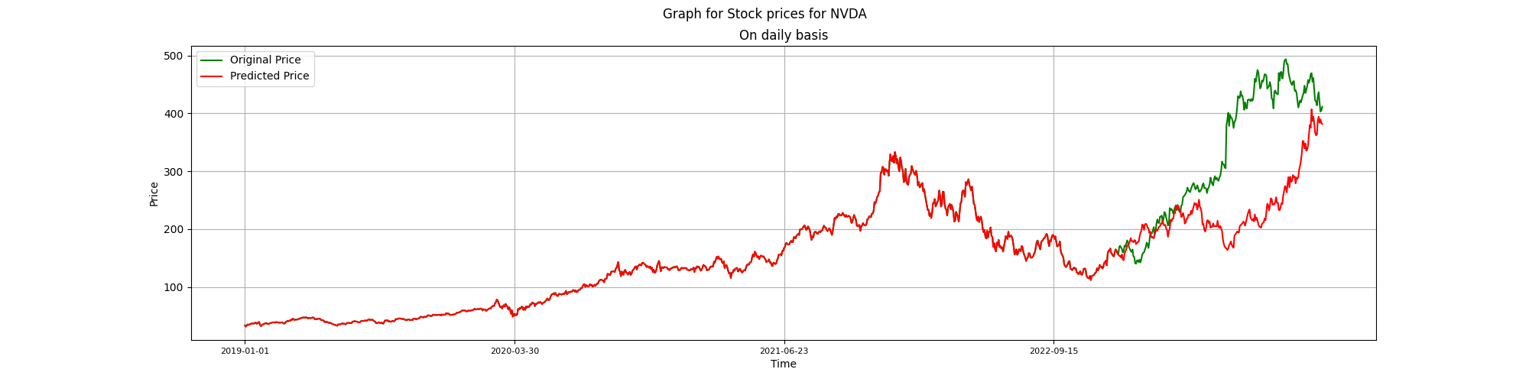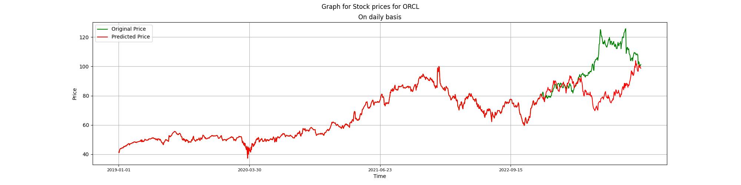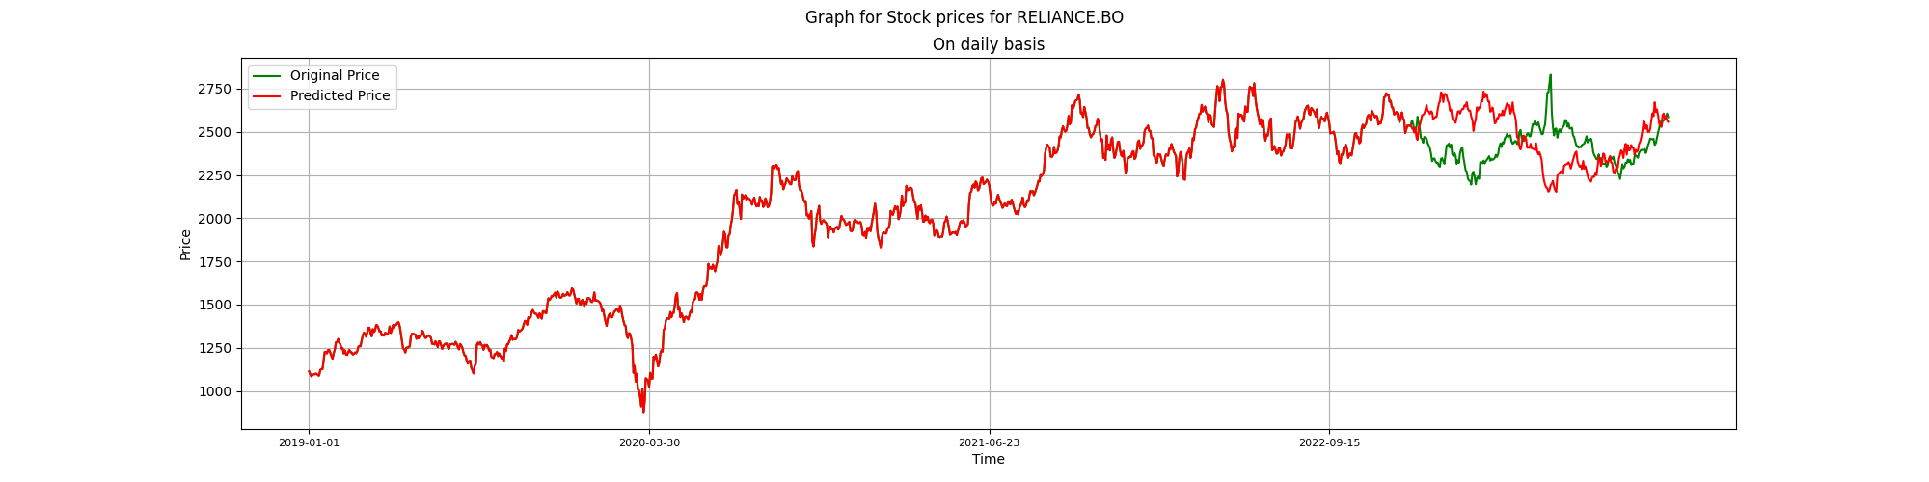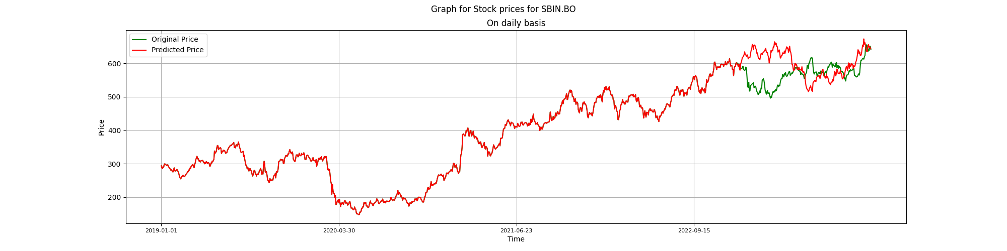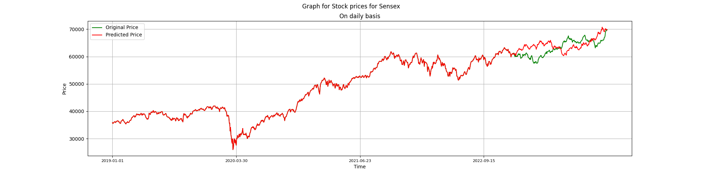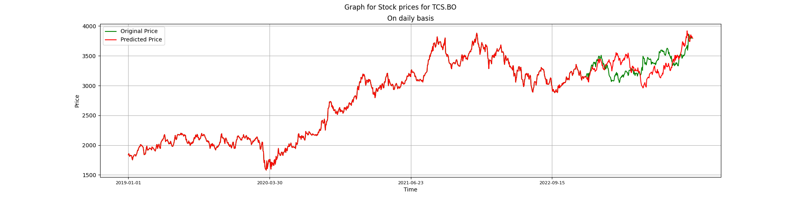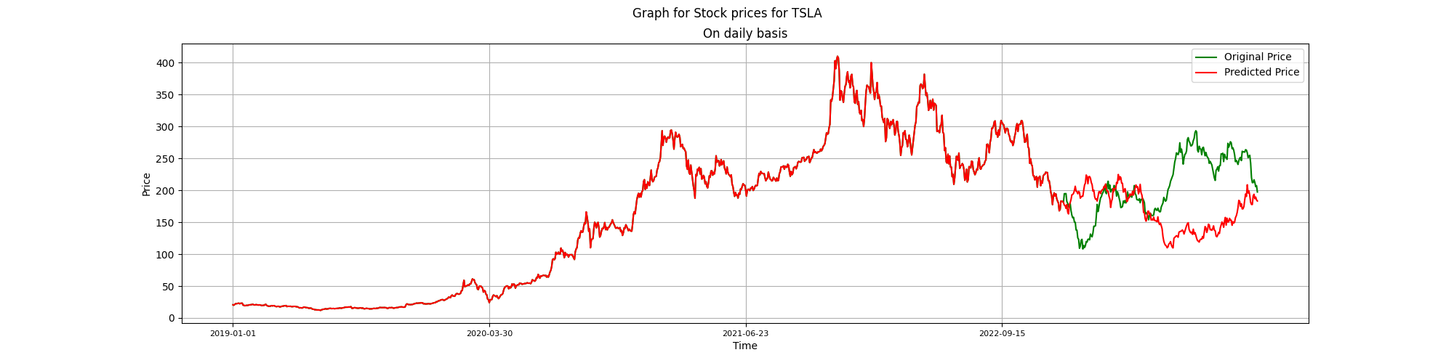

For daily data, the graphs of the generated path of stock prices along with the actual path of the stock for the stocks and Nifty in nsedata1.csv are as follows:

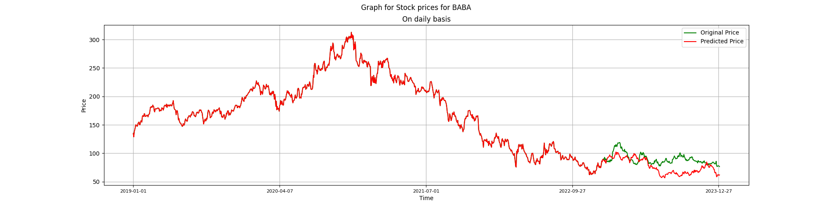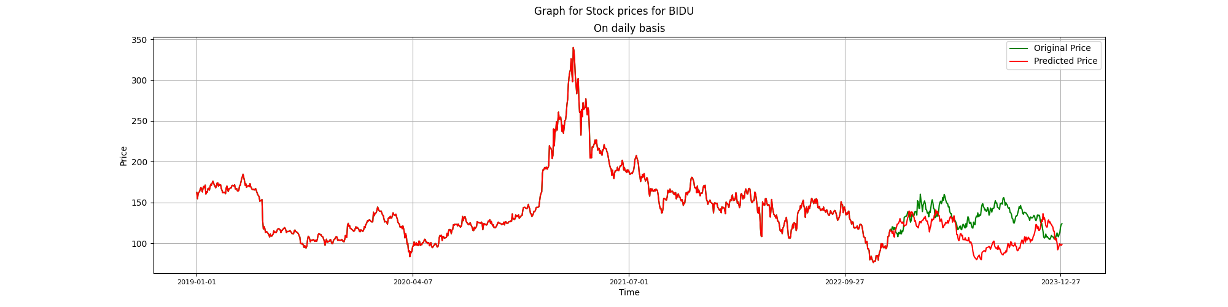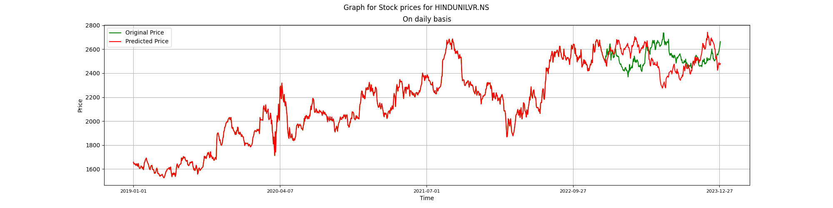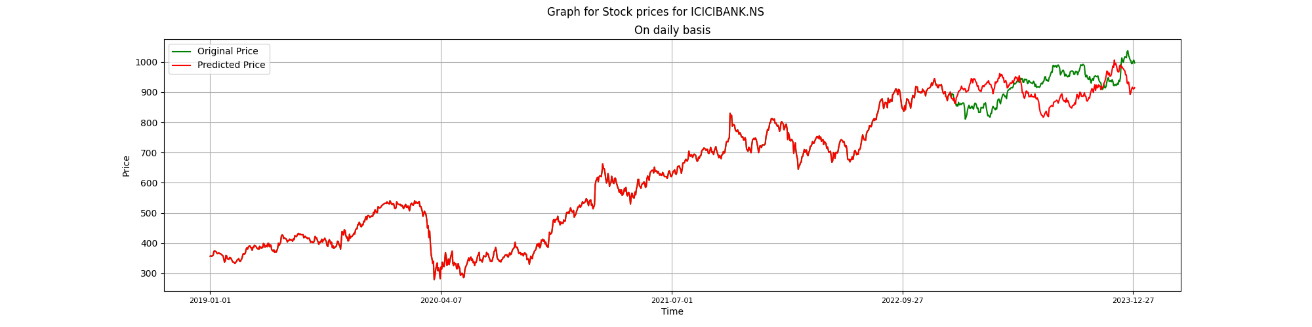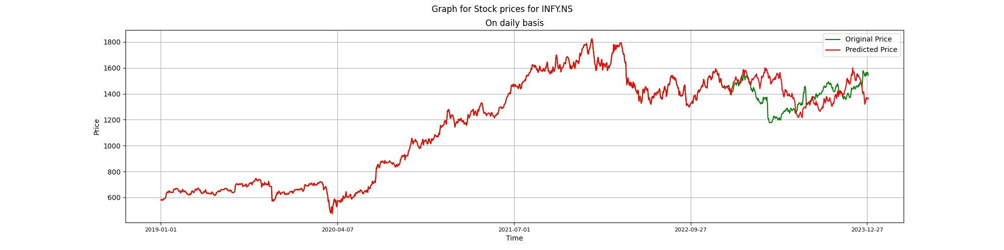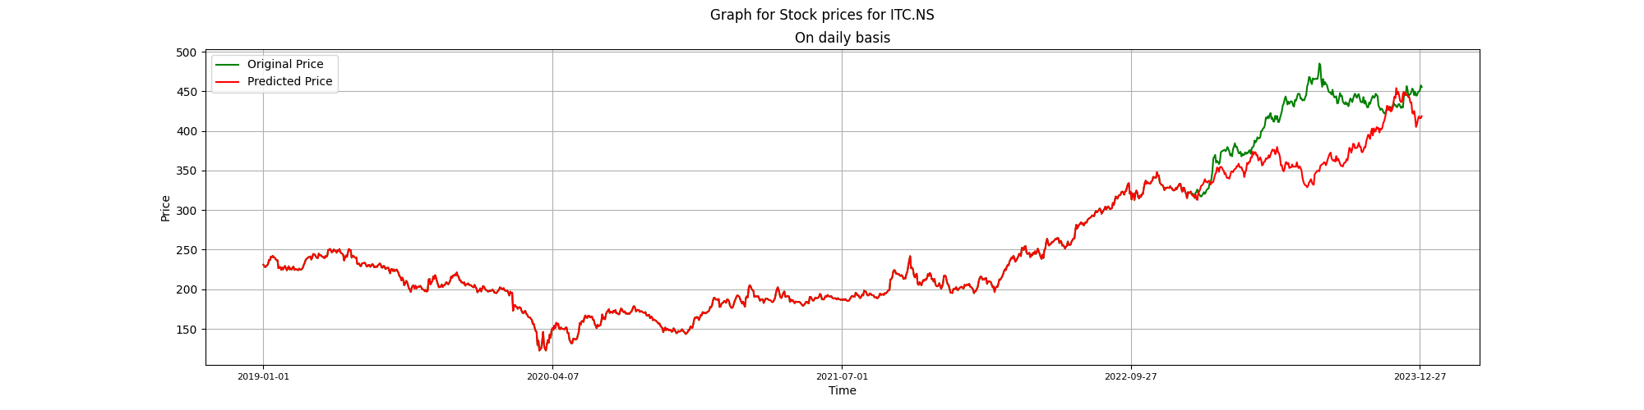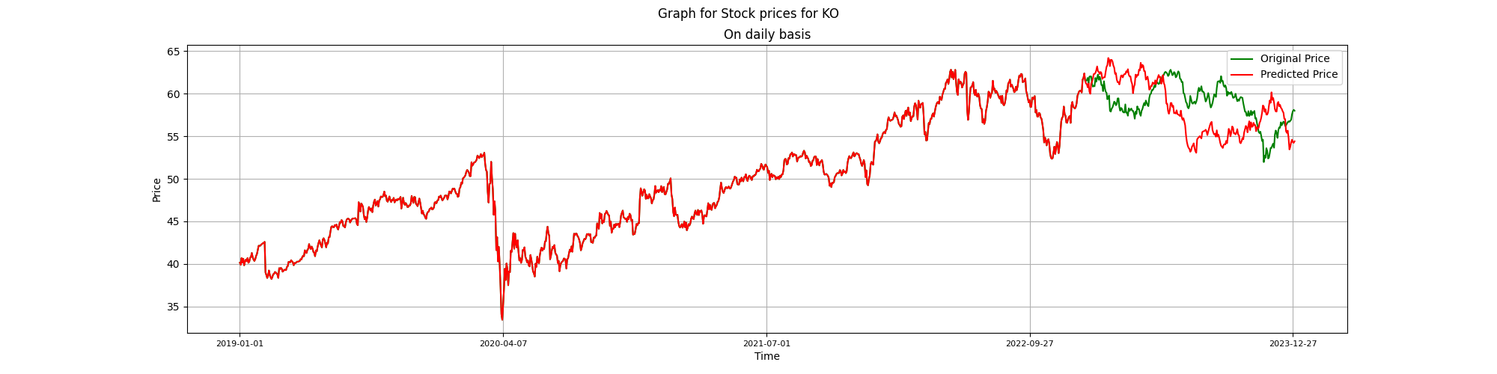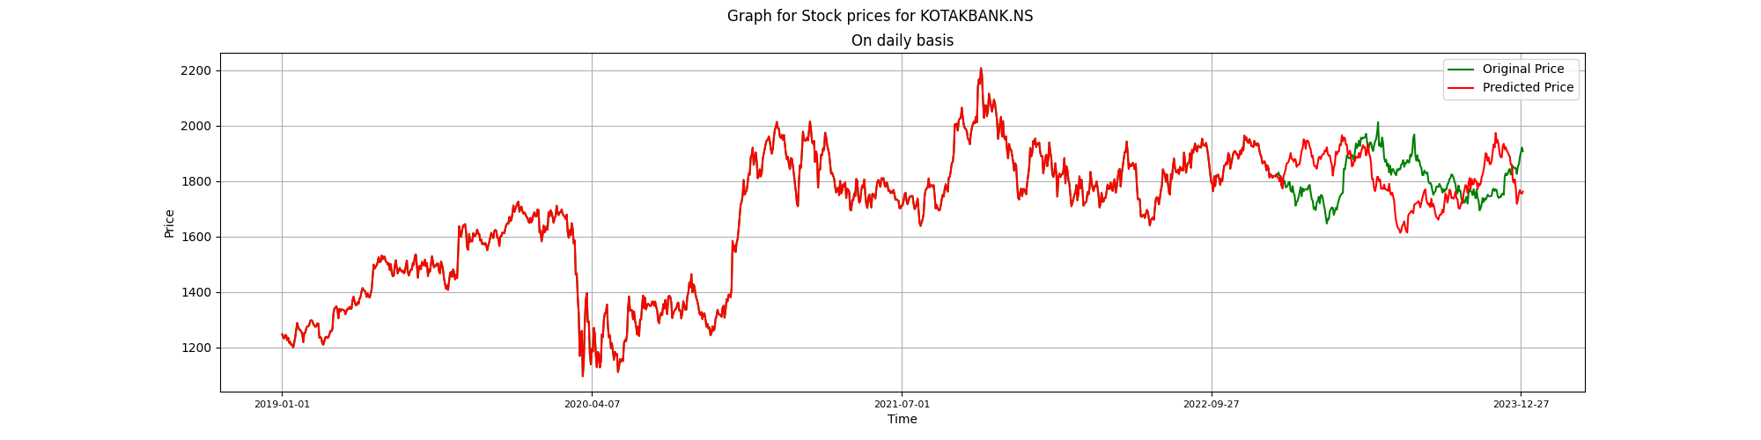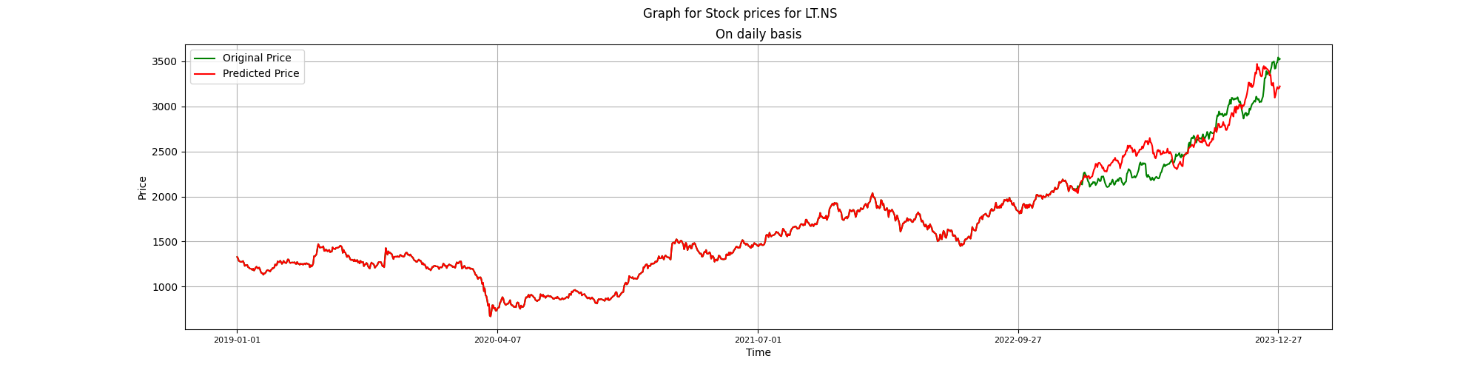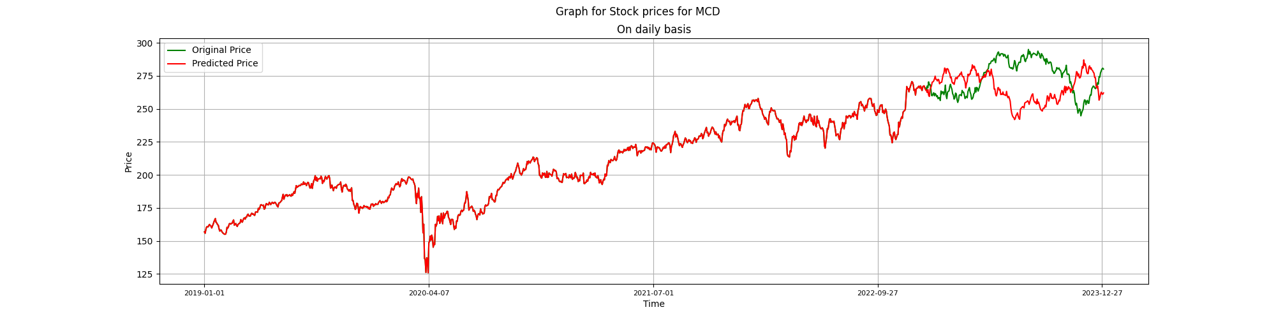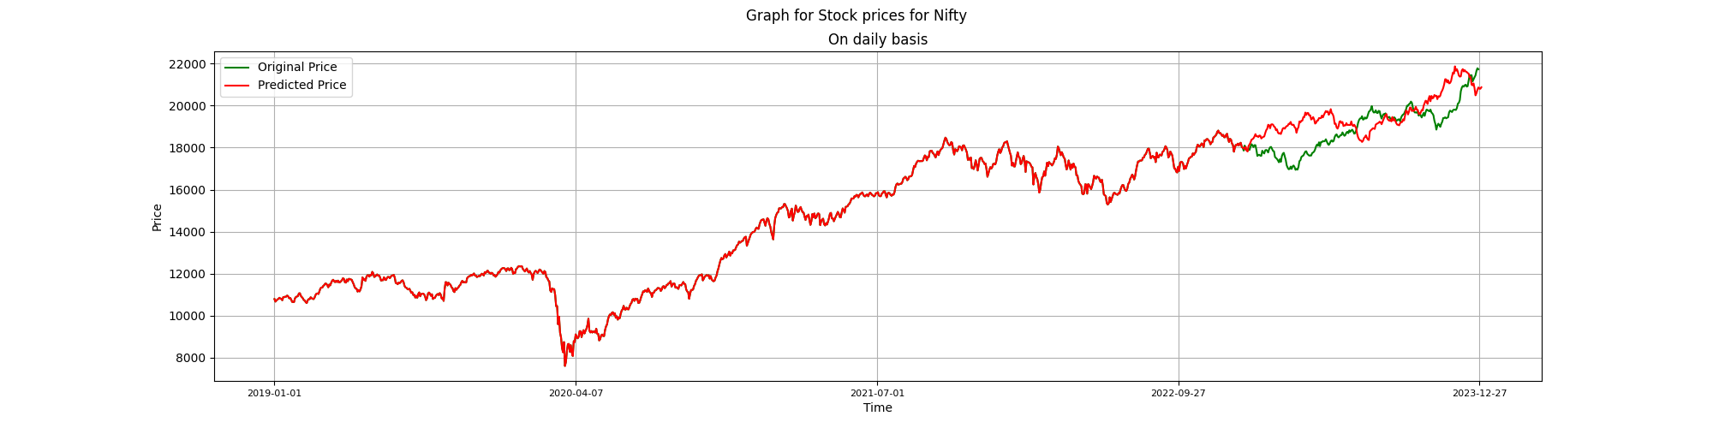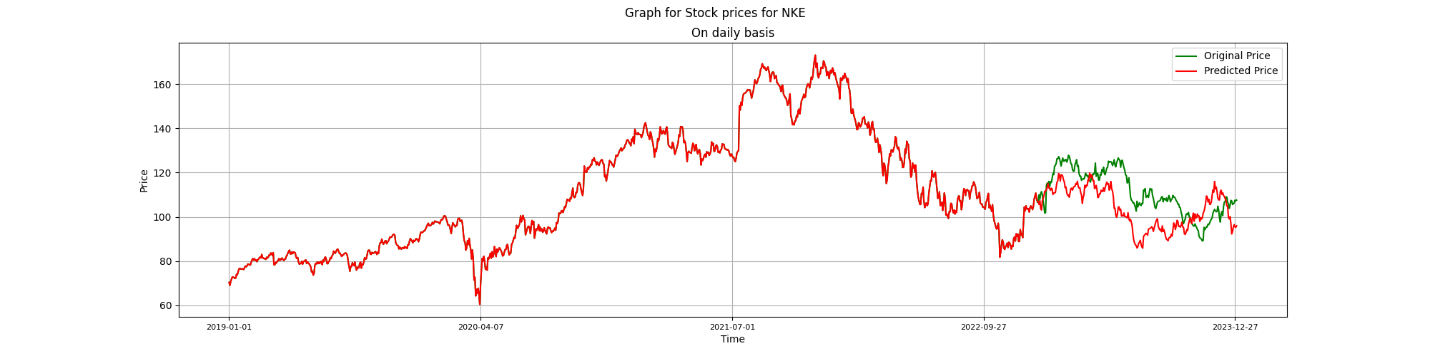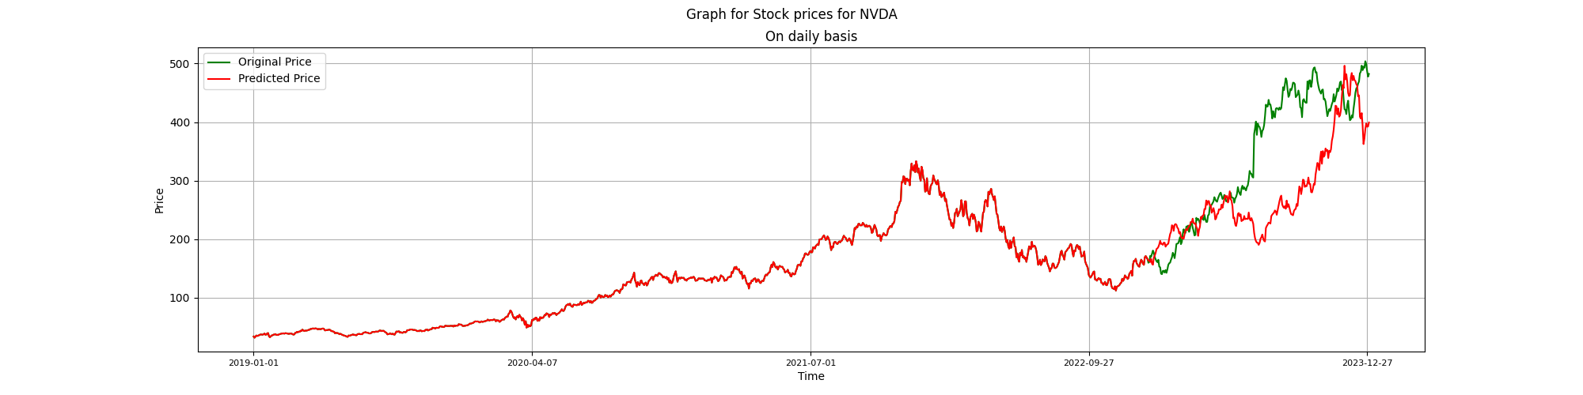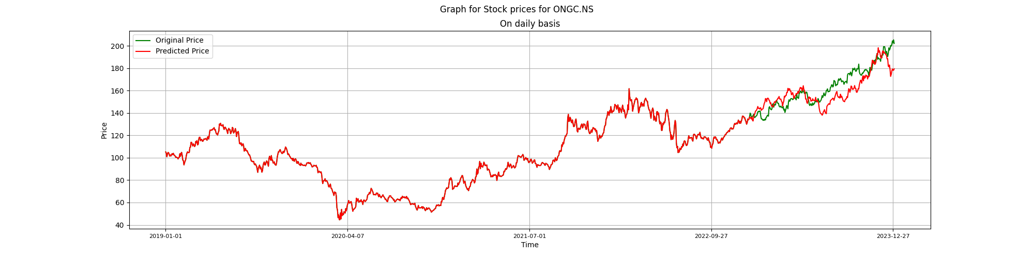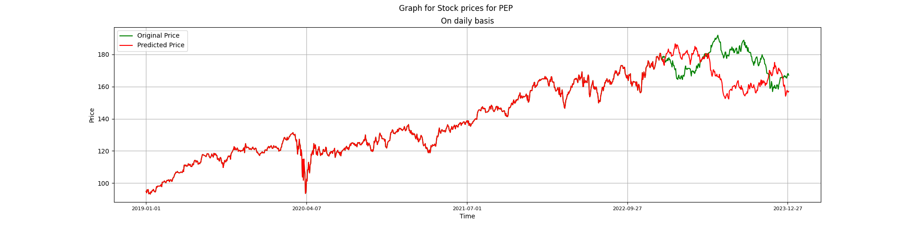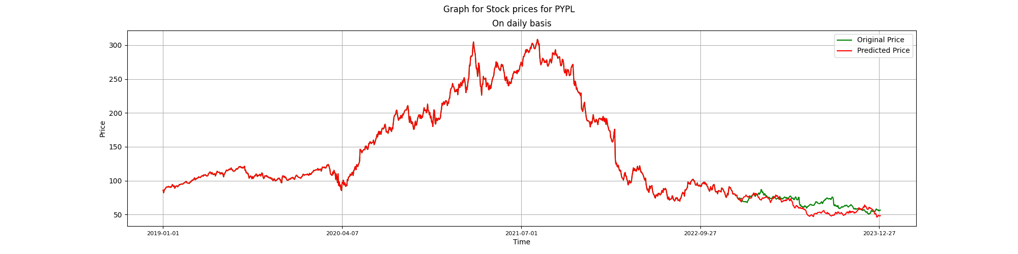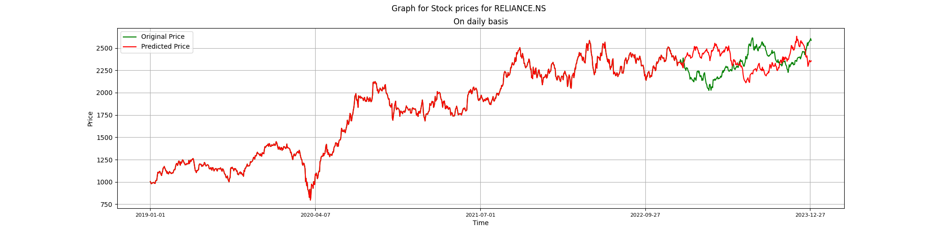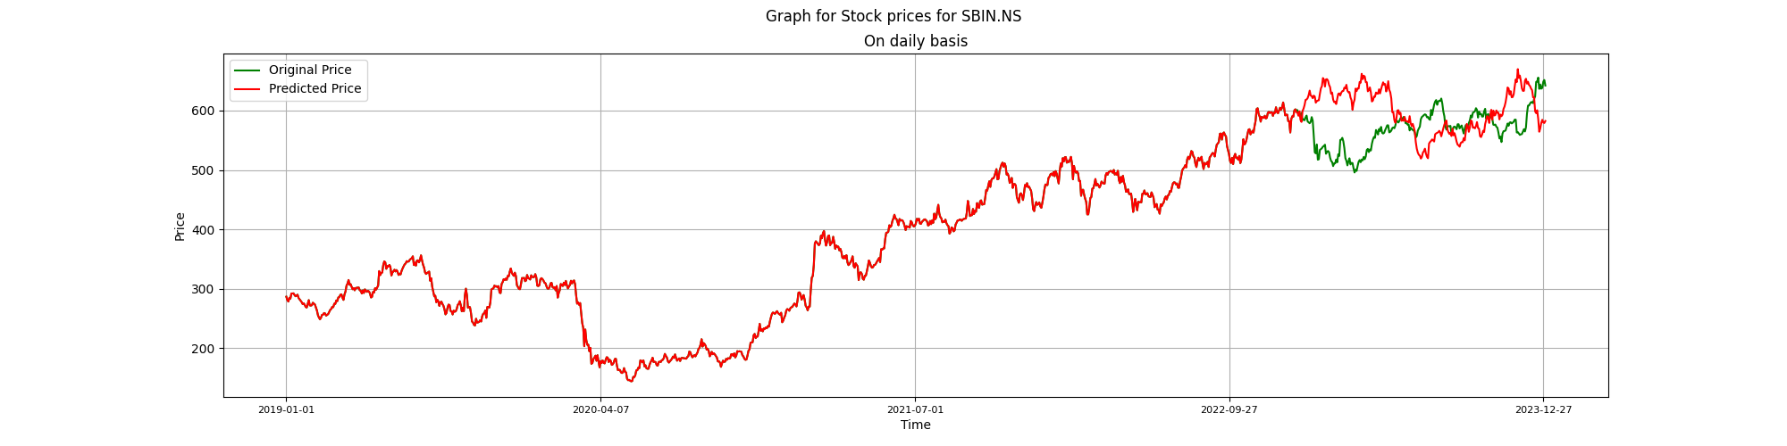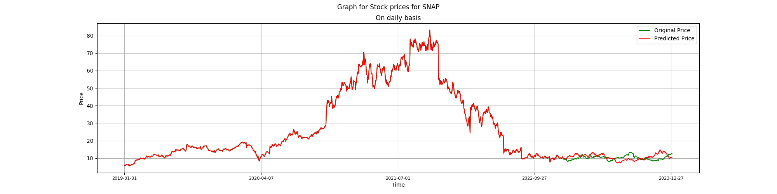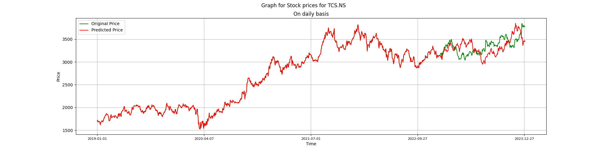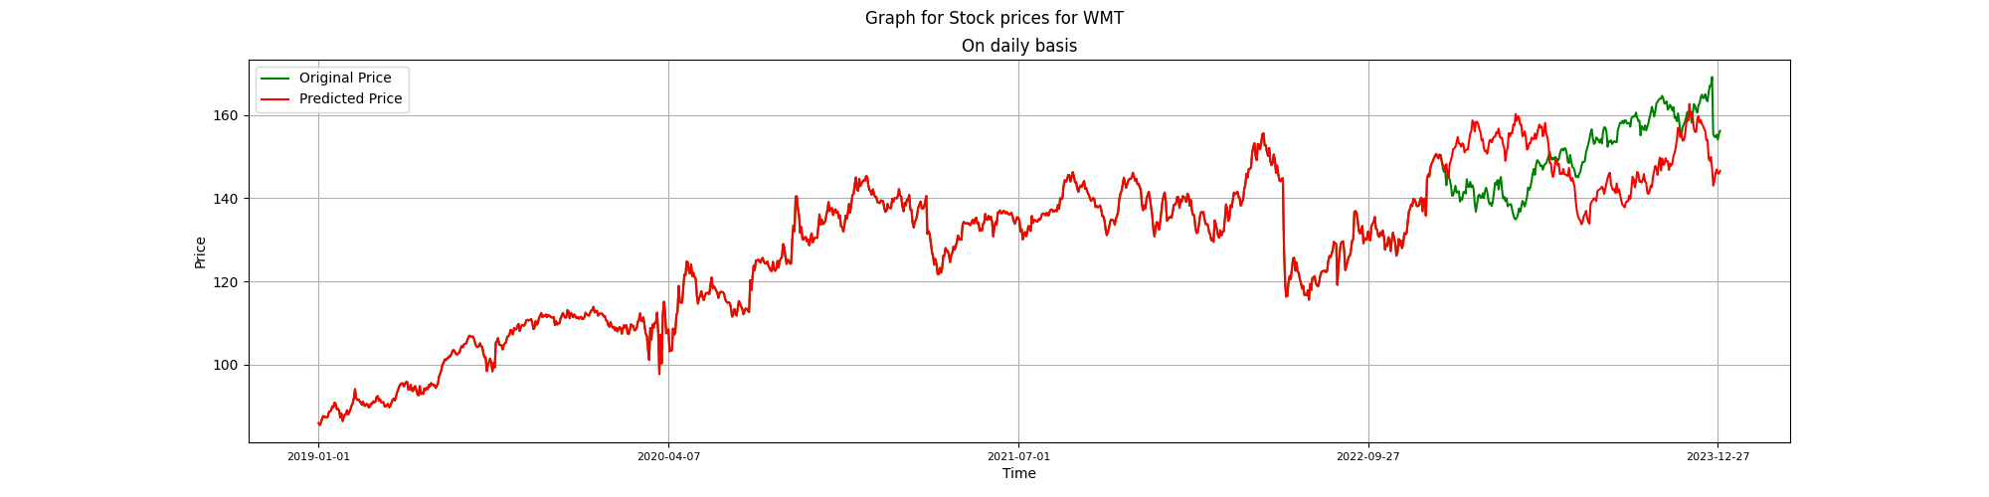

Question 5:

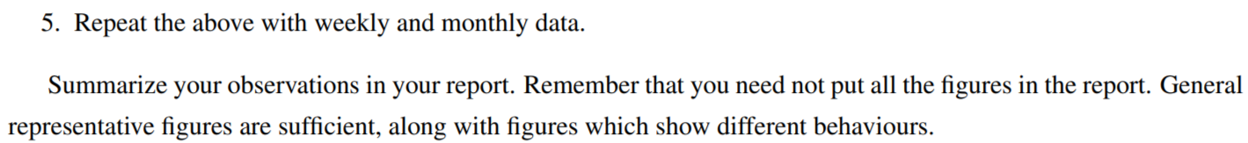

Geometric Brownian motion is used to model the scenario since stock prices behave like a stochastic process.



For weekly and monthly data, the graphs of the generated path of stock prices along with the actual path of the stock for the stocks and Sensex in bsedata1.csv are as follows:

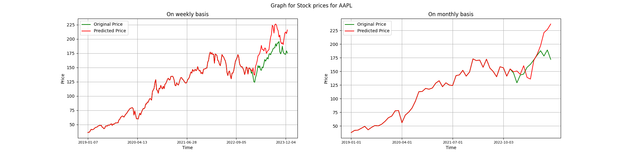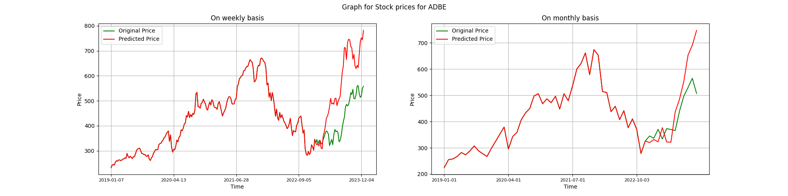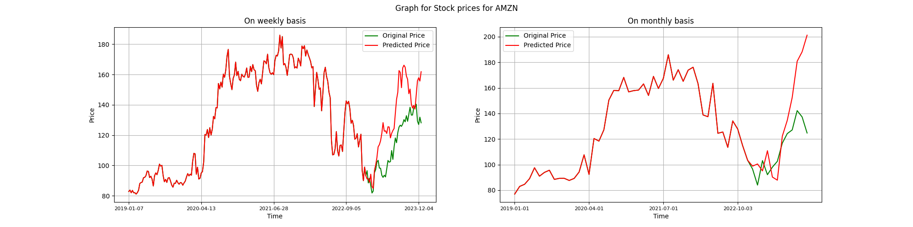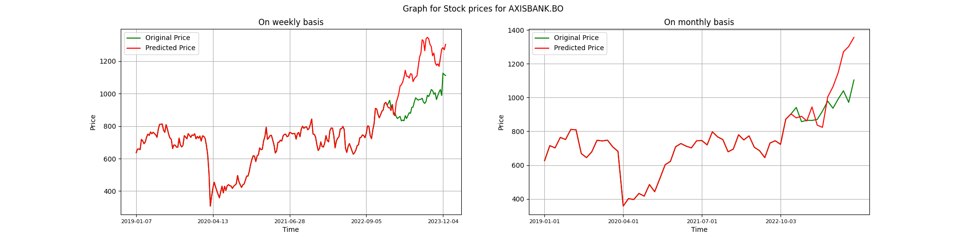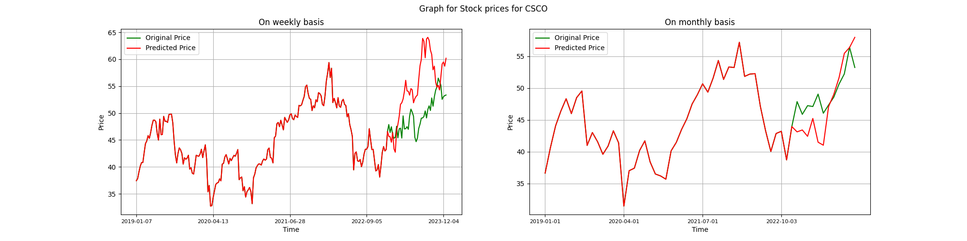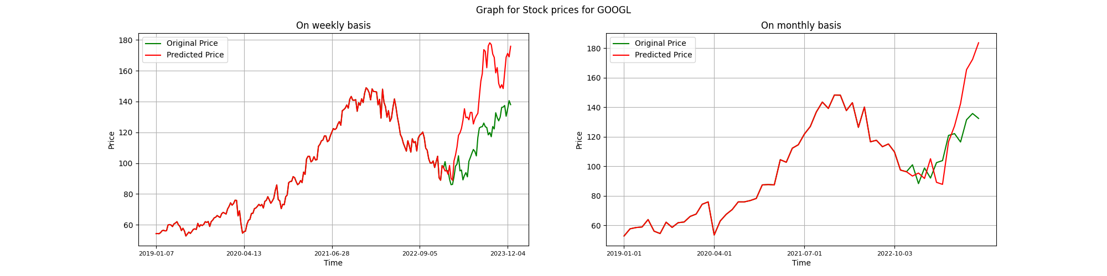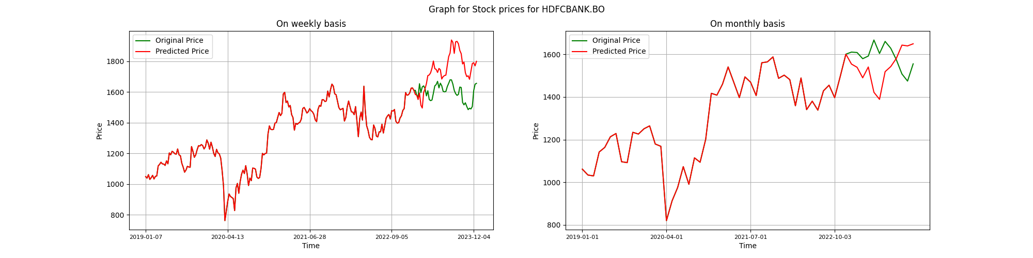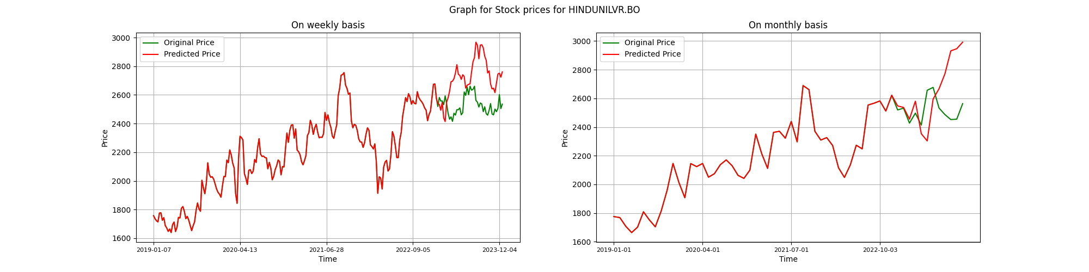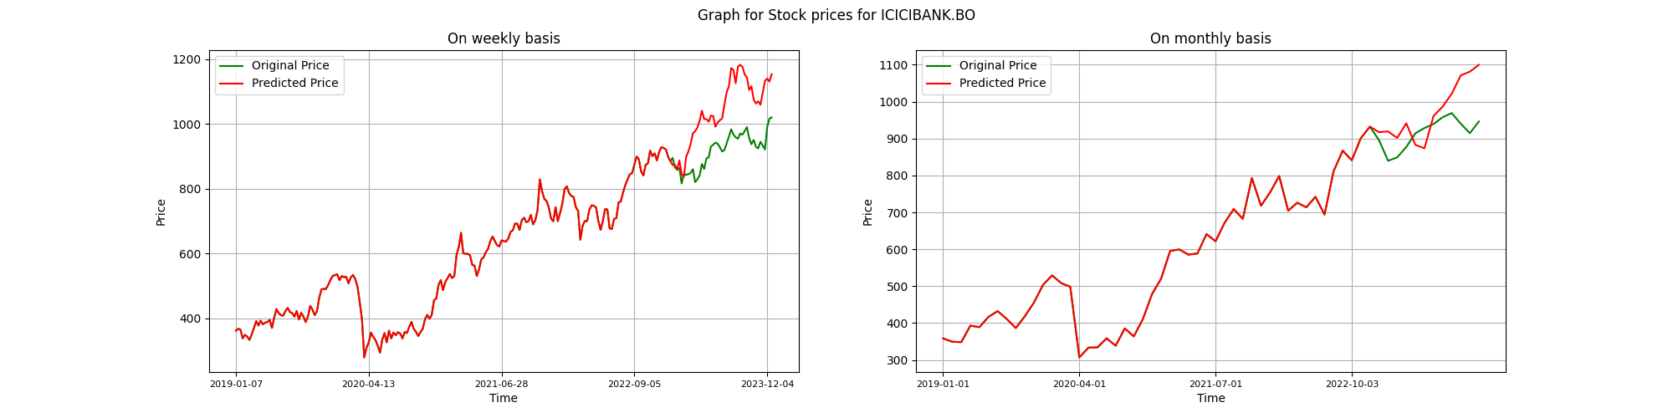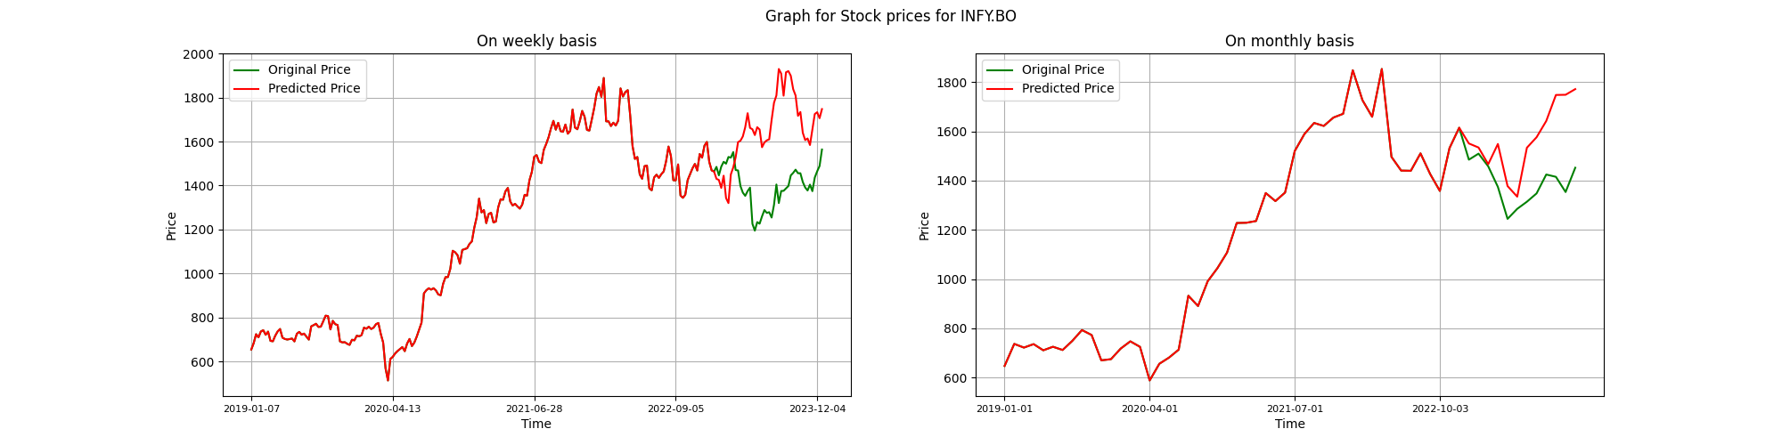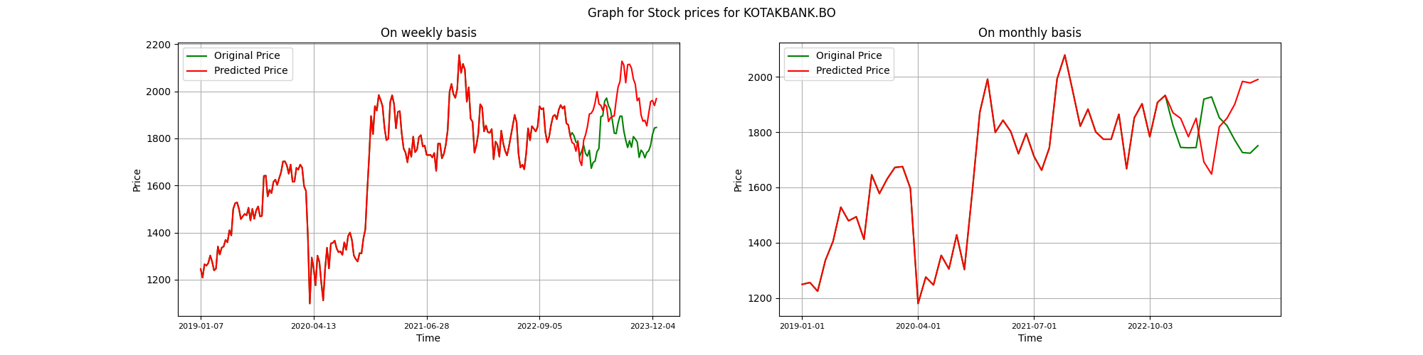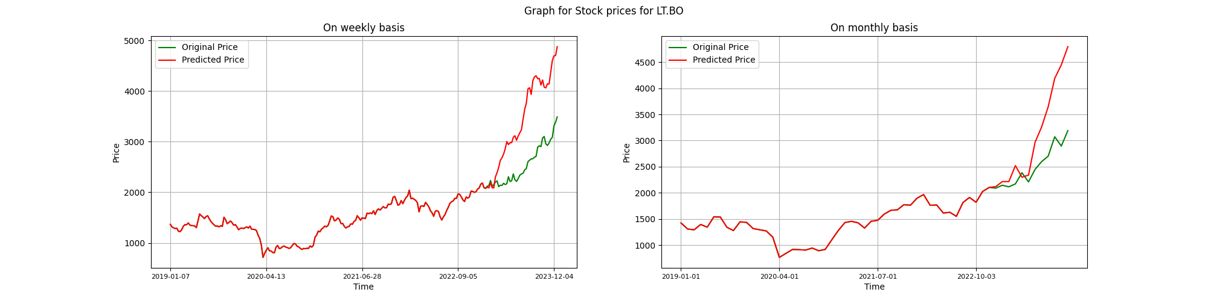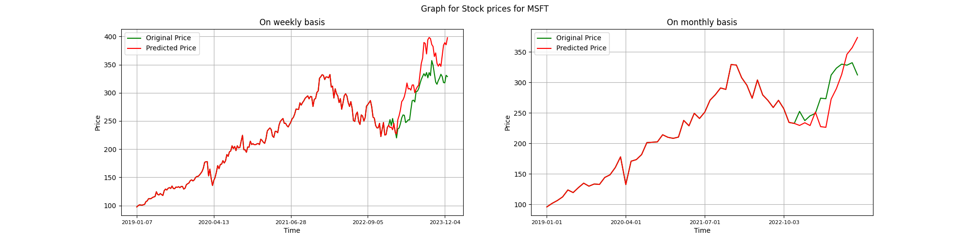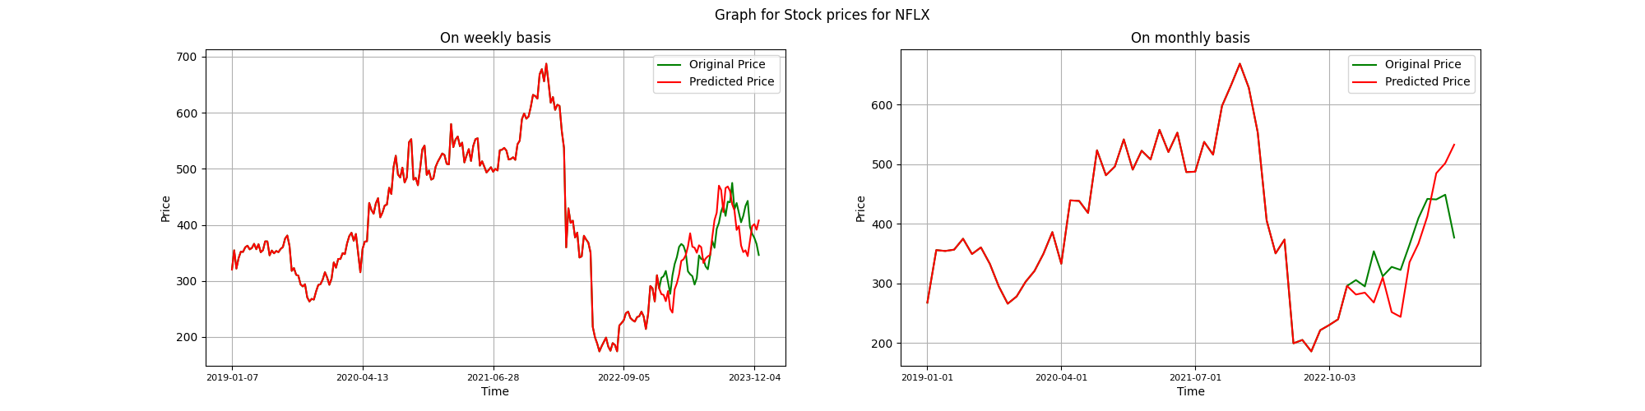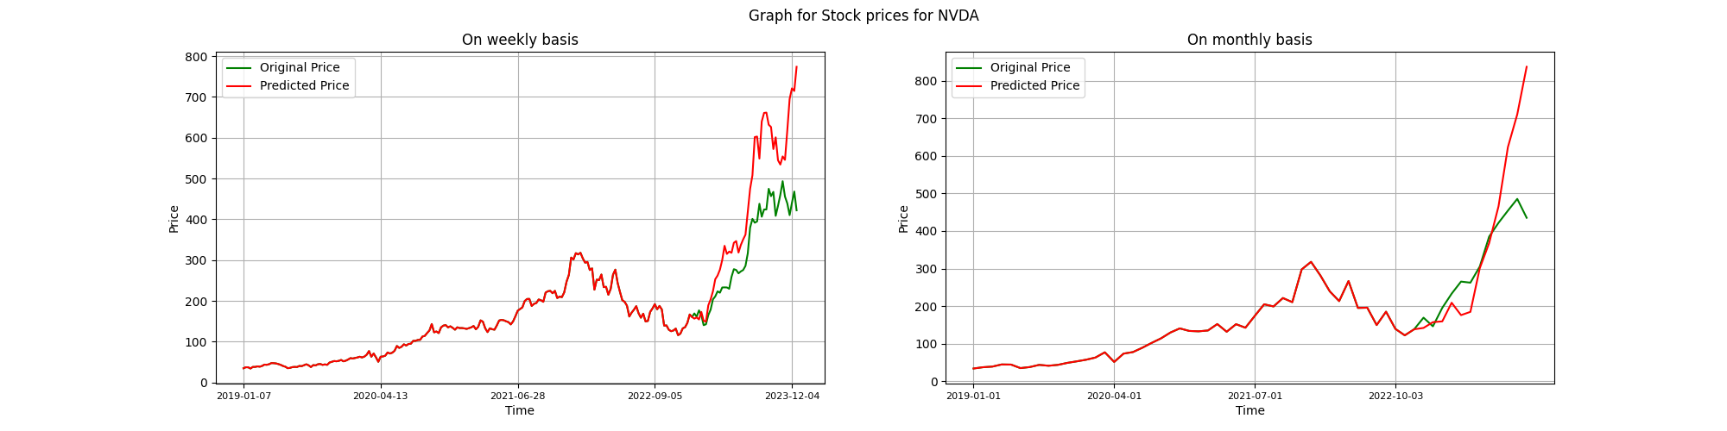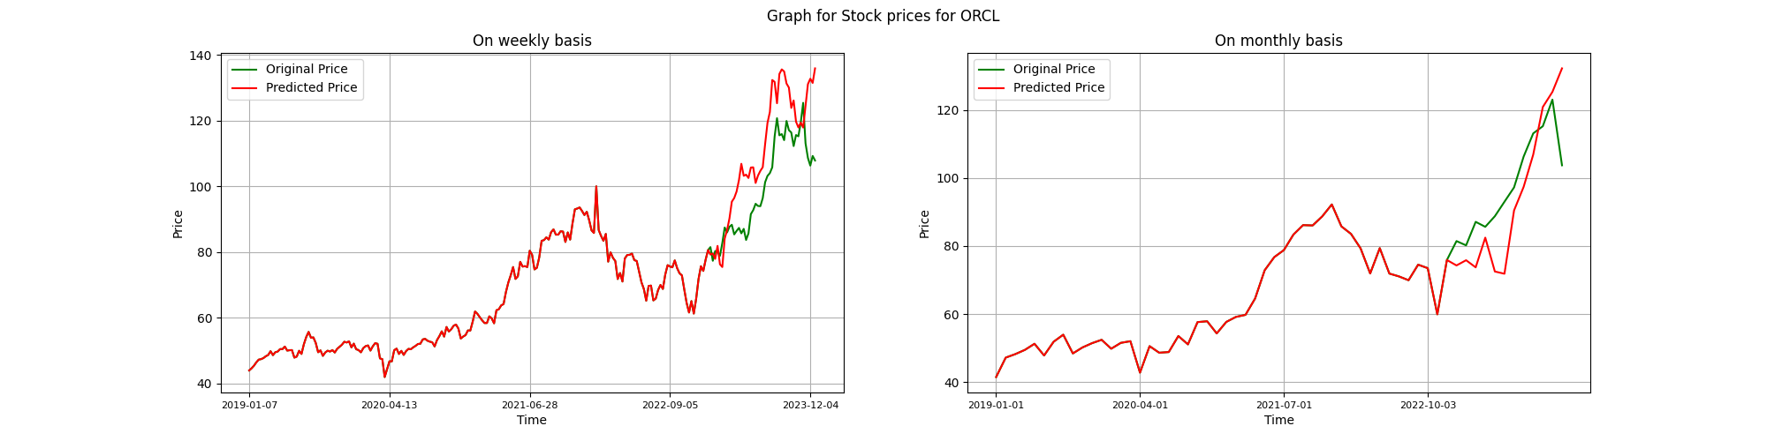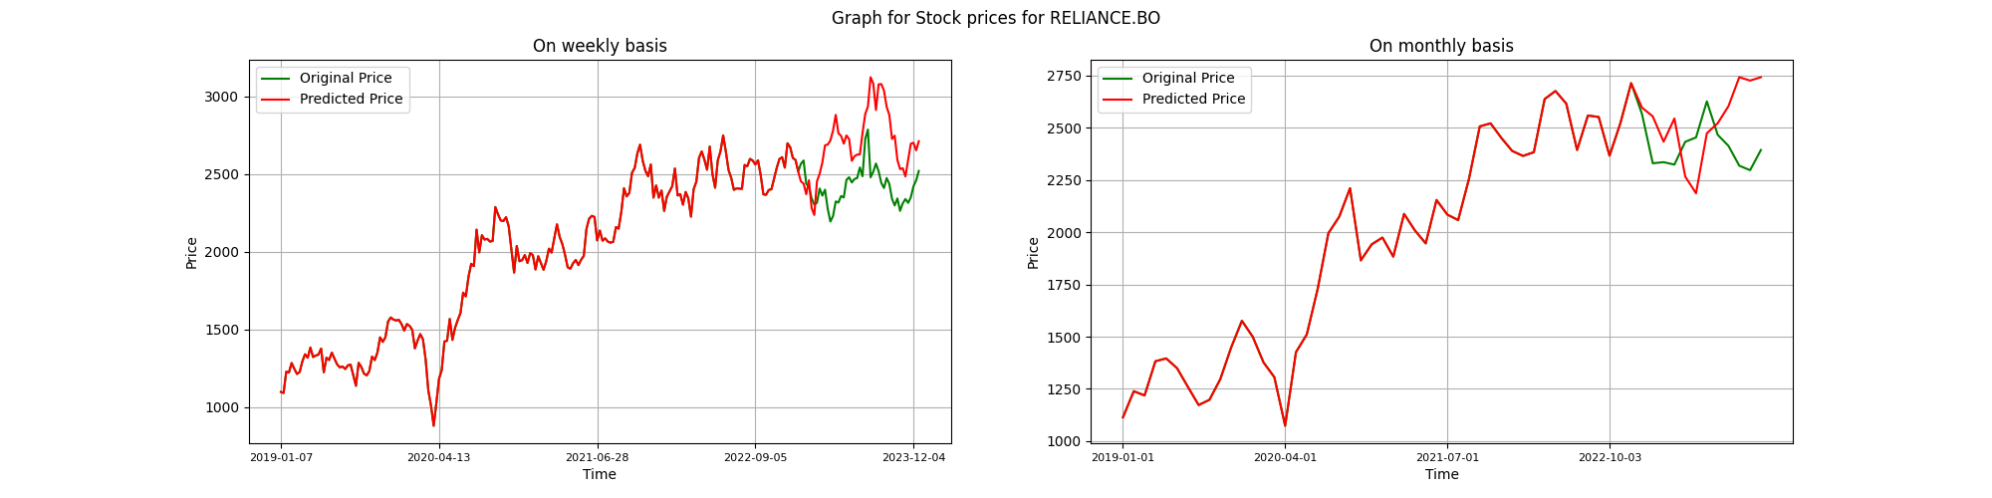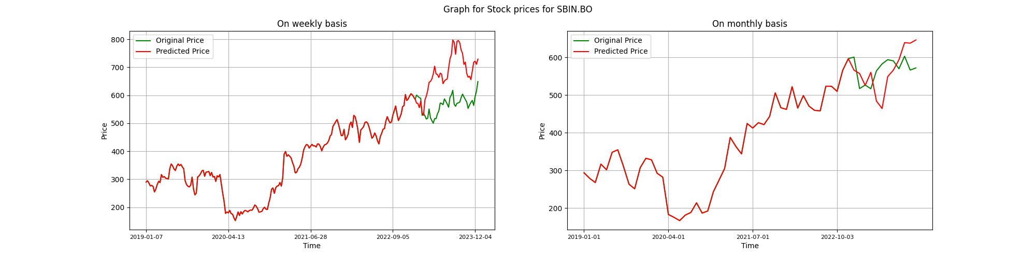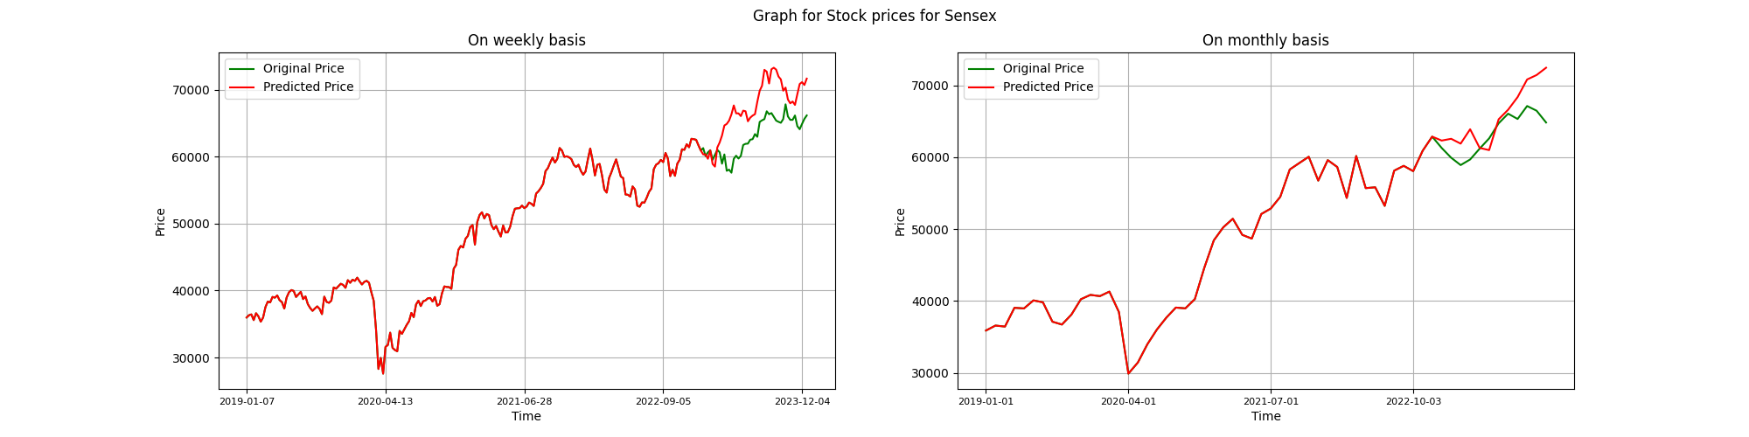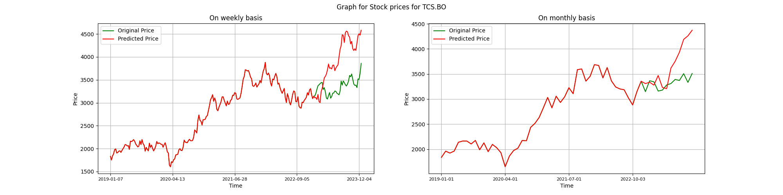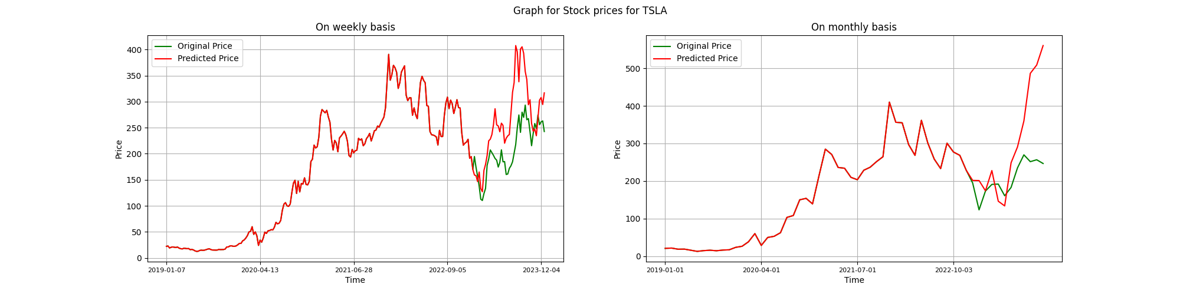

For weekly and monthly data, the graphs of the generated path of stock prices along with the actual path of the stock for the stocks and Nifty in nsedata1.csv are as follows:

